|  |  |
| --- | --- |
| **­** | **MINISTRY OF EDUCATION AND TRAINING** |

**FPT UNIVERSITY**

|  |  |
| --- | --- |
| **Capstone Project Document** | |
| **Parking Guidance System Solution** | |
| **Group 1** | |
| **Group members** | Trần Nguyễn Minh Trung – Team Leader – SE61496  Bùi Phú Hiệp – Team Member – SE61438  Nguyễn Đỗ Phương Huy – Team Member – SE61358 |
| **Supervisor** | Nguyễn Đức Lợi |
| **Ext. Supervisor** | N/A |
| **Capstone Project Code** | PGSS |

- Ho Chi Minh City, Jan, 2017

*This page is intentionally left blank*

# Table of Contents

Table of Contents 1

List of Tables 10

List of Figures 19

Definitions, Acronyms and Abbreviations 24

A. Introduction 25

1. Project Information 25

2. Introduction 25

3. Current Situation 25

3.1. Indoor parking area 26

3.2. Outdoor parking area 27

3.3. Traditional PGS 28

4. Problem Definition 29

5. Proposed Solution 30

5.1. Feature functions 30

5.1.1. Parking Guidance System 30

5.1.2. Mobile app 30

5.2. Advantages 30

5.3. Disadvantages 30

6. Functional Requirements 31

7. Roles and Responsibilities 31

8. Conclusion 32

B. Software – Hardware Project Management Plan 33

1. Problem Definition 33

1.1. Name of this Capstone Project 33

1.2. Problem Abstract 33

1.3. Project Overview 33

1.3.1. Current Situation 33

1.3.2. The Proposed System 33

1.3.2.1. Interaction Block 34

1.3.2.2. Information Block 34

1.3.2.3. Central Control Unit 34

1.3.2.4. Web API Server 34

1.3.2.5. Mobile Application 34

1.3.3. Boundaries of the System 34

1.3.4. Future Plans 35

1.3.5. Development Environment 36

1.3.5.1. Hardware requirements 36

1.3.5.2. Software requirements 37

2. Project organization 37

2.1. Software Process Model 37

2.2. Roles and responsibilities 38

2.3. Tools and Techniques 39

3. Project Management Plan 40

3.1. System development life cycle 40

3.2. Plan Detail 42

3.3. All Meeting Minutes 1

4. Coding Convention 1

4.1. C/C++ Convention 1

4.2. C#, ASP.NET Convention 1

4.3. Python Convention 1

4.4. Android Convention 2

C. Software – Hardware Requirement Specification 3

1. Software Requirement Specification 3

1.1. Software Requirement 3

1.2. GUI Requirement 3

2. Hardware Requirement Specification 3

2.1. Hardware Requirement 3

2.1.1. Hardware Interface 3

2.1.1.1. Block Diagram 4

2.1.1.2. Raspberry Pi 3 5

2.1.1.3. Arduino Nano 6

2.1.1.4. Compass Module 3-Axis HMC5883L 7

2.1.1.5. RF module nRF24L01+ 9

2.1.1.6. Information LED Display Module 10

2.1.1.7. Indicator LED Module 14

2.1.1.8. Servo Motor SG90 18

2.1.2. Communication Protocol 19

2.2. System Overview Use Case 19

2.3. List of Use Case 20

2.3.1. Manager Use Case 20

2.3.2. Administrator Use Case 24

2.3.3. End User Use Case 25

3. Software System Attribute 28

3.1. Usability 28

3.2. Reliability 28

3.3. Availability 28

3.4. Security 28

3.5. Maintainability 28

3.6. Portability 28

3.7. Performance 28

4. Conceptual Diagram 29

D. Software – Hardware Design Description 30

1. Design Overview 30

2. System Architectural Design 31

2.1. Hardware Program Architecture Description 32

2.2. Mobile Application Architecture Description 34

2.3. Web API Architecture Description 35

3. Component Diagram 35

3.1. General Component Diagram 35

3.2. Lot Device Diagram 36

3.3. Information Device Diagram 36

3.4. Server Diagram 37

3.5. Component Dictionary 37

4. Detailed Description 39

4.1. Web API Detailed Description 39

4.1.1. Class Diagram 39

4.1.2. Class Diagram Explanation 41

4.1.2.1. Model Class Diagram 41

4.1.2.2. View Model Class Diagram 44

4.1.2.3. Repository Class Diagram 47

4.1.2.4. Service Class Diagram 48

4.1.3. Interaction Diagram 51

4.2. Mobile Detailed Description 55

4.2.1. Class Diagram 55

4.2.2. Class Diagram Explanation 65

4.2.2.1. [Activities] MainActivity 65

4.2.2.2. [Activities] CarParkDetailActivity 66

4.2.2.3. [Activities] ManagerActivity 67

4.2.2.4. [Activities] AreaListActivity 68

4.2.2.5. [Activities] ParkingLotListActivity 69

4.2.2.6. [Activities] LoginActivity 69

4.2.2.7. [Activities] RegisterActivity 70

4.2.2.8. [Activities] UserActivity 71

4.2.2.9. [Activities] CarParkListActivity 72

4.2.2.10. [Activities] TransactionActivity 73

4.2.2.11. [Adapters] AreaAdapter 73

4.2.2.12. [Adapters] AreaAdapter.OnItemClickListener 74

4.2.2.13. [Adapters] AreaAdapter.ViewHolder 74

4.2.2.14. [Adapters] CarParkAdapter 75

4.2.2.15. [Adapters] CarParkAdapter.OnItemClickListener 75

4.2.2.16. [Adapters] CarParkAdapter.ViewHolder 75

4.2.2.17. [Adapters] ParkingLotAdapter 76

4.2.2.18. [Adapters] ParkingLotAdapter.OnItemClickListener 76

4.2.2.19. [Adapters] ParkingLotAdapter.ViewHolder 76

4.2.2.20. [Adapters] CarParkAdvanceAdapter 77

4.2.2.21. [Adapters] CarParkAdvanceAdapter.OnItemClickListener 77

4.2.2.22. [Adapters] CarParkAdvanceAdapter.ViewHolder 77

4.2.2.23. [Adapters] TransactionAdapter 78

4.2.2.24. [Adapters] TransactionAdapter.OnItemClickListener 78

4.2.2.25. [Adapters] TransactionAdapter.ViewHolder 79

4.2.2.26. [Adapters] UserInfoWindowAdapter 79

4.2.2.27. [Helpers] AppDatabaseHelper 79

4.2.2.28. [Helpers] PubnubHelper 80

4.2.2.29. [Helpers] AccountHelper 81

4.2.2.30. [Helpers] MapMarkerHelper 81

4.2.2.31. [Helpers] InternetHelper 81

4.2.2.32. [Interfaces] AreaClient 82

4.2.2.33. [Interfaces] TransactionClient 82

4.2.2.34. [Interfaces] CarParkClient 82

4.2.2.35. [Interfaces] AccountClient 83

4.2.2.36. [Interfaces] ParkingLotClient 83

4.2.2.37. [Models] Account 83

4.2.2.38. [Models] Area 84

4.2.2.39. [Models] CheckCode 84

4.2.2.40. [Models] Geo 84

4.2.2.41. [Models] CarPark 85

4.2.2.42. [Models] Transaction 85

4.2.2.43. [Models] ParkingLot 86

4.2.2.44. [Models] TransactionStatus 86

4.2.2.45. [Models] AreaStatus 87

4.2.2.46. [Models] ParkingLotStatus 87

4.2.2.47. [Network] AccountPackage 88

4.2.2.48. [Network] AreaPackage 88

4.2.2.49. [Network] CarParkPackage 88

4.2.2.50. [Network] CheckCodePackage 89

4.2.2.51. [Network] CommandPackage 89

4.2.2.52. [Network] RealtimeMapPackage 90

4.2.2.53. [Network] ControlPubnubPackage 90

4.2.2.54. [Network] MobilePubnubPackage 90

4.2.2.55. [Network] GetCoordinationPackage 91

4.2.2.56. [Network] CarParkAdvancePackage 91

4.2.2.57. [Network] NotificationPackage 91

4.2.2.58. [Network] TransactionPackage 92

4.2.2.59. [Network] ParkingLotPackage 92

4.2.2.60. [Network] ServiceGenerator 92

4.2.2.61. [Network] DateTypeDeserializer 93

4.2.3. Interaction Diagram 93

4.2.3.1. Load car parks on map 93

4.2.3.2. Load car parks in list 94

4.2.3.3. Car park detail information 95

4.2.3.4. Reserve parking lot process 96

4.2.3.5. Transaction controller 97

4.2.3.6. Manage car parks 99

4.2.3.7. Manage areas 100

4.2.3.8. Manage parking lots 101

4.2.3.9. Check reservation PIN code 102

4.3. Embedded Program Detailed Description 103

4.3.1. Class Diagram 103

4.3.2. Class Diagram Explanation 106

4.3.2.1. [Lot] Main 106

4.3.2.2. [Lot] HMC5883L 107

4.3.2.3. [Lot] RGBLED 107

4.3.2.4. [Lot] common_type 108

4.3.2.5. [Sign] Main 108

4.3.2.6. [Sign] SEVEN_SEGMENT 109

4.3.2.7. [Lot/Sign] RFUtil 109

4.3.2.8. [Lot/Sign] CRC24 110

4.3.2.9. [Hub] hub 111

4.3.2.10. [Hub] rf_meta 112

4.3.2.11. [Hub] crc24 113

4.3.2.12. [Hub] api_service 113

4.3.2.13. [Hub] pubnub_meta 113

4.3.2.14. [Hub] Area 114

4.3.2.15. [Hub] ParkingLot 114

4.3.2.16. [Hub] UserPackage 115

4.3.3. Interaction Diagram 115

4.3.3.1. Lot node process 115

4.3.3.2. Sign node process 117

4.3.3.3. Hub polling process 119

4.3.3.1. Hub execute request process 121

4.4. Hardware Detailed Description 123

4.4.1. Raspberry Pi 3 model B 123

4.4.2. Arduino Nano 125

4.4.3. Compass module 3-Axis HMC5883L 127

4.4.4. RF module nRF24L01+ 129

4.4.5. Lot node 134

4.4.5.1. RGB LED common anode 134

4.4.5.2. Transistor TIP122 136

4.4.5.3. Servo motor SG90 138

4.4.6. Sign node 139

4.4.6.1. 7-Segment LED display 139

4.4.6.2. Power logic 8-bit shift register TPIC6B595 139

4.4.7. Components connection 142

5. Interface 142

5.1. Component Interface 142

5.2. User Interface Design 142

5.2.1. Common Interface 142

5.2.1.1. Login screen 142

5.2.1.2. Register screen 144

5.2.2. User/Guest Interface 145

5.2.2.1. Map view screen 145

5.2.2.2. Navigation view 147

5.2.2.3. Car park list view screen 149

5.2.2.4. Car park detail view screen 150

5.2.2.5. History transaction list view screen 152

5.2.2.6. History transaction detail view screen 153

5.2.2.7. Reservation process view screen 155

5.2.3. Manager Interface 158

5.2.3.1. Car park list view screen 158

5.2.3.2. Car park detail view screen 159

5.2.3.3. Area list view screen 161

5.2.3.4. Area detail view screen 162

5.2.3.5. Parking lot list view screen 163

5.2.3.6. Parking lot detail view screen 164

5.2.3.7. Check code view screen 165

6. Database Design 167

6.1. Logical Diagram 167

6.2. Data Dictionary 167

7. Algorithms 169

7.1. GetDistance formula 169

7.2. CRC Error Detection 169

7.2.1. Definition 169

7.2.2. Define Problem 169

7.2.3. Solution theory 169

7.2.4. Implementation 172

7.2.5. Table-driven implementation 173

F. User’s Manual 177

1. Installation Guide 177

1.1. Hardware installation 177

1.2. Hub installation 177

1.3. Mobile Application 178

2. User Guide 179

2.1. Manager 179

2.1.1. Edit car park information 179

2.1.2. Edit area information 181

2.1.3. Edit parking lot information 183

2.1.4. Check PIN code for user 185

2.2. User 187

2.2.1. Search for car park near user in map 187

2.2.2. Search for car park near location in map 189

2.2.3. Search for car park near user/location in list view 191

2.2.4. Call the car park 193

2.2.5. Find best route from current location to car park 195

2.2.6. Reserve a parking lot in car park 197

2.2.7. Cancel/Check-in reservation 200

# List of Tables

Table 1: Definitions, Acronyms and Abbreviations 24

Table 2: Roles and Responsibilities 31

Table 3: Database requirement 36

Table 4: API Service Requirement 36

Table 5: Provide CCU Hardware 36

Table 6: Roles and Responsibilities Details 39

Table 7: Tools 39

Table 8: Techniques 40

Table 9: System Development Life Cycle 41

Table 10: System Development Detail Plan 44

Table 11: Raspberry Pi 3 – Specification 5

Table 12: Arduino Nano - Specification 7

Table 13: The Compass Module 3-Axis HMC5883L - Pin Function 8

Table 14: RF Module nRF24L01 – Pin function 10

Table 15: IC TPIC6B595 - Pin Function 14

Table 16: Servo Motor SG90 – Pin-outs 19

Table 17: Component dictionary 38

Table 18: CarPark class attributes 42

Table 19: CarParkWithAmountEntities class attributes 42

Table 20: Area class attributes 42

Table 21: AreaCustom class attributes 42

Table 22: ParkingLot class attributes 43

Table 23: Transaction class attributes 43

Table 24: AspNetUser class attributes 44

Table 25: CarParkViewModel class attributes 44

Table 26: CarParkWithAmount class attributes 44

Table 27: CarParkUpdateViewModel class attributes 45

Table 28: AreaViewModel class attributes 45

Table 29: AreaCustomViewModel class attributes 45

Table 30: ParkingLotViewModel class attributes 45

Table 31: ParkingLotUpdateViewModel class attributes 46

Table 32: Transaction class attributes 46

Table 33: TransactionCustomViewModel class attributes 46

Table 34: TransactionCreateViewModel class attributes 46

Table 35: TransactionCreateReturnViewModel class attributes 47

Table 36: TransactionUpdateViewModel class attributes 47

Table 37: AspNetUser class attributes 47

Table 38: BaseRepository class methods 48

Table 39: BaseService class methods 49

Table 40: AreaService class methods 50

Table 41: CarParkService class methods 50

Table 42: ParkingLotService class methods 50

Table 43: TransactionService class methods 51

Table 44: Packages dictionary 56

Table 45: Activities package class dictionary 58

Table 46: Adapters package class dictionary 60

Table 47: Helpers package class dictionary 61

Table 48: Interfaces package class dictionary 62

Table 49: Models package class dictionary 64

Table 50: Networks package class dictionary 65

Table 51: [Activities] MainActivity methods 65

Table 52: [Activities] CarParkDetailActivity attributes 66

Table 53: [Activities] CarParkDetailActivity methods 66

Table 54: [Activities] ManagerActivity attributes 67

Table 55: [Activities] ManagerActivity methods 68

Table 56: [Activities] AreaListActivity attributes 68

Table 57: [Activities] AreaListActivity methods 69

Table 58: [Activities] ParkingLotListActivity attributes 69

Table 59: [Activities] ParkingLotListActivity methods 69

Table 60: [Activities] LoginActivity attributes 70

Table 61: [Activities] LoginActivity methods 70

Table 62: [Activities] RegisterActivity attributes 70

Table 63: [Activities] RegisterActivity methods 70

Table 64: [Activities] UserActivity attributes 71

Table 65: [Activities] UserActivity methods 72

Table 66: [Activities] CarParkListActivity attributes 73

Table 67: [Activities] CarParkListActivity methods 73

Table 68: [Activities] TransactionActivity attributes 73

Table 69: [Activities] TransactionActivity methods 73

Table 70: [Adapters] AreaAdapter attributes 74

Table 71: [Adapters] AreaAdapter methods 74

Table 72: [Adapters] AreaAdapter.OnItemClickListener methods 74

Table 73: [Adapters] AreaAdapter.ViewHolder attributes 74

Table 74: [Adapters] AreaAdapter.ViewHolder methods 74

Table 75: [Adapters] CarParkAdapter attributes 75

Table 76: [Adapters] CarParkAdapter methods 75

Table 77: [Adapter] CarParkAdapter.OnItemClickListener methods 75

Table 78: [Adapters] CarParkAdapter.ViewHolder attributes 75

Table 79: [Adapters] CarParkAdapter.ViewHolder methods 76

Table 80: [Adapters] ParkingLotAdapter attributes 76

Table 81: [Adapters] ParkingLotAdapter methods 76

Table 82: [Adapters] ParkingLotAdapter.OnItemClickListener methods 76

Table 83: [Adapters] ParkingLotAdapter.ViewHolder attributes 76

Table 84: [Adapters] ParkingLotAdapter.ViewHolder methods 77

Table 85: [Adapters] CarParkAdvanceAdapter attributes 77

Table 86: [Adapters] CarParkAdvanceAdapter methods 77

Table 87: [Adapters] CarParkAdvanceAdapter.OnItemClickListener methods 77

Table 88: [Adapters] CarParkAdvanceAdapter.ViewHolder attributes 78

Table 89: [Adapters] CarParkAdvanceAdapter.ViewHolder methods 78

Table 90: [Adapters] TransactionAdapter attributes 78

Table 91: [Adapters] TransactionAdapter methods 78

Table 92: [Adapters] TransactionAdapter.OnItemClickListener methods 79

Table 93: [Adapters] TransactionAdapter.ViewHolder attributes 79

Table 94: [Adapters] TransactionAdapter.ViewHolder methods 79

Table 95: [Adapters] UserInfoWindowAdapter attributes 79

Table 96: [Adapters] UserInfoWindowAdapter methods 79

Table 97: [Helpers] AppDatabaseHelper attributes 80

Table 98: [Helpers] AppDatabaseHelper methods 80

Table 99: [Helpers] PubnubHelper attributes 81

Table 100: [Helpers] PubnubHelper methods 81

Table 101: [Helpers] AccountHelper attributes 81

Table 102: [Helpers] AccountHelper methods 81

Table 103: [Helpers] MapMarkerHelper methods 81

Table 104: [Helpers] InternetHelper methods 82

Table 105: [Interfaces] AreaClient methods 82

Table 106: [Interfaces] TransactionClient methods 82

Table 107: [Interfaces] CarParkClient methods 83

Table 108: [Interfaces] AccountClient methods 83

Table 109: [Interfaces] ParkingLotClient methods 83

Table 110: [Models] Account attributes 84

Table 111: [Models] Account methods 84

Table 112: [Models] Area attributes 84

Table 113: [Models] Area methods 84

Table 114: [Models] CheckCode attributes 84

Table 115: [Models] CheckCode methods 84

Table 116: [Models] Geo attributes 85

Table 117: [Models] Geo methods 85

Table 118: [Models] CarPark attributes 85

Table 119: [Models] CarPark methods 85

Table 120: [Models] Transaction attributes 86

Table 121: [Models] Transaction methods 86

Table 122: [Models] ParkingLot attributes 86

Table 123: [Models] ParkingLot methods 86

Table 124: [Models] TransactionStatus attributes 87

Table 125: [Models] TransactionStatus methods 87

Table 126: [Models] AreaStatus attributes 87

Table 127: [Models] AreaStatus methods 87

Table 128: [Models] ParkingLotStatus attributes 88

Table 129: [Models] ParkingLotStatus methods 88

Table 130: [Network] AccountPackage attributes 88

Table 131: [Network] AccountPackage methods 88

Table 132: [Network] AreaPackage attributes 88

Table 133: [Network] AreaPackage methods 88

Table 134: [Network] CarParkPackage attributes 89

Table 135: [Network] CarParkPackage methods 89

Table 136: [Network] CheckCodePackage attributes 89

Table 137: [Network] CheckCodePackage methods 89

Table 138: [Network] CommandPackage attributes 89

Table 139: [Network] CommandPackage methods 90

Table 140: [Network] RealtimeMapPackage attributes 90

Table 141: [Network] RealtimeMapPackage methods 90

Table 142: [Network] ControlPubnubPackage attributes 90

Table 143: [Network] ControlPubnubPackage methods 90

Table 144: [Network] MobilePubnubPackage attributes 90

Table 145: [Network] MobilePubnubPackage methods 91

Table 146: [Network] GetCoordinationPackage attributes 91

Table 147: [Network] GetCoordinationPackage methods 91

Table 148: [Network] CarParkAdvancePackage attributes 91

Table 149: [Network] CarParkAdvancePackage methods 91

Table 150: [Network] NotificationPackage attributes 92

Table 151: [Network] NotificationPackage methods 92

Table 152: [Network] TransactionPackage attributes 92

Table 153: [Network] TransactionPackage methods 92

Table 154: [Network] ParkingLotPackage attributes 92

Table 155: [Network] ParkingLotPackage methods 92

Table 156: [Network] ServiceGenerator attributes 93

Table 157: [Network] ServiceGenerator methods 93

Table 158: [Network] DateTypeDeserializer attributes 93

Table 159: [Network] DateTypeDeserializer methods 93

Table 160: Lot node class dictionary 104

Table 161: Sign node class dictionary 104

Table 162: Hub class dictionary 106

Table 163: [Lot] Main attributes 106

Table 164: [Lot] Main methods 106

Table 165: [Lot] HMC5883L attributes 107

Table 166: [Lot] HMC5883L methods 107

Table 167: [Lot] RGBLED attributes 107

Table 168: [Lot] RGBLED methods 108

Table 169: [Lot] common_type attributes 108

Table 170: [Sign] Main attributes 108

Table 171: [Sign] Main methods 109

Table 172: [Sign] SEVEN_SEGMENT attributes 109

Table 173: [Sign] SEVEN_SEGMENT methods 109

Table 174: [Lot/Sign] RFUtil attributes 110

Table 175: [Lot/Sign] RFUtil methods 110

Table 176:: [Lot/Sign] CRC24 attributes 110

Table 177: [Lot/Sign] CRC24 methods 110

Table 178: [Hub] hub attributes 111

Table 179: [Hub] hub methods 112

Table 180: [Hub] rf_meta attributes 112

Table 181: [Hub] rf_meta methods 113

Table 182: [Hub] crc24 attributes 113

Table 183: [Hub] crc24 methods 113

Table 184: [Hub] api_service methods 113

Table 185: [Hub] pubnub_meta attributes 114

Table 186: [Hub] pubnub_meta methods 114

Table 187: [Hub] Area attributes 114

Table 188: [Hub] ParkingLot attributes 115

Table 189: [Hub] UserPackage attributes 115

Table 190: HMC55883L Register list 129

Table 191: nRF24L01+ pinout 131

Table 192: nRF24L01+ SPI commands 133

Table 193: Servo motor SG90 specifications 138

Table 194: Servo motor SG90 pinout 139

Table 195: Power logic 8-bit shift register TPIC6B595 pinout 141

Table 196: Login screen fields 143

Table 197: Login screen button/hyperlinks 143

Table 198: Register screen fields 145

Table 199: Register screen button/hyperlinks 145

Table 200: Map view screen fields 146

Table 201: Map view screen button/hyperlinks 146

Table 202: Navigation view fields 147

Table 203: Navigation view button/hyperlinks 148

Table 204: Car park list view screen fields 150

Table 205: Car park list view screen button/hyperlinks 150

Table 206: Car park detail view screen fields 151

Table 207: Car park detail view screen button/hyperlinks 151

Table 208: History transaction list view screen fields 153

Table 209: History transaction list view screen button/hyperlinks 153

Table 210: History transaction detail view screen fields 154

Table 211: History transaction detail view screen button/hyperlinks 154

Table 212: Reservation process view screen 1 fields 155

Table 213: Reservation process view screen 1 button/hyperlinks 156

Table 214: Reservation process view screen 2 fields 156

Table 215: Reservation process view screen 2 button/hyperlinks 157

Table 216: Reservation process notification fields 157

Table 217: Car park list view screen fields 159

Table 218: Login screen button/hyperlinks 159

Table 219: Car park detail view screen fields 160

Table 220: Car park detail view screen button/hyperlinks 160

Table 221: Area list view screen fields 161

Table 222: Area list view screen button/hyperlinks 162

Table 223: Area detail view screen fields 162

Table 224: Area detail view screen button/hyperlinks 163

Table 225: Parking lot list view screen fields 164

Table 226: Parking lot list view screen button/hyperlinks 164

Table 227: Parking lot detail view screen fields 165

Table 228: Parking lot detail view screen button/hyperlinks 165

Table 229: Check code screen fields 166

Table 230: Check code screen button/hyperlinks 166

Table 231: Database data dictionary 168

Table 232: Edit car park information step 1 179

Table 233: Edit car park information step 2 180

Table 234: Edit area information step 1 181

Table 235: Edit area information step 2 182

Table 236: Edit parking lot information step 1 183

Table 237: Edit parking lot information step 2 184

Table 238: Check PIN code for user step 1, 2 185

Table 239: Check PIN code for user step 3 186

Table 240: Search for car park near user in map step 1, 2 187

Table 241: Search for car park near user in map step 3, 4 188

Table 242: Search for car park near location in map step 1, 2, 3 189

Table 243: Search for car park near location in map step 4, 5, 6 190

Table 244: Search for car park near user/location in list view step 1, 2 191

Table 245: Search for car park near user/location in list view step 3 192

Table 246: Call the car park step 1 193

Table 247: Call the car park step 2 194

Table 248: Find best route from current location to car park step 1 195

Table 249: Find best route from current location to car park step 2 196

Table 250: Reserve a parking lot in car park step 1 197

Table 251: Reserve a car park in parking lot step 2 198

Table 252: Reserve a parking lot in car park step 3 199

Table 253: Cancel/Check-in reservation step 1, 2 200

Table 254: Cancel/Check-in reservation step 3 201

Table 255: Cancel/Check-in reservation step 4 202

# List of Figures

Figure 1: Indoor parking area 26

Figure 2: Outdoor parking area 27

Figure 3: Parking area with PGS 28

Figure 4: Zone Control Unit 29

Figure 5: Project Block Diagram 35

Figure 6: Iterative and Incremental development 38

Figure 7: PGSS Block Diagram 4

Figure 8: Raspberry Pi 3 5

Figure 9: Arduino Nano 6

Figure 10: Compass Module 3-Axis HMC5883L 7

Figure 11: RF module nRF24L01+ 9

Figure 12: RF module nRF24L01+ - Specification 10

Figure 13: 7-segment LED Display 11

Figure 14: TPIC6B595 Power Logic 8-Bit Shift Register 12

Figure 15: TPIC6B595 Pin-outs 13

Figure 16: RGB LED common anode 14

Figure 17: RGB LED common anode pin-out 15

Figure 183: Overview use case diagram 19

Figure 195: Conceptual Diagram 29

Figure 20: System architecture design 31

Figure 21: Hardware Program architectural 32

Figure 22: Mobile Application architecture 34

Figure 23: Hardware - Software Connection Architecture Description 35

Figure 24: General Component Diagram 35

Figure 25: Lot Device Diagram 36

Figure 26: Information Device Diagram 36

Figure 27: Server Diagram 37

Figure 28: Model Class Diagram 39

Figure 29: Vỉew Model Class Diagram 40

Figure 30: Repository Class Diagram 41

Figure 31: Service Class Diagram 41

Figure 32: Register Diagram 51

Figure 33: Login Diagram 52

Figure 34: GetCarPark Diagram 52

Figure 35: GetArea Diagram 53

Figure 36: GetParkingLot Diagram 53

Figure 37: UpdateArea Diagram 54

Figure 38: UpdateParkingLot Diagram 54

Figure 39: UpdateListStatusParkingLot Diagram 55

Figure 40: Main class diagram and package view 55

Figure 41: Activities package class diagram 57

Figure 42: Adapters package class diagram 59

Figure 43: Helpers package class diagram 61

Figure 44: Interfaces package class diagram 62

Figure 45: Models package class diagram 63

Figure 46: Networks package class diagram 64

Figure 47: Interaction diagram - Load car parks on map 94

Figure 48: Interaction diagram - Load car parks in list 95

Figure 49: Interaction diagram - Car park detail information 96

Figure 50: Interaction diagram - Reserve parking lot process 97

Figure 51: Interaction diagram - Transaction controller 98

Figure 52: Interaction diagram - Manage car parks 99

Figure 53: Interaction diagram - Manage areas 100

Figure 54: Interaction diagram - Manage parking lots 101

Figure 55: Interaction diagram - Check reservation PIN code 102

Figure 56: Lot node class diagram 103

Figure 57: Sign node class diagram 104

Figure 58: Hub class diagram 105

Figure 59: Interaction diagram - Lot node process 116

Figure 60: Interaction diagram - Sign node 118

Figure 61: Interaction diagram - Hub polling process 120

Figure 62: Interaction diagram - Hub request process 122

Figure 63: Raspberry Pi 3 model B 123

Figure 64: Raspberry Pi 3 Model B pinount 124

Figure 65: Arduino Nano 125

Figure 66: Arduino Nano specifications 126

Figure 67: Arduino Nano pinout 126

Figure 68: 3-Axis HMC5883L 127

Figure 69: RF module nRF24L01+ 129

Figure 70: nRF24L01+ pinout 130

Figure 71: nRF24L01+ packet format 131

Figure 72: RGB LED common anode 134

Figure 73: RGB LED common anode pinout 135

Figure 74: Transistor TIP122 136

Figure 75: Transistor TIP122 pinout 137

Figure 76: Servo motor SG90 138

Figure 77: Power logic 8-bit shift register TPIC6B595 139

Figure 78: Power logic 8-bit shift register TPIC6B595 pinout 140

Figure 79: Login screen 142

Figure 80: Register screen 144

Figure 81: Map view screen 145

Figure 82: Navigation view 147

Figure 83: Car park list view screen 149

Figure 84: Car park detail view screen 150

Figure 85: History transaction list view screen 152

Figure 86: History transaction detail view screen 153

Figure 87: Reservation process view screen 1 155

Figure 88: Reservation process view screen 2 156

Figure 89: Reservation process notification 157

Figure 90: Car park list view screen 158

Figure 91: Car park detail view screen 159

Figure 92: Area list view screen 161

Figure 93: Area detail view screen 162

Figure 94: Parking lot list view screen 163

Figure 95: Parking lot detail view screen 164

Figure 96: Check code view screen 165

Figure 97: Database logical diagram 167

Figure 98: CRC arithmetic addition 170

Figure 99: CRC arithmetic subtraction 170

Figure 100: CRC arithmetic multiplication 170

Figure 101: CRC arithmetic division 171

Figure 102: CRC implementation register 172

Figure 103: CRC implementation simple flow 173

Figure 104: CRC 32-bits register 174

Figure 105: CRC implementation table-driven flow 175

Figure 106: CRC24 precomputed table 176

Figure 107: Update Raspbian 177

Figure 108: Install and enable GPIO on Raspbian 178

Figure 109: Edit car park information step 1 179

Figure 110: Edit car park information step 2 180

Figure 111: Edit area information step 1 181

Figure 112: Edit area information step 2 182

Figure 113: Edit parking lot information step 1 183

Figure 114: Edit parking lot information step 2 184

Figure 115: Check PIN code for user step 2 185

Figure 116: Check PIN code for user step 3 186

Figure 117: Search for car park near user in map step 1, 2 187

Figure 118: Search for car park near user in map step 3, 4 188

Figure 119: Search for car park near location in map step 1 189

Figure 120: Search for car park near location in map step 4 190

Figure 121: Search for car park near user/location in list view step 2 191

Figure 122: Search for car park near user/location in list view step 3 192

Figure 123: Call the car park step 1 193

Figure 124: Call the car park step 2 194

Figure 125: Find best route from current location to car park step 1 195

Figure 126: Find best route from current location to car park step 2 196

Figure 127: Reserve a parking lot in car park step 1 197

Figure 128: Reserve a car park in parking lot step 2 198

Figure 129: Reserve a parking lot in car park step 3 199

Figure 130: Cancel/Check-in reservation step 2 200

Figure 131: Cancel/Check-in reservation step 3 201

Figure 132: Cancel/Check-in reservation step 4 202

# Definitions, Acronyms and Abbreviations

|  |  |
| --- | --- |
| **Name** | **Definition** |
| PGS | Parking Guidance System |
| Parking area | An area set aside for parking vehicles, aircraft, etc. |
| Parking lot | A place inside parking area that provide space for one vehicle |
| IoT | Internet of Things |
| CCU | Central Control Unit |
| ASIC | Application-specific integrated circuit |
| LCC | leadless chip carrier |

Table : Definitions, Acronyms and Abbreviations

# A. Introduction

## Project Information

* Project name: Parking Guidance System Solution
* Project Code: PGSS
* Product Type: Internet of Things Application
* Start Date: 3-Jan-2017
* End Date:

## Introduction

Information and guidance system is designed the monitoring and provision of information on the occupancy of individual parking lots in the parking area. The system represents a solution to the current problem of a high proportion of a traffic generated by drivers seeking vacant parking spaces. The guidance system is able to provide drivers with the latest and dynamically changing information on the availability status of monitored parking lots. Using clear guidance signs, vehicles are guided directly to identified vacant parking lots that are the closest to vehicles’ current positions.

With the help of the parking guidance system, drivers are able to find a vacant parking lot quickly and easily. The resulting benefits are the reduction of stop-start traffic, pleasant experience of parking, elimination of stressful situations and positive attitude towards the car park operator. The reduction of traffic minimizes the occurrence of traffic accidents. The positive mental state of drivers is important for all commercial subjects that need to stimulate required shopping behavior, repeated visits and the increase of customers’ loyalty. In highly competitive environment, the parking guidance system may become a competitive advantage and generate additional profits for operators.

## Current Situation

The current situation can be summarized through the following 3 categories:

### Indoor parking area

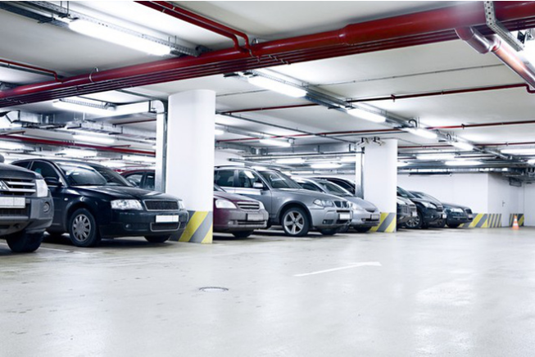

Figure : Indoor parking area

Indoor parking areas are growing with the increasing number of vehicles in a developing economy and causing many problems due to multiple floors, followed by zones, distributed parking lots and absence of parking guidance to vehicles drivers. The traditional method of having to navigate around searching for an empty parking lot causes many troubles for drivers, as well as traffic jam in parking areas.

### Outdoor parking area

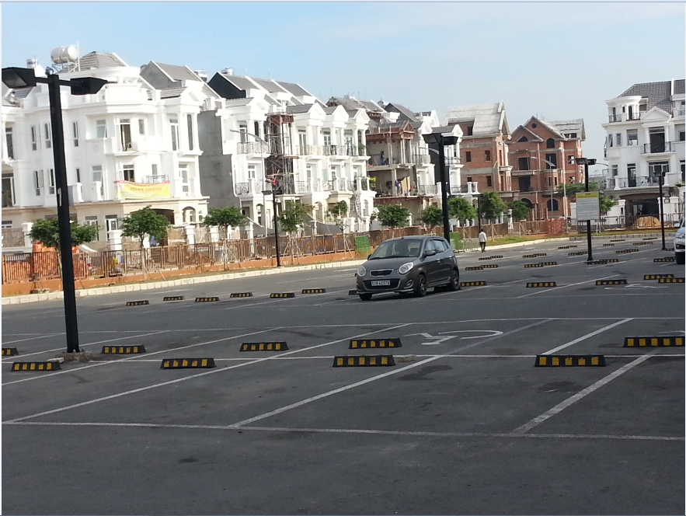

Figure : Outdoor parking area

With the increasing number of vehicles, it creates lots of issues to build a parking building, or a basement plus some other kind of building on top, especially cost and planning structure. There is no other way except to utilize outdoor spaces of places like public parks, mall, hospital… as an outdoor parking areas.

### Traditional PGS

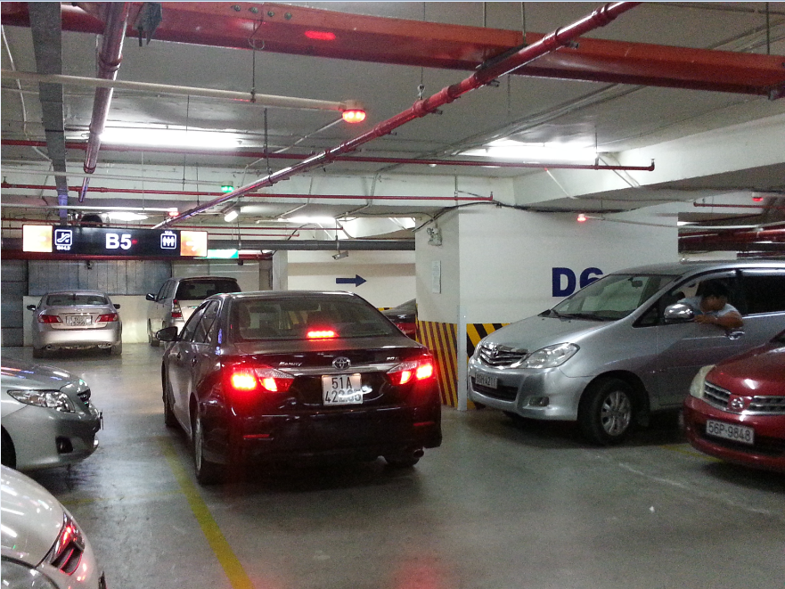

Figure : Parking area with PGS

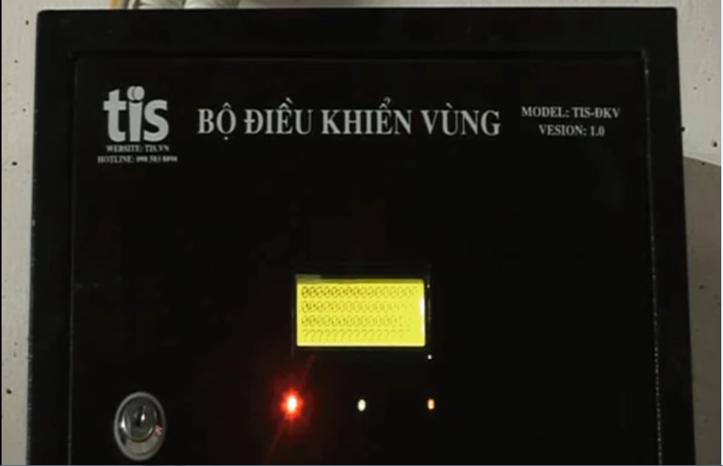

Figure : Zone Control Unit

As opposed to the traditional parking areas, the parking areas with PGS keep parking lots under systematic real-time monitoring so as drivers can see what parking spaces are available immediately and with minimal effort. By implementing this, operators also have the chance of increasing their revenues because of the increasing number of satisfied drivers.

The current version of PGS that implemented in a large number parking areas in Vietnam made use of RS485. Each parking lot is fitted with an ultrasonic detector and Indicator light, hence information displays at main entrance and at internal junction points are driven with real-time occupancy detected by ultrasonic detectors. All status sent to a Zone Control Unit on RS485, which in turn be sent to the Central Control Unit.

## Problem Definition

The current version of PGS is working well but it still has some disadvantages:

* The system implements the RS485 so each Zone Control Unit can have maximum 8 loops of 32 Detectors hence supporting 256 parking lots with 8 Information LED Displays. This is fine for most of the current parking areas, but it provides complicated in a parking area with large number of parking lots like the 6 multi-story car parks with around 7000 parking lots each proposed by Ho Chi Minh City Transport Department.
* The Zone Control Units need to be wired with Detectors, Indicator LED, Information LED Displays and Central Control Unit hence the wiring is pretty complicated and need careful planning in the construction stage. Therefore, the current version of PGS is hard to implement in most of the existed parking areas.
* The current version of PGS is difficult to use for outdoor parking areas because of the need of installation of the frame.
* Drivers can only get the information of available parking lots at the entrance of parking areas, so the issues of high proportion of traffic generated by drivers seeking vacant parking lots still remains.

## Proposed Solution

The current version of PGS contains many flaws and proved to be unacceptable for a greater business. Therefore, our proposed solution is to build a parking guidance system with RF modules. The RF modules provide wireless communication directly between Central Control Unit and Detectors, Indicator LED, Information LED Displays so there is no need for the Zone Control Units.

### Feature functions

#### Parking Guidance System

* Detectors sends out ultrasonic signals from the bottom upward and transmits the signals to the guidance units through RF.
* The Indicator LED, Information LED Displays also use RF communication so they are easier to install.
* The Central Control Unit connect with data stream network to provide real-time information to the app.

#### Mobile app

* Management portal for operators to setup and manage theirs parking area.
* Customer portal where drivers can view on maps the real time information of nearby parking areas or search for one.

### Advantages

* Fast orientation of drivers when seeking vacant parking lots
* Minimizing the time needed for finding a vacant parking lot
* Improvement of safety, the increase of the traffic effectiveness and efficiency
* Decreases of exhaust fumes as well as the negative impact of traffic on the environment
* Maximum use of the entire car park capacity
* Easy to assemble

### Disadvantages

* System does not provide car find feature
* The detector can only detect at the location above it so it can’t detect if there is anything around the corner of parking lot
* Management portal does not have web version

## Functional Requirements

Function requirements of the system are listed as below:

* Detector component:
  + Sensor (ultrasonic, infrared, magnetic field, load cell…)
  + RF communication
* Indicator LED component:
  + RGB led controller
  + RF communication
* Information LED Displays component:
  + Main entrance LED Display
  + Internal junction points LED Display
  + RF communication
* Reservation Barrier component:
  + Servo motor controller
  + RF communication
* Central Control System component:
  + Data Stream Network
  + Web API communication
  + RF communication
* Management portal app component:
  + Parking Area Setup
  + Parking Area Analysis
  + Parking Lot Control
* Customer portal app component:
  + Parking Areas Search
  + Parking Lot Reservation
* Web API component:
  + Parking Areas Search
  + Parking Area Setup
  + Parking Area Analysis
  + Parking Lot Status

## Roles and Responsibilities

| **No** | **Full name** | **Role** | **Position** | **Contact** |
| --- | --- | --- | --- | --- |
| 1 | Nguyễn Đức Lợi | Project manager | Supervisor | loind@fpt.edu.vn |
| 2 | Trần Nguyễn Minh Trung | Developer | Leader | trungtnmse61496@fpt.edu.vn |
| 3 | Bùi Phú Hiệp | Developer | Member | hiepbpse61438@fpt.edu.vn |
| 4 | Nguyễn Đỗ Phương Huy | Developer | Member | huyndpse61358@fpt.edu.vn |

Table : Roles and Responsibilities

## Conclusion

For this project, we will try to to reproduce the traditional Parking Guidance System with wireless technology, add a web server to manage information, a mobile app to provide UI for normal users and parking area operators to make this more like an IoT application. Therefore, we will need to:

* Research to determine and implement the appropriate MCU for the Central Control Unit and other nodes (**Arduino, Raspberry**, CC1310…)
* Research to determine and implement the appropriate sensor for the Detector (ultrasonic sensor, infrared sensor, **magnetic sensor**, load sensor…)
* Research to determine and implement the appropriate RF value and module to provide communication between nodes for the project (315Mhz, 433Mhz, **2.4Ghz**…)
* Research and implement LED RGB, seven-segment LED
* Research and implement real-time communication channel
* Research and host Web API on a cloud service
* Study and develop a mobile application (**Android**, iOS, Windows phone…)
* Study and develop program using embedded language (**Arduino**, C, **C++**, **Python**, Java Embedded, C#…)
* Study and create a Web API (Spring MVC, **ASP.NET**, Ruby…)
* Study and create a database (**SQL**, Oracle, MySQL, **SQLite** …)

# B. Software – Hardware Project Management Plan

## Problem Definition

### Name of this Capstone Project

* Official name: Parking Guidance System Solution
* Vietnamese name: Giải pháp hệ thống chỉ dẫn đỗ xe
* Abbreviation: PGSS

### Problem Abstract

As the economy of Vietnam growth, the number of personal cars also increasing, and that create a high proportion of traffic generated by drivers seeking vacant sparking lots. The current common Parking Guidance Systems in Vietnam are only suitable for a small number of indoor parking areas, and can’t be implemented for outdoor parking areas, because of the need of complicated planning and wiring. Moreover, all of the current PGS parking areas are working separately in their own local area network so there is no way for drivers to know the current available parking lots except by coming to the entrance.

We provide a system which ease the complicated in set up a PGS for parking areas. Furthermore, we make the system in a way that each PGS parking area can connect to each other so we can provide more information to drivers to help them find a suitable parking areas more quickly and easily.

### Project Overview

#### Current Situation

In the market, we have some ways to manage car park:

* The guard check each car in each parking lot:
  + Advantages:
    - Can check empty or using slot exactly
  + Disadvantages:
    - Consume people’s energy
    - Need much time to check all the parking lot
* Tradition PGS base on RS-485:
  + Advantages:
    - Can automatically check the empty slot in car park
  + Disadvantages:
    - Limited number of managed parking lots
    - Complicated wired system
    - Limited information provided to drivers

#### The Proposed System

Based on the result of our research, we propose the following solution: A Parking Guidance System based on Internet of Things that utilize the RF wireless technology to communicate between components. The system consists of Detectors, Indicator LED, Information LED Displays, Reservation Barrier, Central Control Unit, Web API Server and a Mobile Application.

After the Detector detect a car in the parking lot, it will send a signal to the Central Control Unit (CCU). The CCU will command the Indicator LED above that parking lot change to occupied color, update all related Information LED Displays, send a message to Web API Server to update information of parking lot on the server and Mobile Application.

In case of users want to reserve a parking lot in the parking area, they can use the Mobile Application to make a reservation. The Web API Server will update the database based on the reservation and the Reservation Barrier will lock the reserved parking lot.

##### Interaction Block

* This block will be place in each parking lot to check existed car and control signal light, barrier.
* Arduino is the main board to control the Interaction block, which show information to the end customer.
* Ultrasonic sensor is used to check the existed car in each parking lot
* DC Servo to monitor the barrier.
* 12A DC-to-DC step down module used to convert voltage high-to-low for other hardware.

##### Information Block

* This is the led panel in each area to show the number of empty slot in each area.
* Arduino is also the main board to control this block.

##### Central Control Unit

* This will be the central point of all Interaction Module.
* It will be control be Raspberry Pi 3.
* Send and receive data from server to analyze then monitor the Interaction Block.

##### Web API Server

* ASP.NET API to communicate between the mobile app, database and CCU.
* Get the position of each car park base on address to view on mobile app.

##### Mobile Application

* Our priority OS for Mobile Application is Android because of a higher market share than other mobile OS and a lower barrier of entry
* The App utilizes the Google Map API to provide an interactive map that show in real time the available parking lots in each parking areas.

#### Boundaries of the System

* System is available for both manager and end user.
* The language of system is English
* The input and output of system is car slot
* The boundaries of mechanical parts include:
  + End user need to park their car correctly in parking lot.
  + The information, which show number of empty slot may delay 5-10 seconds when the system start.
  + The system will run correctly when the weather condition is good.
* The boundaries of mobile application include:
  + End user only pay for the booking time, not pay the parking time on mobile app.
  + Need connect to internet to run smoothly.
* The complete product includes:
  + The entire PGSS system in car park.
  + The mobile application for manager and end user.
  + The database to store all needed information.
  + All the documents of the project.



Figure : Project Block Diagram

#### Future Plans

There are no perfect solutions to problems, as well as there are no perfect systems. With the inexperience of our team members and the time constrains, our proposed solution and project contains many issues. Below are the problems encountered in this project:

* **Parking Operate Knowledge:** We are not experts in parking operating. All functions and features are developed in order to serve the needs which we had identified during 4 months of research.
* **Hardware Knowledge:** We are inexperienced with hardware. All the hardware components chosen to be used in this project is based on our familiar with them, or based on the shortest time we need to learn how to use them. So they are only the most appropriate, not the best choice for the project.
* **Single point of failure:** The communication of the PGS system and server is highly depended on the Central Control Unit in each parking area. So if the Central Control Unit crash, the PGS can no longer commute with server.
* **Server crash:** All the needed data for the app is stored in the server. So if server crash, all the devices cannot get parking area information.
* **Security:** Currently, there is few possible problems encountered with RF, as RF is vulnerable to replay attack.

Our future plan is try to solve these problems one by one. We design the system with separated modules in mind to make it easy to change one module without affect others and we also make it easy to scale to bigger models.

#### Development Environment

##### Hardware requirements

**For Web API Server**

|  |  |
| --- | --- |
| **Components** | **Requirement** |
| DTU | 10 DTU |
| Storage | 250 GB |

Table : Database requirement

|  |  |
| --- | --- |
| **Components** | **Requirement** |
| Number of cores | 1 core |
| RAM | 1.75 GB Ram |
| Storage | 10 GB |

Table : API Service Requirement

**For CCU**

|  |  |
| --- | --- |
| **Components** | **Hardware** |
| Mainboard | Raspberry Pi 3 |
| Communication | USB Cable |
| Sensor Devices | Ultrasonic Sensor |
| Motors | Servo |
| Power Source |  |

Table : Provide CCU Hardware

##### Software requirements

* Windows XP/7/8/10: operating system for developing and deploying.
* SQL Server Express 2012: used to create and manage database for PGSS.
* Visual Studio 2015: used to develop API.
* Arduino IDE: used to develop Arduino program.
* Proteus 8: used to drawing board with other hardware.
* Github & SourceTree: used for source control.
* StarUML: used to create models and diagrams.
* Slack: used for communication and meeting.
* C/C++: used for embedded module
* Python 3: used for Central Control Unit
* C#: used for web server
* Java: used for mobile application

## Project organization

### Software Process Model

This project is developed under Iterative and incremental development model. We apply customized Iterative and incremental development model to capable with current situation in our team. We choose this model because of the following reasons:

* We are still inexperienced and by develop the system through iterations (repeated cycles) and incrementally (in small portions of time), we can learn from our mistakes and apply that knowledge on the next iteration.
* We are researching and developing the system at the same time, so using this model allow us more flexibility to adapt to changes.
* Working with embedded system hides a lot of problems that are unknown in the planning phase until it is too late. With Iterative and incremental development model, we test the system in small portion at a time, therefore reduce risk and build a feature rich and robust system.

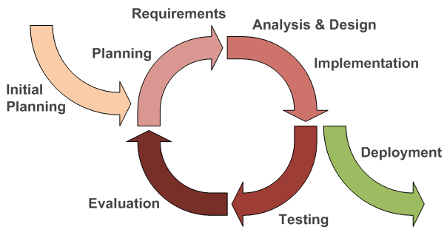

Figure : Iterative and Incremental development

### Roles and responsibilities

|  |  |  |  |
| --- | --- | --- | --- |
| **No** | **Full name** | **Team Role** | **Responsibilities** |
| 1 | Nguyễn Đức Lợi | Supervisor, Project Manager | * Specify user requirement * Advisor for ideas and solutions * Control the development process * Give out techniques and business analysis support |
| 2 | Trần Nguyễn Minh Trung | Team Leader, BA, Developer, Tester | * Managing process * Managing budget * Dividing tasks for team member * Create test plan * Clarifying requirements * Prepare document * Coding * Testing |
| 3 | Bùi Phú Hiệp | Team Member, Developer, Tester | * Create test plan * Clarifying requirements * Prepare document * Coding * Testing |
| 4 | Nguyễn Đỗ Phương Huy | Team Member, Developer, Tester | * Create test plan * Clarifying requirements * Prepare document * Coding * Testing |

Table : Roles and Responsibilities Details

### Tools and Techniques

|  |  |
| --- | --- |
| **Tools** | |
| Operating System | Windows 7 Ultimate |
| Raspbian Jessie |
| Developing tool | Android Studio |
| Visual Studio 2015 Community |
| IDLE 3 |
| Arduino IDE 1.6.12 |
| Managing Database | SQL Server 2014 Management Studio |
| Source Control | Git 2.8.1 (Server https://github.com) |
| SourceTree 1.9.10 |
| Communication tool | Gmail |
| Slack |
| Trello |
| Models and Diagrams tool | <https://www.draw.io/>, StarUML |

Table : Tools

|  |  |
| --- | --- |
| **Techniques** | |
| Embedded System | C/C++ |
| Arduino |
| Python 3 |
| Mobile System | Android SDK |
| Retrofit 2 |
| Google Map |
| Web Server System | Azure Cloud |
|  | ASP.NET |
| Database Management System | SQL Server 2014 |
|  | SQLite 3.7 |

Table : Techniques

## Project Management Plan

### System development life cycle

Incremental development slices the system functionality into increments (portions). In each increment, a slice of functionality is delivered through cross-discipline work, from the requirements to the deployment. The Unified Process groups increments/iterations into phases:

|  |  |  |  |
| --- | --- | --- | --- |
| **Phase** | **Description** | **Deliverables** | **Risks** |
| Inception | In this phase, we will identify project scope, requirements (functional and non-functional) and risks at a high level but in enough detail that work can be estimated | * Introduction of proposed system * Software and Hardware requirement specification * Project Task Plan and Risk | * The lack of knowledge may lead to misunderstand of the requirement * The inexperienced of team may lead to deficient in Task Plan and Risk |
| Elaboration | Delivers a working architecture that mitigates the top risks and fulfills the non-functional requirements | * Software and Hardware design document | * System architecture or design issues may arise because not all requirements are gathered |
| Construction | Incrementally fills-in the architecture with production-ready code produced from analysis, design, implementation, and testing of the functional requirements | * Completed and fully tested system * Implementation and Test document | * The lack of knowledge of team member about hardware * The inexperienced of team may lead to missing test cases * There may be hidden High to Critical bugs in the system |
| Transition | Delivers the system into the production operating environment | * User manual document * Installation guide document * The final and full version document of the system | * The documents may not fully describe the system |

Table : System Development Life Cycle

Each of the phases may be divided into 1 or more iterations, which are usually time-boxed rather than feature-boxed.

### Plan Detail

| **Iteration** | **Scope** | **Evaluation** | **Activities** | **Estimated Duration** | **Assign Responsibilities** |
| --- | --- | --- | --- | --- | --- |
| Initial Iteration | Initial team workplace and identify project scope | A working team environment | * Set up Git Repository with Gitflow * Set up Slack * Set up Trello | 5 days | TrungTNM, HiepBP, HuyNĐP |
| Iteration 1 | Identify boundaries of the system, planning software and hardware. Create a proof-of-concept prototype. | Report 1, Report 2 and a proof-of-concept prototype | * Introduction document * Software and Hardware Project Management Plan document * Proof-of-concept prototype | 15 days | TrungTNM, HiepBP, HuyNĐP |
| Iteration 2 | Produce an architectural prototype | Report 3, Report 4 and an architectural prototype | * Software and Hardware Requirement Specification document * Software and Hardware Design Description document * Architectural prototype | 15 days | TrungTNM, HiepBP, HuyNĐP |
| Iteration 3 | Build the product (up to beta release) | Report 5 and a working product (beta release) | * System Implementation and Test document * PCB * Mobile Application * Web API Server | 15 days | TrungTNM, HiepBP, HuyNĐP |
| Iteration 4 | Finish the product (full product release) | Report 6 and the completed product | * Software and Hardware User’s Manual document * Product demonstration model | 15 days | TrungTNM, HiepBP, HuyNĐP |
| Final Iteration | Prepare for Demo Day | Final Documentation, Presentation Slide | * Final Document * Mini Document * CD contains all source code * Presentation Slide | 5 days | TrungTNM, HiepBP, HuyNĐP |

Table : System Development Detail Plan

### All Meeting Minutes

All meeting minutes are saved at:

<https://github.com/Hinaka/-FPT-CAPSTONE-PGSS/tree/master/Common>

## Coding Convention

### C/C++ Convention

C/C++: Using to develop program and solve algorithm on hardware.

Summary:

* Naming Convention:
  + Using Pascal case for class name.
  + Using Camel case for function, variable’s name.
  + The #define and global variable’s name must uppercase and separate by underscore. Ex: GLOBAL_VARIABLE.
* Commenting Convention:
  + Place the comment on the separate line with function.
  + Place the comment at the end of the line, which has calculation formula.

More details about coding conventions for C/C++ language by Google:

<https://google-styleguide.googlecode.com/svn/trunk/cppguide.html>

### C#, ASP.NET Convention

C#: Using to develop Web API

Summary:

* Naming Convention:
  + Use Camel case for variable’s name.
  + Use Pascal case for class’s name, function’s name.
  + Global variable’s name must uppercase and separate by underscore.

More detail about code conventions for C# language by Microsoft:

<https://msdn.microsoft.com/en-us/library/ff926074.aspx>

### Python Convention

Python: Using to develop program on Raspberry Pi

Summary:

* Naming Convention:
  + "Internal" means internal to a module or protected or private within a class.
  + Prepending a single underscore (_) has some support for protecting module variables and functions (not included with import * from). Prepending a double underscore (__) to an instance variable or method effectively serves to make the variable or method private to its class (using name mangling).
  + Place related classes and top-level functions together in a module. Unlike Java, there is no need to limit yourself to one class per module.
  + Use Pascal Case for class names, but lower_with_under.py for module names.

More detail about code conventions for Python by Google:

<https://google.github.io/styleguide/pyguide.html>

### Android Convention

Android use Java and HTML to develop mobile application

Summary:

* Naming convention:
  + Follow basic principle of <WHAT>_<WHERE>_<DESCRIPTION>_<SIZE> for resource names
  + Follow basic principle of <WHAT>_<WHERE>.XML for layout
  + Follow basic principle of <WHERE>_<DESCRIPTION> for string resources
  + Follow basic principle of <WHERE>_<DESCRIPTION>_<SIZE> for drawable resource
  + Follow basic principle of <WHAT>_<WHERE>_<DESCRIPTION> for IDs

More detail about code conventions for Android by Google and our team:

<https://source.android.com/source/code-style.html>

<https://github.com/Hinaka/-FPT-CAPSTONE-PGSS/tree/master/Common>

# C. Software – Hardware Requirement Specification

## Software Requirement Specification

### Software Requirement

Manager can show the information of their car park to the end user, which will increase the interaction between car park provider and end user. The information include:

* Address
* Contact info
* Number of empty parking lot

End user can find the nearest car park, which has empty parking lot.

Manager can manage their car park easily; make an automatic system to guide the end user base on the interaction panel, which show number of empty parking lot in each area and the status light on each parking lot.

Users can see empty slot and detail information about parking area by touching a marker on map.

User can reserve a parking slot.

### GUI Requirement

User interface of mobile app must be simple, clearly and easy to use.

The color of mobile app must be elegant, not garish.

Each UI element must be arranged logically, allowing user access easily.

Meet all main function requirements.

## Hardware Requirement Specification

### Hardware Requirement

#### Hardware Interface

The hardware interface must have satisfied the following requirements:

* Easy to replace
* Low-cost module
* Easy to implement

Based on project requirement we have choose following hardware components.

##### Block Diagram

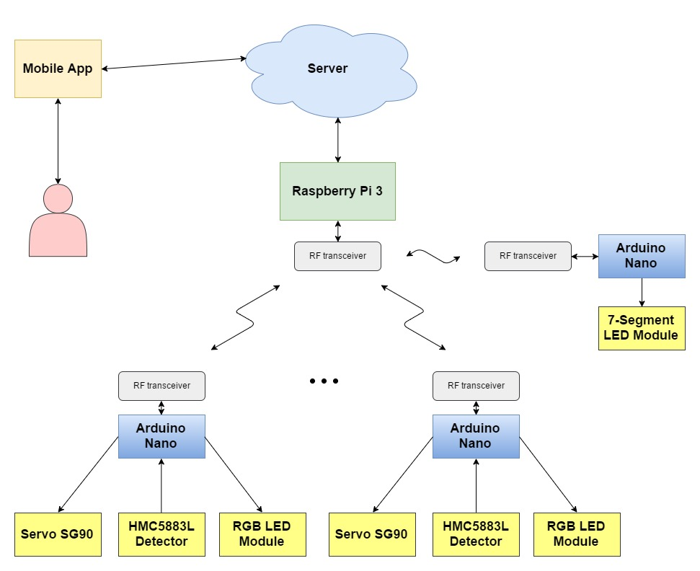

Figure : PGSS Block Diagram

##### Raspberry Pi 3

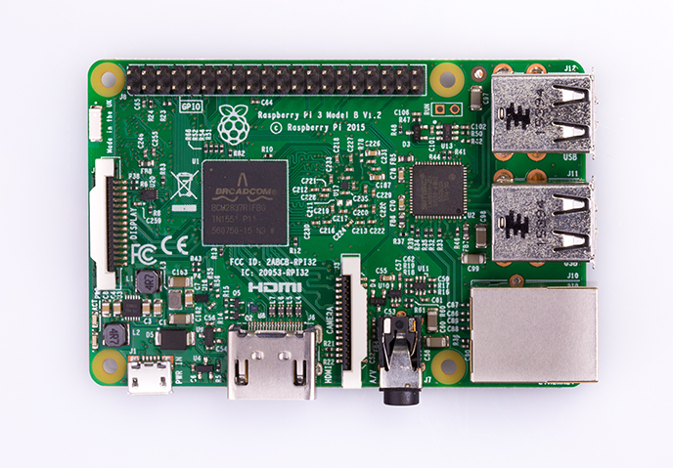

Figure : Raspberry Pi 3

**Overview:** To communicate with all other hardware component and processing value, we must have a Central control unit, there are many kind of central control unit in the market. After evaluate requirement of project, we decide to choose Raspberry Pi 3. Raspberry Pi 3 is powerful mini-computer with many features.

**Specification:**

|  |  |
| --- | --- |
| SoC | Broadcom BCM2837 |
| CPU | 4× ARM Cortex-A53, 1.2GHz |
| GPU | Broadcom VideoCore IV |
| RAM | 1GB LPDDR2 (900 MHz) |
| Network | 10/100 Ethernet, 2.4GHz 802.11n wireless |
| Bluetooth | Bluetooth 4.1 Classic, Bluetooth Low Energy |
| Storage | microSD |
| GPIO | 40 |

Table : Raspberry Pi 3 – Specification

More details about Raspberry Pi 3:

<https://www.raspberrypi.org/products/raspberry-pi-3-model-b/>

##### Arduino Nano

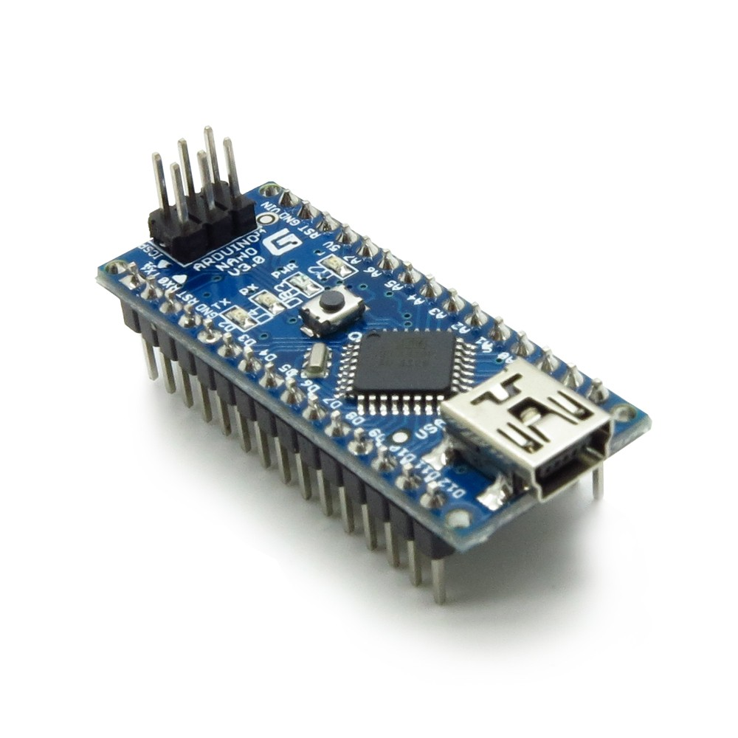

Figure : Arduino Nano

**Overview:** The Arduino Nano is a small, complete, and breadboard-friendly board based on the ATmega328 (Arduino Nano 3.x).

**Specification:**

|  |  |
| --- | --- |
| Microcontroller | ATmega328 |
| Architecture | AVR |
| Operating Voltage | 5 V |
| Flash Memory | 32 KB of which 2 KB used by bootloader |
| SRAM | 2 KB |
| Clock Speed | 16 MHz |
| Analog I/O Pins | 8 |
| EEPROM | 1 KB |
| DC Current per I/O Pins | 40 mA (I/O Pins) |
| Input Voltage | 7-12 V |
| Digital I/O Pins | 22 |
| PWM Output | 6 |
| Power Consumption | 19 mA |
| PCB Size | 18 x 45 mm |
| Weight | 7 g |
| Product Code | A000005 |

Table : Arduino Nano - Specification

More detail about Arduino Nano:

<https://www.arduino.cc/en/Main/arduinoBoardNano>

##### Compass Module 3-Axis HMC5883L

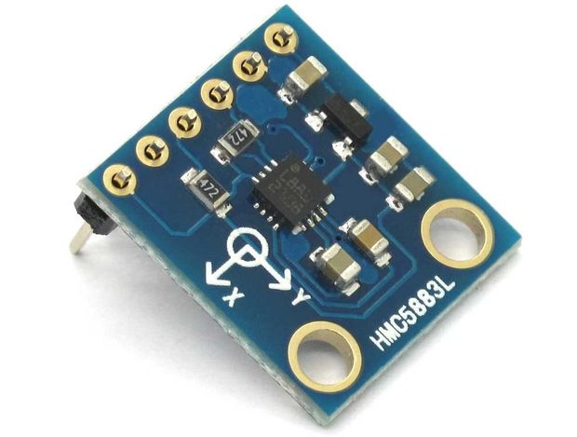

Figure : Compass Module 3-Axis HMC5883L

**Overview:** For detecting obstacle, we choose The Compass Module 3-Axis HMC5883L instead of ultrasonic sensor because ultrasonic sensor has many weaknesses, they are not accuracy, cannot be used outdoor in the bad weather in Vietnam.

The Compass Module 3-Axis HMC5883L is a low-field magnetic sensing device with a digital interface.

We choose The Compass Module 3-Axis HMC5883L because:

* It has reasonable price.
* Compatible with arduino and other board.
* Compact size.

**Specification:**

Input and Output Pins:

|  |  |  |  |
| --- | --- | --- | --- |
| **Pin** | | **I/O** | **Function** |
| **Name** | **No.** |
| **VIN** | **1** |  | Supply Voltage – 2.7 to 6.5 VDC |
| **GND** | **2** |  | Ground |
| **SCL** | **3** | **I** | I²C Clock |
| **SDA** | **4** | **IO** | I²C Data |
| **RDY** | **5** | **I** | Data Ready |

Table : The Compass Module 3-Axis HMC5883L - Pin Function

##### RF module nRF24L01+

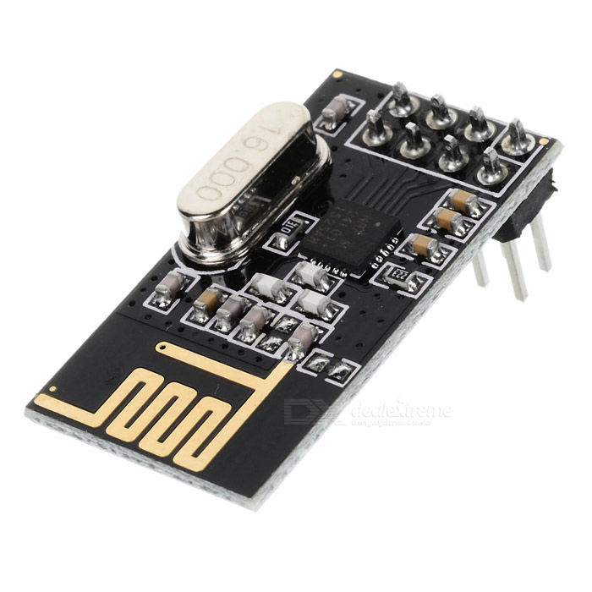

Figure : RF module nRF24L01+

**Overview:** Reason for PGSS use RF module nRF24L01 to communicate between Central control unit and other hardware component:

* It has reasonable price.
* Easy to buy.
* Ultra low power consumption.

**Specification:**

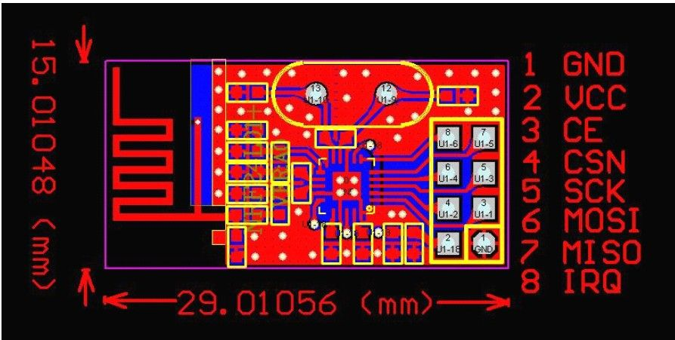

Figure : RF module nRF24L01+ - Specification

|  |  |  |  |
| --- | --- | --- | --- |
| **Pin** | | **I/O** | **Description** |
| **No.** | **Name** |
| 1 | GND |  | Power Supply Ground |
| 2 | VCC |  | 3.3V |
| 3 | CE | I | Chip Enable |
| 4 | CSN | I | SPI Chip Select |
| 5 | SCK | I | SPI Clock |
| 6 | MOSI | I | SPI Slave Data Input |
| 7 | MISO | O | SPI Slave Data Output |
| 8 | IRQ | O | Maskable Interrupt Pin |

Table : RF Module nRF24L01 – Pin function

##### Information LED Display Module

Information LED Display Module include: 7-segment LED Display, TPIC6B595 Power Logic 8-Bit Shift Register

###### **F:\CP\Image\7seg.jpg7-segment LED Display**

Figure : 7-segment LED Display

**Specification:**

* 0.56 inch digit height
* Super Red emitting color
* White segment color, gray face
* Low current operation
* Easy mounting on PCB boards or sockets

###### **TPIC6B595 Power Logic 8-Bit Shift Register**

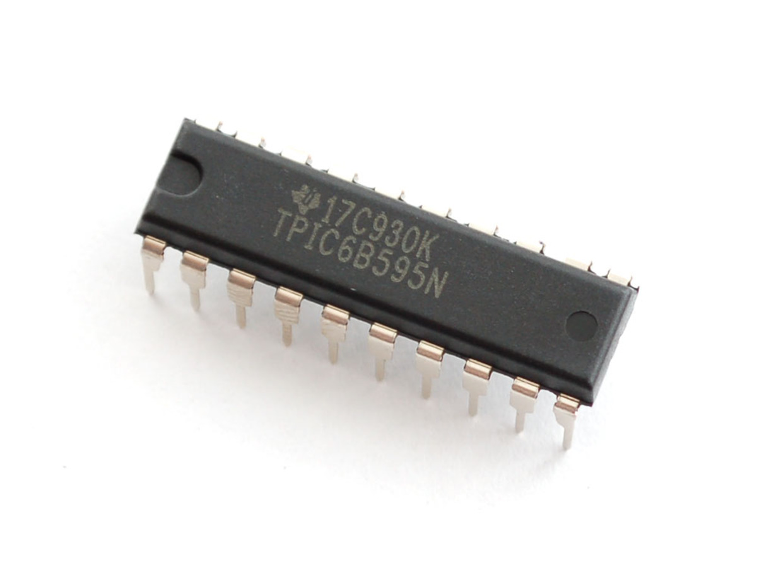

Figure : TPIC6B595 Power Logic 8-Bit Shift Register

**Specification:**

To display high power 7-segment display, we choose IC TPIC6B595 instead of IC 74HC595 because TPIC6B595 is asimple shift register IC that can control high-voltage/high-current devices directly**.** Each output pin can sink 150mA and then supports the maximum of Load Voltage at 50V.

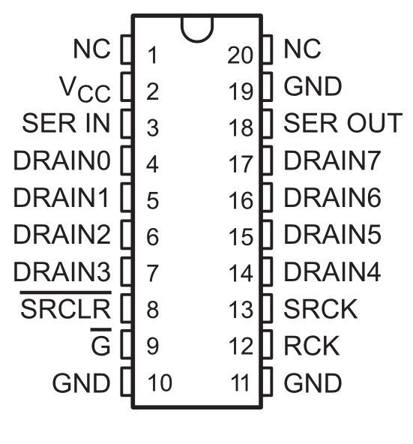

Figure : TPIC6B595 Pin-outs

|  |  |  |  |
| --- | --- | --- | --- |
| **Pin** | | **I/O** | **Description** |
| **Name** | **No.** | O | Open-drain output |
| DRAIN0 | 4 |
| DRAIN1 | 5 |
| DRAIN2 | 6 |
| DRAIN3 | 7 |
| DRAIN4 | 14 |
| DRAIN5 | 15 |
| DRAIN6 | 16 |
| DRAIN7 | 17 |
| G | 9 | I | Output enable, active-low |
| GND | 10,11,19 | - | Power ground |
| NC | 1, 20 | - | No internal connection |
| RCK | 12 | I | Register clock |
| SERIN | 3 | I | Serial data input |
| SEROUT | 18 | O | Serial data output |
| SRCK | 15 | I | Shift register clock |
| SRCLR | 8 | I | Shift register clear, active-low |
| VCC | 2 | I | Power supply |

Table : IC TPIC6B595 - Pin Function

##### Indicator LED Module

Indicator LED Module include: Common anode RGB LED, TIP122 Transistor

###### **RGB LED common anode**

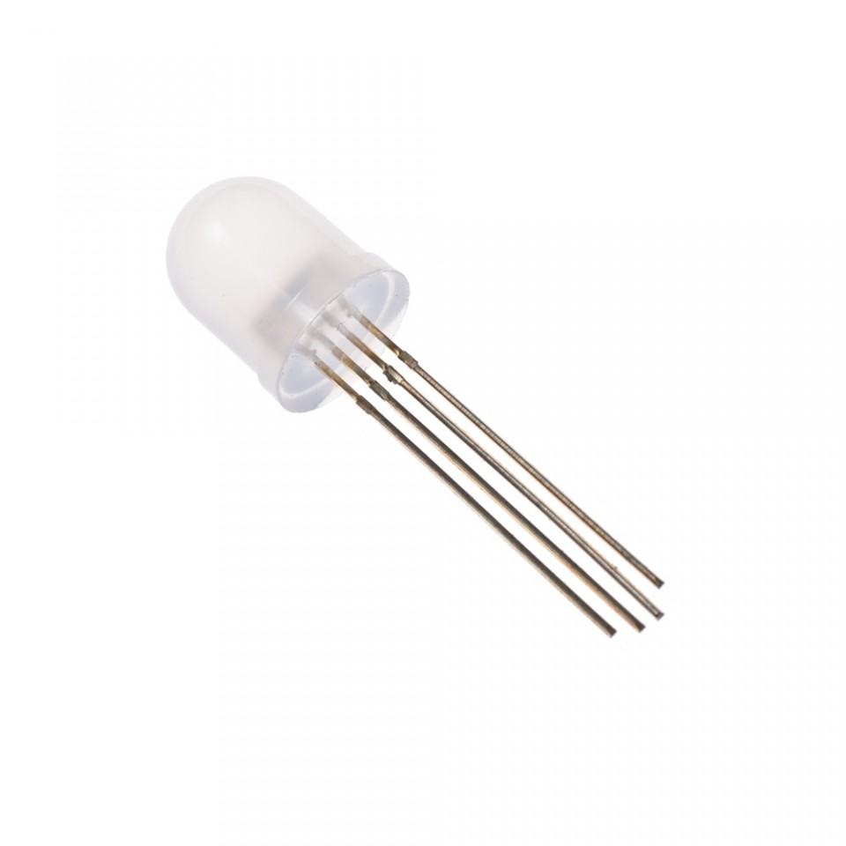

Figure : RGB LED common anode

**Overview:**

RGB LED allows you to change the lights to any color to show state of parking slot.

**Specification:**

* Forward Voltage (RGB): (2.0, 3.2, 3.2)V
* Max Forward Current (RGB): (20, 20, 20)mA
* Max Luminosity (RGB): (2800, 6500, 1200)mcd

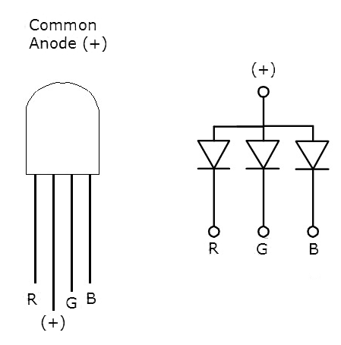

Figure : RGB LED common anode pin-out

###### **TIP122 Transistor**

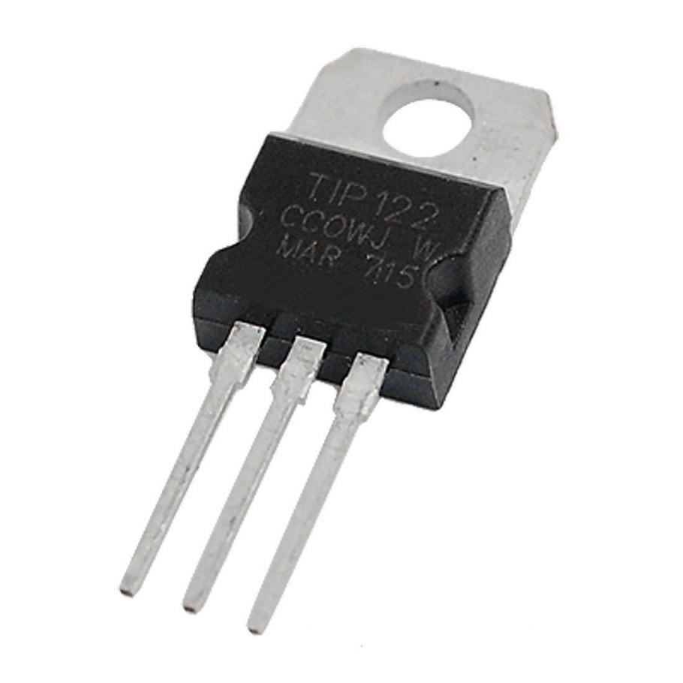

Figure 12:: TIP122 Transistor

**Overview:** A single digital pin on Arduino Nano do not provide enough current to power RGB LED, A solution for this situation is to use an NPN Darlington Transistor designed for medium power linear switching applications, so we use TIP122 Transistor to provide RGB LED with power from an external source. It can power devices up to 100VDC at 5 Amps.

**Specification:**

* TIP122 is power transistors
* Collector Current: 5 ampere
* Collector-Emitter Volt: 100 volts
* Power Dissipation: 65 watts

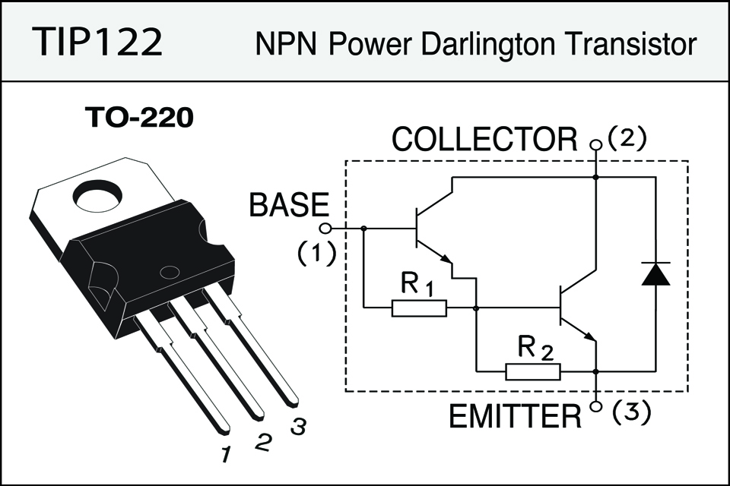

Figure 12: TIP122 Transistor- Pin Layout

##### Servo Motor SG90

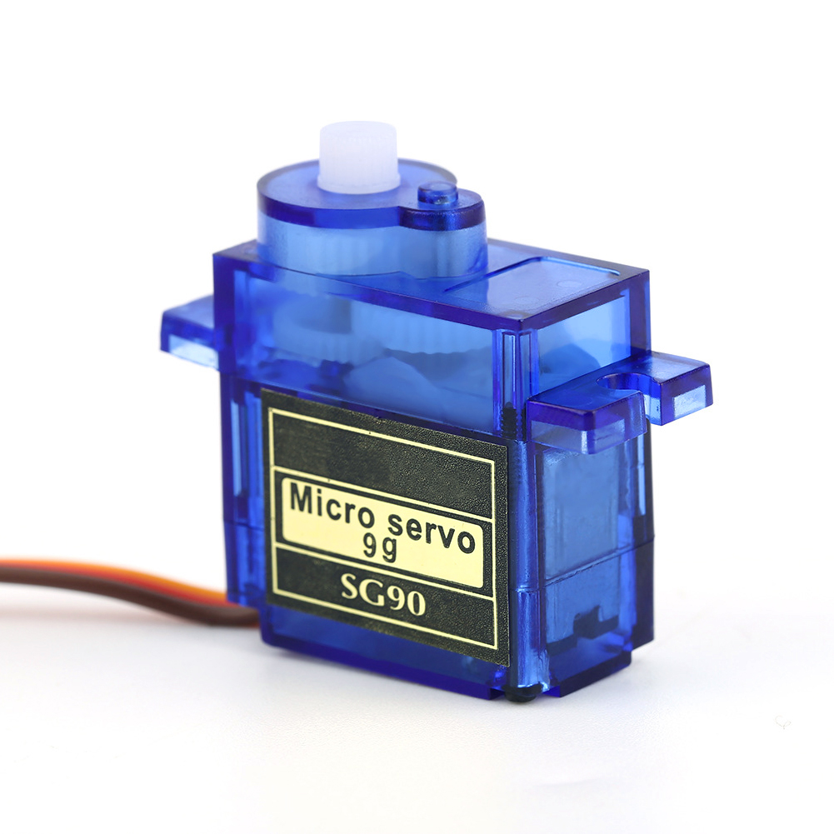

Figure 13:: Servo Motor – Tower Pro SG90

**Overview:** PGSS use Servo Motor SG90 to control barrier at each parking slot.

**Specification:**

|  |  |
| --- | --- |
| **Torque** | 1.80 kg-cm at 4.8V |
| **Speed** | 0.1sec/60° at 4.8V |
| **Voltage** | 4.0V to 7.2V, 4.6V - 5.2V nominal |
| **Dimensions** | 23mm x 12.2mm x 29mm |
| **Rotation range** | 180o |
| **Weight** | 9g |
| **Pulse width** | 500-2400uS |
| **Operating Temperature range** | 30°C to 60°C |

Table 7: Servo Motor SG90 – Specification

|  |  |  |
| --- | --- | --- |
| **Pin of Servo SG90** | **Name** | **Description** |
| Red | VCC | Power supply 5V |
| Black | GND | Power supply ground |
| Yellow | Signal | The servo will move based on the signal sent to signal wire. |

Table : Servo Motor SG90 – Pin-outs

#### Communication Protocol

* We communicate between hardware component and board through GPIO pin.
* Arduino Nano board communicate with Raspberry Pi 3 via RF Module.

### System Overview Use Case



Figure 183: Overview use case diagram

### List of Use Case

#### Manager Use Case



Figure 14: Manager Use case diagram

**Use case specifications**

|  |  |  |  |
| --- | --- | --- | --- |
| **Use Case-1 specification** | | | |
| **Use-case no.** | PGSS01 | **Use-case version** | 1.0 |
| **Use-case name** | Configuration System | | |
| **Author** | Bui Phu Hiep | | |
| **Date** | 13/02/17 | **Priority** | High |
| **Actor:**   * Manager   **Summary:**   * This use case allow user to change the configuration of their system.   **Goal:**   * Manager can change the information of car park, which show to the end user.   **Triggers:**   * User click on “Setting” button.   **Preconditions:**   * Mobile application is already launch. * Manager has been logged in   **Post Conditions:**   * **On Success:** New configuration is apply and save to server * **On Failure:** Show error message   **Main Success Scenario:**   |  |  |  | | --- | --- | --- | | **No.** | **Actor Action** | **System Response** | | 1 | User click on “Setting” button | Application navigate to “Setting” menu | | 2 | User select option in the Menu  Change by click toggle or change value in the text box  Select “Submit” button | Change the value and save to server |   **Alternative Scenario:**   * N/A   **Exceptions:**   * N/A   **Business Rules:**   * N/A | | | |

|  |  |  |  |
| --- | --- | --- | --- |
| **Use Case-2 specification** | | | |
| **Use-case no.** | PGSS02 | **Use-case version** | 1.0 |
| **Use-case name** | Manage Car Park | | |
| **Author** | Bui Phu Hiep | | |
| **Date** | 13/02/17 | **Priority** | High |
| **Actor:**   * Manager   **Summary:**   * This use case allow user to change their car park info.   **Goal:**   * Manager can change the information of car park, which show to the end user.   **Triggers:**   * User select their car park. * Click “Edit”   **Preconditions:**   * Mobile application is already launch. * Manager has been logged in   **Post Conditions:**   * **On Success:** New information of edited car park saved to server. * **On Failure:** Show error message   **Main Success Scenario:**   |  |  |  | | --- | --- | --- | | **No.** | **Actor Action** | **System Response** | | 1 | User select car park.  User click on “Edit” button | Application navigate to “Setting” menu | | 2 | User select option in the Menu  Change by click toggle or change value in the text box  Select “Submit” button | Change the value and save to server |   **Alternative Scenario:**   * N/A   **Exceptions:**   * N/A   **Business Rules:**   * N/A | | | |

|  |  |  |  |
| --- | --- | --- | --- |
| **Use Case-3 specification** | | | |
| **Use-case no.** | PGSS03 | **Use-case version** | 1.0 |
| **Use-case name** | Manage Area | | |
| **Author** | Bui Phu Hiep | | |
| **Date** | 13/02/17 | **Priority** | High |
| **Actor:**   * Manager   **Summary:**   * This use case allow user to change the status of each area.   **Goal:**   * The status of selected area updated and change in mobile app.   **Triggers:**   * User select their car park. * User select area in selected car park.   **Preconditions:**   * Mobile application is already launch. * Manager has been logged in   **Post Conditions:**   * **On Success:** New configuration is apply and save to server * **On Failure:** Show error message   **Main Success Scenario:**   |  |  |  | | --- | --- | --- | | **No.** | **Actor Action** | **System Response** | | 1 | User select car park | Application change to car park detail page | | 2 | User select area in the selected car park | Application change to area detail page | | 3 | User select status in the drop down list.  Click “Update” button | The status of the area will change on server and update in mobile application |   **Alternative Scenario:**   * N/A   **Exceptions:**   * N/A   **Business Rules:**   * N/A | | | |

|  |  |  |  |
| --- | --- | --- | --- |
| **Use Case-4 specification** | | | |
| **Use-case no.** | PGSS04 | **Use-case version** | 1.0 |
| **Use-case name** | Manage Parking Slot | | |
| **Author** | Bui Phu Hiep | | |
| **Date** | 13/02/17 | **Priority** | High |
| **Actor:**   * Manager   **Summary:**   * This use case allow user to manage the parking slot.   **Goal:**   * The status of selected area updated and change in mobile app.   **Triggers:**   * User select their car park. * User select area in selected car park. * Then select parking slot   **Preconditions:**   * Mobile application is already launch. * Manager has been logged in   **Post Conditions:**   * **On Success:** New configuration is apply and save to server * **On Failure:** Show error message   **Main Success Scenario:**   |  |  |  | | --- | --- | --- | | **No.** | **Actor Action** | **System Response** | | 1 | User select car park | Application change to car park detail page | | 2 | User select area in the selected car park | Application change to area detail page | | 3 | User select parking slot to edit  After change information, select “Update” button | The information of parking slot is change on server and update in mobile application. |   **Alternative Scenario:**   |  |  |  | | --- | --- | --- | | **No.** | **Actor Action** | **System Response** | | 1 | User select car park | Application change to car park detail page | | 2 | User select area in the selected car park | Application change to area detail page | | 3 | User click menu beside list parking spot to delete. | The parking spot will be set to deleted in server and update in mobile app. |   **Exceptions:**   * N/A   **Business Rules:**   * N/A | | | |

#### Administrator Use Case

|  |  |  |  |
| --- | --- | --- | --- |
| **Use Case-5 specification** | | | |
| **Use-case no.** | PGSS05 | **Use-case version** | 1.0 |
| **Use-case name** | Add Car Park | | |
| **Author** | Bui Phu Hiep | | |
| **Date** | 13/02/17 | **Priority** | High |
| **Actor:**   * Administrator   **Summary:**   * This use case allow user to add new car park to the system   **Goal:**   * New car park is added and save to server.   **Triggers:**   * User click on “Add” button.   **Preconditions:**   * Mobile application is already launch. * Administrator has been logged in   **Post Conditions:**   * **On Success:** New car park is save to server * **On Failure:** Show error message   **Main Success Scenario:**   |  |  |  | | --- | --- | --- | | **No.** | **Actor Action** | **System Response** | | 1 | User click on “Add” or “+” button | Application navigate to add car park menu | | 2 | User fill in the textbox  Select “Submit” button | New car park with filled in info is added to server |   **Alternative Scenario:**   * N/A   **Exceptions:**   * Name of the car park is unique * Address of the car park is unique (don’t has same latitude and longitude)   **Business Rules:**   * N/A | | | |

#### End User Use Case

|  |  |  |  |
| --- | --- | --- | --- |
| **Use Case-6 specification** | | | |
| **Use-case no.** | PGSS06 | **Use-case version** | 1.0 |
| **Use-case name** | Check number of empty slot | | |
| **Author** | Bui Phu Hiep | | |
| **Date** | 13/02/17 | **Priority** | High |
| **Actor:**   * End User   **Summary:**   * This use case allow user view number of empty slot in each car park   **Goal:**   * Show number of empty slot   **Triggers:**   * User login to the mobile application   **Preconditions:**   * Mobile application is already launch. * End user had logged in.   **Post Conditions:**   * **On Success:** User know the number of empty slot in car park * **On Failure:** Don’t show number of empty slot in car park   **Main Success Scenario:**   |  |  |  | | --- | --- | --- | | **No.** | **Actor Action** | **System Response** | | 1 | User log in to the application | Show the map with the marker as car park and the number, which indicate the number of empty slot |   **Alternative Scenario:**   * N/A   **Exceptions:**   * The number will have tick/ exclamation points to show that the number is recently update or not.   **Business Rules:**   * Tick: recently update * Exclamation points: number is not update in more than 1 hour. | | | |

|  |  |  |  |
| --- | --- | --- | --- |
| **Use Case-7 specification** | | | |
| **Use-case no.** | PGSS07 | **Use-case version** | 1.0 |
| **Use-case name** | Book parking slot | | |
| **Author** | Bui Phu Hiep | | |
| **Date** | 13/02/17 | **Priority** | High |
| **Actor:**   * End User   **Summary:**   * This use case allow user to book parking slot before go to the car park   **Goal:**   * Book the parking slot before go to car park   **Triggers:**   * User has selected the car park to book   **Preconditions:**   * Mobile application is already launch. * End user had logged in.   **Post Conditions:**   * **On Success:** User book the parking slot success * **On Failure:** Show error message when book   **Main Success Scenario:**   |  |  |  | | --- | --- | --- | | **No.** | **Actor Action** | **System Response** | | 1 | User log in to the application | Show the map with the marker as car park and the number, which indicate the number of empty slot | | 2 | User select the car park they want to book | Show the “Book” button if has empty slot | | 3 | Fill information for transaction  Click “Submit” | Make a transaction and set one parking slot to booked  Show the address of booked parking slot to the user |   **Alternative Scenario:**   * N/A   **Exceptions:**   * Transaction fail by 3rd party.   **Business Rules:**   * N/A | | | |

|  |  |  |  |
| --- | --- | --- | --- |
| **Use Case-8 specification** | | | |
| **Use-case no.** | PGSS08 | **Use-case version** | 1.0 |
| **Use-case name** | Search car park | | |
| **Author** | Bui Phu Hiep | | |
| **Date** | 13/02/17 | **Priority** | High |
| **Actor:**   * End User   **Summary:**   * This use case allow user to search a car park by name or address   **Goal:**   * Show the searched car park   **Triggers:**   * User login to the mobile application   **Preconditions:**   * Mobile application is already launch. * End user had logged in.   **Post Conditions:**   * **On Success:** Show the searched car park on the map if success * **On Failure:** Show message error   **Main Success Scenario:**   |  |  |  | | --- | --- | --- | | **No.** | **Actor Action** | **System Response** | | 1 | User log in to the application | Show the map with the marker as car park and the number, which indicate the number of empty slot | | 2 | Enter the name or address in the search bar  Press “Enter” or click “Search” | Find the car park base on name or address then focus on the map. |   **Alternative Scenario:**   |  |  |  | | --- | --- | --- | | **No.** | **Actor Action** | **System Response** | | 1 | User log in to the application | Show the map with the marker as car park and the number, which indicate the number of empty slot | | 2 | Enter the name or address in the search bar  Press “Enter” or click “Search” | Show message don’t have car park if the name or address is incorrect |   **Exceptions:**   * N/A   **Business Rules:**   * N/A | | | |

## Software System Attribute

### Usability

* User controls all system components via only mobile application.
* The system can install easily.
* User can learn how to use the system fast.

### Reliability

### Availability

* The mechanical component require electrical system to work well.
* Hardware components are easy to find in the market.

### Security

* Mobile application require authentication and authorization implement well because manager and end user use the same application.

### Maintainability

* Use plug and play component so we can easily replace it.

### Portability

* Easy to construct.

### Performance

* Detection car is fast, less then 50ms.
* The speed of server can scale base on the budget easily.

## Conceptual Diagram



Figure 195: Conceptual Diagram

**Data Dictionary**

|  |  |
| --- | --- |
| **Entity Data dictionary: describe content of all entities** | |
| **Entity Name** | **Description** |
| CarPark | Descript all car park information in the system |
| Area | Describe all area detail in car park |
| ParkingLot | Describe parking lot information in the area |
| Item | Describe hardware item in each parking lot |
| BookingHistory | Describe the booking history of the user |
| Transaction | Save the transaction of each booking |

# D. Software – Hardware Design Description

## Design Overview

This document describes the technical and user interface design of **PGSS.** It includes the architectural design, the detailed design of common functions and business functions and the design of database model.

The architectural design describes the overall architecture of the system and the architecture of each main component and subsystem.

The detailed design describes static and dynamic structure for each component and functions. It includes class diagrams, class explanations and sequence diagrams for each use case.

The database design describes the relationships between entities and details of each entity.

Document overview:

* Section 2: gives an overall description of the system architecture design.
* Section 3: gives component diagrams that describe the connection and integration of the system.
* Section 4: gives the detail design description which includes class diagram, class explanation, and sequence diagram to details the application functions.
* Section 5: describe screen design.
* Section 6: describe a fully attributed ERD.
* Section 7: describe algorithms.

## System Architectural Design

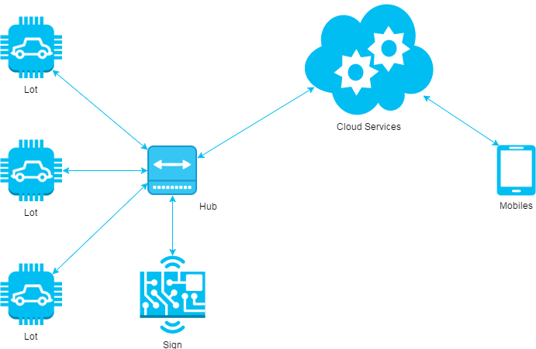

Figure : System architecture design

This diagram is referenced and modified from an original concept from: The Internet of Things: An Overview by The Internet Society (ISOC). In this device-to-gateway model, or more typically, the device-to-application-layer gateway (ALG) model, the IoT device connects through an ALG service as a conduit to reach a cloud service. The hub serves as a local gateway between individual IoT devices and a cloud service, but they can also bridge the interoperability gap between devices themselves.

### Hardware Program Architecture Description



Figure : Hardware Program architectural

**Parking Lot Node** is a device placed at each lot in the car park. It plays the role as a passive IoT node and controls other components, which connects to it through several kinds of port to perform various works:

* **Arduino Nano**: plays the roles as central processing unit for IoT node.
* **Magnetometer**: an instrument that measures magnetism, which is used as metal detectors to detect ferrous metals in a car.
* **Servo**: a linear actuator that allows for precise control of angular or linear position, velocity and acceleration. This will be used to control the barrier in each lot.
* **LED**: a RGB LED used as an Indicator LED in each lot.
* **RF Module**: a small device used to transmit/receive radio signals between two devices. This is used to create a network bridge for the whole system.

**Sign Node** is a device placed at each area and at the entrance of the car park. It also a passive node and used to display the available lots in each area:

* **Arduino Nano**: plays the roles as central processing unit for IoT node.
* **RF Module**: a small device used to transmit/receive radio signals between two devices. This is used to create a network bridge for the whole system.
* **LED:** a large LED display screen

**Hub** is a stand-alone gateway device that has RF Module installed to communicate with all other IoT nodes. It also connects to cloud service, allowing the user to gain access to the devices using a smartphone app and an Internet connection:

* **Raspberry Pi**: plays the roles as central processing unit for Hub node.
* **RF Module**: a small device used to transmit/receive radio signals between two devices. This is used to create a network bridge for the whole system.
* **Network Interfaces:** an interfaces to connect to the Internet.
* **API Service:** is a cloud service that provides all necessary APIs and database.
* **Real time Service:** a cloud service that provides real time communication between smartphone app and Hub.

### Mobile Application Architecture Description

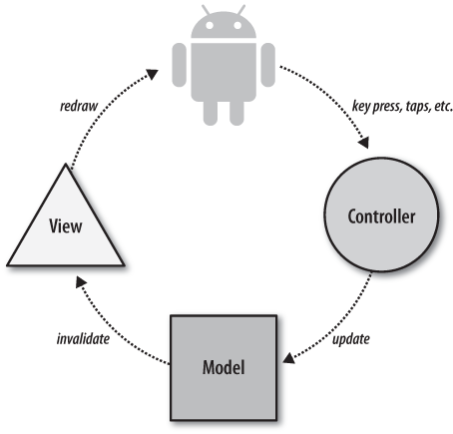

Figure : Mobile Application architecture

In Mobile Application, the system is developed under Standard Android Architecture. This is the default approach with layout files, Activities/Fragments acting as the controller and Models used for data and persistence. With this approach, Activities are in charge of processing the data and updating the views. Activities act like a controller in MVC but with some extra responsibilities that should be part of the view.

### Web API Architecture Description

Figure : Hardware - Software Connection Architecture Description

## Component Diagram

### General Component Diagram

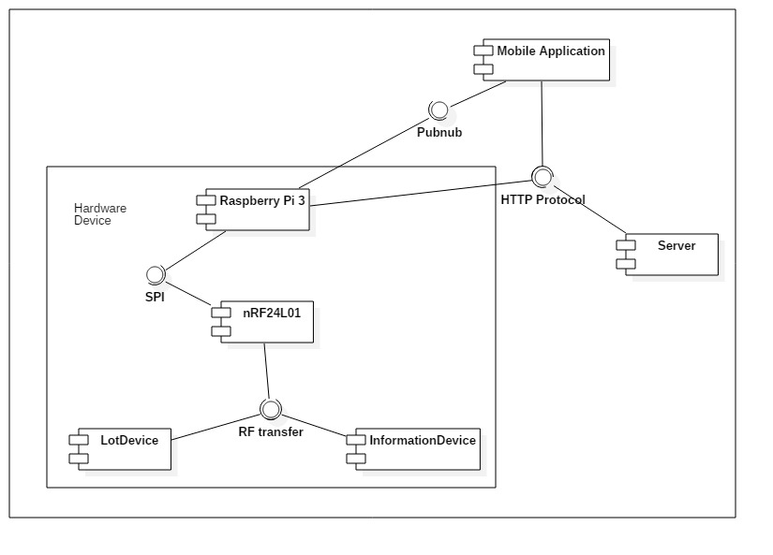

Figure : General Component Diagram

### Lot Device Diagram

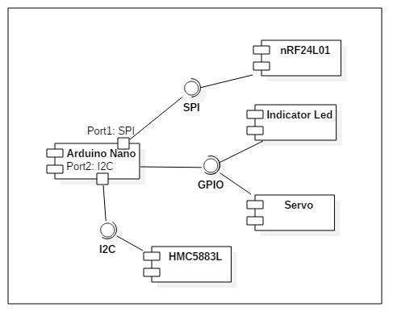

Figure : Lot Device Diagram

### Information Device Diagram

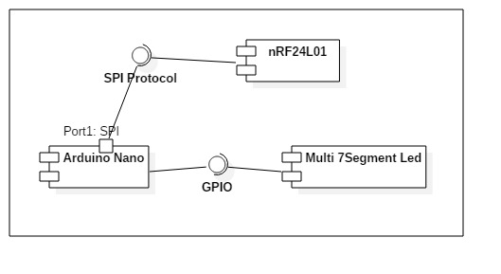

Figure : Information Device Diagram

### Server Diagram

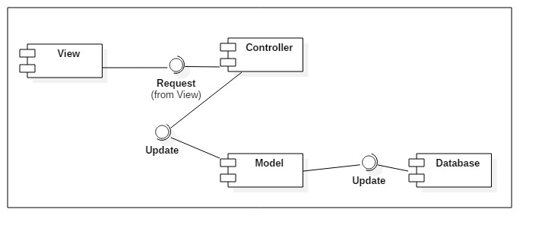

Figure : Server Diagram

### Component Dictionary

|  |  |
| --- | --- |
| Component Dictionary: Describes components | |
| **Mobile Application** | The application for user on android devices |
| **Server** | The Web API server, which make the interaction between the Raspberry Pi and the Mobile Application. It also save information to the database. |
| **Raspberry Pi 3** | The main controller in the hardware system that control all Lot Device and Information Device in each car park. |
| **Lot Device** | The device in each parking lot that control the indicator led, servo and use the magnetometer sensor to detect car. |
| **Information Device** | The number led board that show the number of empty lot in each area and number of empty lot in car park. |
| **nRF24L01** | The RF module, which help main controller, lot device and information device interact with each other. |
| **Arduino Nano** | The controller in lot device and information device. |
| **Indicator Led** | The RGB led to show the status of parking lot (empty, in used, reserved, disabled). |
| **Servo** | The barrier to prevent other car get in the parking lot when it is reserved. |
| **HMC5883L** | The magnetometer sensor to realize if the metal is near. |
| **Pubnub** | The third party API that help real time interaction. |
| **HTTP Protocol** | A transfer protocol to interact between server, mobile application and Raspberry Pi 3. |
| **SPI** | Synchronous serial communication interface used for short distance communication. |
| **I2C** | The inter-intergrated circuit to communicate between arduino and magnetometer sensor. |
| **GPIO** | The communication between Arduino and led, servo, … |
| **Multi 7Segment Led** | The 7 segment led to indicate number. |
| **View** | The JSON result of the API controller. |
| **Controller** | The API controller in the server. |
| **Model** | The entity model. |
| **Database** | The collection of data. |

Table : Component dictionary

## Detailed Description

### Web API Detailed Description

#### Class Diagram

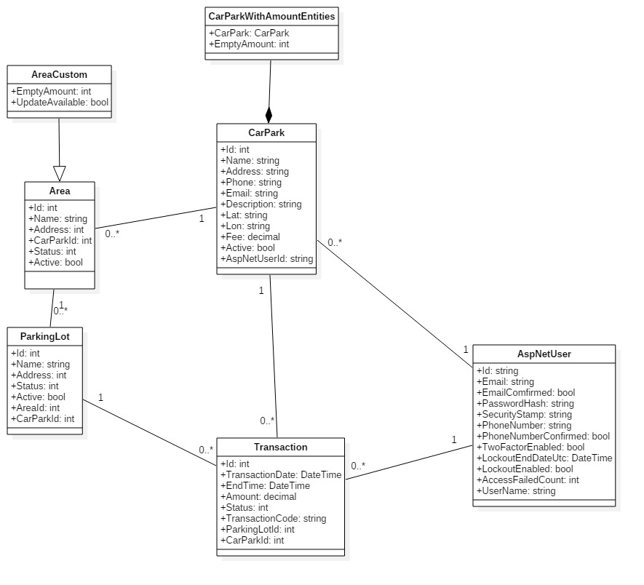

Figure : Model Class Diagram

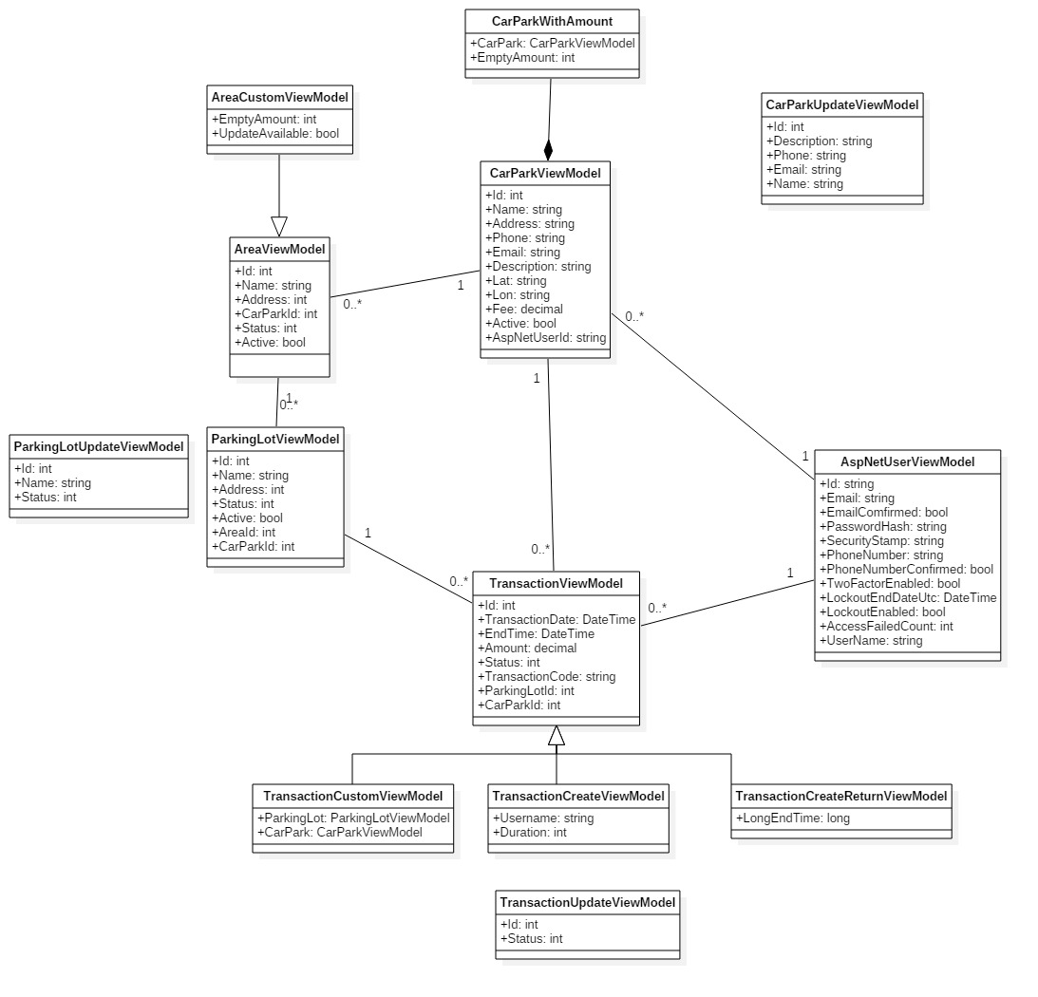

Figure : Vỉew Model Class Diagram

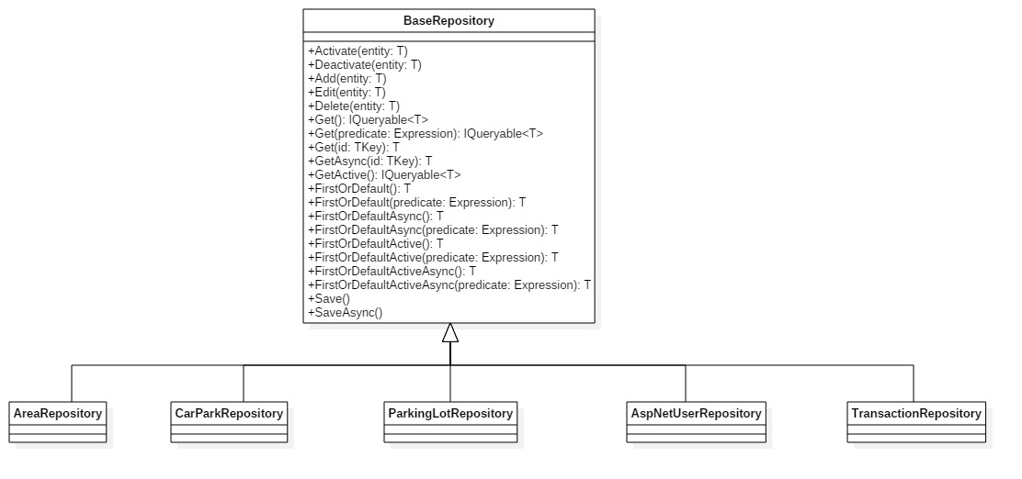

Figure : Repository Class Diagram

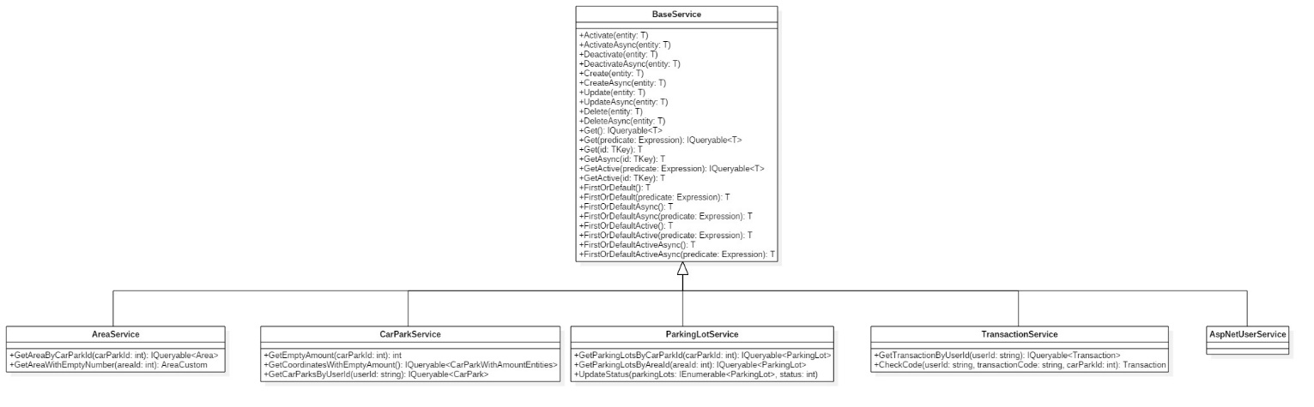

Figure : Service Class Diagram

#### Class Diagram Explanation

##### Model Class Diagram

**CarPark**

|  |  |  |  |
| --- | --- | --- | --- |
| Attribute | Type | Visibility | Description |
| Id | int | public | Unique Id for each car park |
| Name | string | public | Name of car park |
| Address | string | public | Address of carpark |
| Phone | string | public | Phone number of car park |
| Email | string | public | Email of car park’s owner |
| Description | string | public | Information of car park |
| Lat | string | public | Latitude of a car park |
| Lon | string | public | Longitude of a car park |
| Fee | decimal | public | Amount of money each hour |
| Active | bool | public | Value show that the car park is deleted or not |
| AspNetUserId | string | public | Id of the owner |

Table : CarPark class attributes

**CarParkWithAmountEntities**

|  |  |  |  |
| --- | --- | --- | --- |
| Attribute | Type | Visibility | Description |
| CarPark | CarPark | public | The car park entity |
| EmptyAmount | int | public | The number of empty lot in car park |

Table : CarParkWithAmountEntities class attributes

**Area**

|  |  |  |  |
| --- | --- | --- | --- |
| Attribute | Type | Visibility | Description |
| Id | int | public | Unique Id for each area |
| Name | string | public | Name of area |
| Address | int | public | Bit address of a area |
| CarParkId | int | public | Id of car park which hold area |
| Status | int | public | The number indicate the status of area |
| Active | bit | public | Value show that the area is deleted or not |

Table : Area class attributes

**AreaCustom**

|  |  |  |  |
| --- | --- | --- | --- |
| Attribute | Type | Visibility | Description |
| EmptyAmount | int | public | The number of empty lot in area |
| UpdateAvailable | bool | public | The boolean value check that area is available for update |

Table : AreaCustom class attributes

**ParkingLot**

|  |  |  |  |
| --- | --- | --- | --- |
| Attribute | Type | Visibility | Description |
| Id | int | public | Unique Id for each parking lot |
| Name | string | public | Name of parking lot |
| Address | int | public | Bit address of a parking lot |
| Status | int | public | The number indicate the status of parking lot |
| Active | bit | public | Value show that the parking lot is deleted or not |
| AreaId | int | public | Id of area which hold parking lot |
| CarParkId | int | public | Id of car park which hold parking lot |

Table : ParkingLot class attributes

**Transaction**

|  |  |  |  |
| --- | --- | --- | --- |
| Attribute | Type | Visibility | Description |
| Id | int | public | Unique Id for each transaction |
| TransactionDate | string | public | The time customer book the parking lot |
| EndTime | int | public | End of the booking time |
| Amount | int | public | The total fee of transaction |
| Status | bit | public | The number indicate status of the transaction |
| TransactionCode | string | public | The code for the user to enter in the car park to unlock the booked parking lot |
| ParkingLotId | int | public | Id of area which hold parking lot |
| CarParkId | int | public | Id of car park which hold parking lot |

Table : Transaction class attributes

**AspNetUser**

|  |  |  |  |
| --- | --- | --- | --- |
| Attribute | Type | Visibility | Description |
| Id | string | public | Unique Id for each user |
| Email | string | public | Email of the user |
| EmailConfirm | bool | public | Check if the user confirm the email |
| PasswordHash | string | public | Hash of the user password, don’t save exact password |
| SecurityStamp | string | public |  |
| PhoneNumber | string | public | The number of the user |
| PhoneNumberConfirmed | bool | public | Check if the number is confirmed |
| TwoFactorEnabled | bool | public |  |
| LockoutEndDateUtc | DateTime | public |  |
| LockoutEnabled | bool | public |  |
| AccessFailedCount | int | public | The number of time access failed |
| UserName | string | public | Username of the user |

Table : AspNetUser class attributes

##### View Model Class Diagram

**CarParkViewModel**

|  |  |  |  |
| --- | --- | --- | --- |
| Attribute | Type | Visibility | Description |
| Id | int | public | Unique Id for each car park |
| Name | string | public | Name of car park |
| Address | string | public | Address of carpark |
| Phone | string | public | Phone number of car park |
| Email | string | public | Email of car park’s owner |
| Description | string | public | Information of car park |
| Lat | string | public | Latitude of a car park |
| Lon | string | public | Longitude of a car park |
| Fee | decimal | public | Amount of money each hour |
| Active | bool | public | Value show that the car park is deleted or not |
| AspNetUserId | string | public | Id of the owner |

Table : CarParkViewModel class attributes

**CarParkWithAmount**

|  |  |  |  |
| --- | --- | --- | --- |
| Attribute | Type | Visibility | Description |
| CarPark | CarParkViewModel | public | The car park entity |
| EmptyAmount | int | public | The number of empty lot in car park |

Table : CarParkWithAmount class attributes

**CarParkUpdateViewModel**

|  |  |  |  |
| --- | --- | --- | --- |
| Attribute | Type | Visibility | Description |
| Id | int | public | Id of update car park |
| Description | string | public | New description |
| Phone | string | public | New phone number |
| Email | string | public | New email |
| Name | string | public | New name |

Table : CarParkUpdateViewModel class attributes

**AreaViewModel**

|  |  |  |  |
| --- | --- | --- | --- |
| Attribute | Type | Visibility | Description |
| Id | int | public | Unique Id for each area |
| Name | string | public | Name of area |
| Address | int | public | Bit address of a area |
| CarParkId | int | public | Id of car park which hold area |
| Status | int | public | The number indicate the status of area |
| Active | bit | public | Value show that the area is deleted or not |

Table : AreaViewModel class attributes

**AreaCustomViewModel**

|  |  |  |  |
| --- | --- | --- | --- |
| Attribute | Type | Visibility | Description |
| EmptyAmount | int | public | The number of empty lot in area |
| UpdateAvailable | bool | public | The boolean value check that area is available for update |

Table : AreaCustomViewModel class attributes

**ParkingLotViewModel**

|  |  |  |  |
| --- | --- | --- | --- |
| Attribute | Type | Visibility | Description |
| Id | int | public | Unique Id for each parking lot |
| Name | string | public | Name of parking lot |
| Address | int | public | Bit address of a parking lot |
| Status | int | public | The number indicate the status of parking lot |
| Active | bit | public | Value show that the parking lot is deleted or not |
| AreaId | int | public | Id of area which hold parking lot |
| CarParkId | int | public | Id of car park which hold parking lot |

Table : ParkingLotViewModel class attributes

**ParkingLotUpdateViewModel**

|  |  |  |  |
| --- | --- | --- | --- |
| Attribute | Type | Visibility | Description |
| Id | int | public | Unique Id for each parking lot |
| Name | string | public | New name if change |
| Status | int | public | New status if change |

Table : ParkingLotUpdateViewModel class attributes

**Transaction**

|  |  |  |  |
| --- | --- | --- | --- |
| Attribute | Type | Visibility | Description |
| Id | int | public | Unique Id for each transaction |
| TransactionDate | string | public | The time customer book the parking lot |
| EndTime | int | public | End of the booking time |
| Amount | int | public | The total fee of transaction |
| Status | bit | public | The number indicate status of the transaction |
| TransactionCode | string | public | The code for the user to enter in the car park to unlock the booked parking lot |
| ParkingLotId | int | public | Id of area which hold parking lot |
| CarParkId | int | public | Id of car park which hold parking lot |

Table : Transaction class attributes

**TransactionCustomViewModel**

|  |  |  |  |
| --- | --- | --- | --- |
| Attribute | Type | Visibility | Description |
| ParkingLot | ParkingLotViewModel | public | ParkingLot’s model |
| CarPark | CarParkViewModel | public | CarPark, where transaction is booked |

Table : TransactionCustomViewModel class attributes

**TransactionCreateViewModel**

|  |  |  |  |
| --- | --- | --- | --- |
| Attribute | Type | Visibility | Description |
| Username | string | public | Username of the customer |
| Duration | int | public | Time of booking |

Table : TransactionCreateViewModel class attributes

**TransactionCreateReturnViewModel**

|  |  |  |  |
| --- | --- | --- | --- |
| Attribute | Type | Visibility | Description |
| LongEndTime | long | public | DateTime in number format |

Table : TransactionCreateReturnViewModel class attributes

**TransactionUpdateViewModel**

|  |  |  |  |
| --- | --- | --- | --- |
| Attribute | Type | Visibility | Description |
| Id | int | public | Id of the transaction |
| Status | int | public | The integer indicate the status of transaction |

Table : TransactionUpdateViewModel class attributes

**AspNetUser**

|  |  |  |  |
| --- | --- | --- | --- |
| Attribute | Type | Visibility | Description |
| Id | string | public | Unique Id for each user |
| Email | string | public | Email of the user |
| EmailConfirm | bool | public | Check if the user confirm the email |
| PasswordHash | string | public | Hash of the user password, don’t save exact password |
| SecurityStamp | string | public |  |
| PhoneNumber | string | public | The number of the user |
| PhoneNumberConfirmed | bool | public | Check if the number is confirmed |
| TwoFactorEnabled | bool | public |  |
| LockoutEndDateUtc | DateTime | public |  |
| LockoutEnabled | bool | public |  |
| AccessFailedCount | int | public | The number of time access failed |
| UserName | string | public | Username of the user |

Table : AspNetUser class attributes

##### Repository Class Diagram

**BaseRepository**

|  |  |  |  |
| --- | --- | --- | --- |
| **Method** | **Type** | **Visibility** | **Description** |
| Activate | void | public | Set the active attribute of current model to True |
| Deactivate | void | public | Set the active attribute of current model to False |
| Add | void | public | Add a model to database |
| Edit | void | public | Edit a input model |
| Delete | void | public | Delete a input model in database |
| Get | IQueryable<T> | public | Get a list of model with condition in database |
| Get | T | public | Get a model by Id in database |
| GetAsync | T | public | Get a model by Id in database asynchronous |
| GetActive | IQueryable<T> | public | Get a list of model with condition in database asynchronous |
| FirstOrDefault | T | public | Get first model in a list with condition in database |
| FirstOrDefaultAsync | T | public | Get first model in a list with condition in database asynchronous |
| FirstOrDefaultActive | T | public | Get first model in a list of active item with condition in database |
| FirstOrDefaultActiveAsync | T | public | Get first model in a list of active item with condition in database asynchronous |
| Save | void | public | Save a current state of entity to database |
| SaveAsync | void | public | Save a current state of entity to database asynchronous |

Table : BaseRepository class methods

##### Service Class Diagram

**Base Service**

|  |  |  |  |
| --- | --- | --- | --- |
| **Method** | **Type** | **Visibility** | **Description** |
| Activate | void | public | Set the active attribute of current model to True |
| ActivateAsync | void | public | Set the active attribute of current model to True asynchronous |
| Deactivate | void | public | Set the active attribute of current model to False |
| DeactivateAsync |  |  | Set the active attribute of current model to False asynchronous |
| Create | void | public | Create a new item in database |
| CreateAsync | void | public | Create a new item in database asynchronous |
| Update | void | public | Update a item in database |
| UpdateAsync | void | public | Update an item in database asynchronous |
| Delete | void | public | Delete an item in database |
| DeleteAsync | void | public | Delete an item in database asynchronous |
| Get | IQueryable<T> | public | Get a list of model with condition in database |
| Get | T | public | Get a model by Id in database |
| GetAsync | T | public | Get a model by Id in database asynchronous |
| GetActive | IQueryable<T> | public | Get a list of model with condition in database asynchronous |
| GetActive | T | public | Get active model by Id in database if exist |
| FirstOrDefault | T | public | Get first model in a list with condition in database |
| FirstOrDefaultAsync | T | public | Get first model in a list with condition in database asynchronous |
| FirstOrDefaultActive | T | public | Get first model in a list of active item with condition in database |
| FirstOrDefaultActiveAsync | T | public | Get first model in a list of active item with condition in database asynchronous |

Table : BaseService class methods

**AreaService**

|  |  |  |  |
| --- | --- | --- | --- |
| **Method** | **Type** | **Visibility** | **Description** |
| GetAreaByCarParkId | IQueryable<Area> | public | Get the area with input car park id |
| GetAreaWithEmptyNumber | AreaCustom | public | Get the area with empty number of lot by area id |

Table : AreaService class methods

**CarParkService**

|  |  |  |  |
| --- | --- | --- | --- |
| **Method** | **Type** | **Visibility** | **Description** |
| GetEmptyAmount | int | public | Get the number of empty lot by car park id |
| GetCoordinates  WithEmptyAmount | IQueryable  <CarParkWith  AmountEntities> | public | Get the list of car park with coordinate and number of empty lot |
| GetCarParksByUserId | IQueryable  <CarPark> | public | Get the list of car park by AspNetUserId (owner of car park) |

Table : CarParkService class methods

**ParkingLotService**

|  |  |  |  |
| --- | --- | --- | --- |
| **Method** | **Type** | **Visibility** | **Description** |
| GetParkingLotsByCarParkId | IQueryable<ParkingLot> | public | Get the list of parking lot in the car park |
| GetParkingLotsByAreaId | IQueryable<ParkingLot> | public | Get the list of parking lot in the area |
| UpdateStatus | void | public | Change the status of a list parking lot |

Table : ParkingLotService class methods

**Transaction Service**

|  |  |  |  |
| --- | --- | --- | --- |
| **Method** | **Type** | **Visibility** | **Description** |
| GetTransactionByUserId | IQueryable<Transaction> | public | Get the list of transaction create by a user |
| CheckCode | Transaction | public | Get the transaction base on user, transaction code and car park |

Table : TransactionService class methods

#### Interaction Diagram

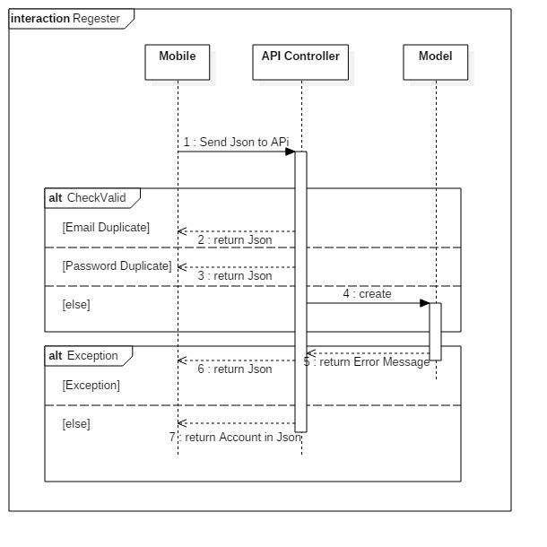

Figure : Register Diagram

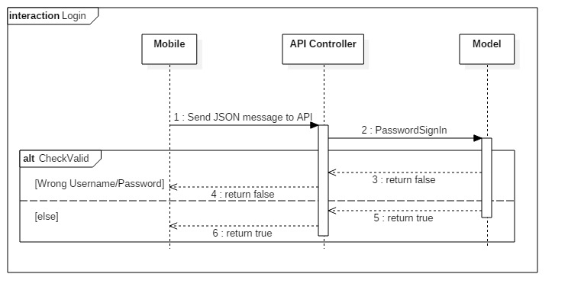

Figure : Login Diagram

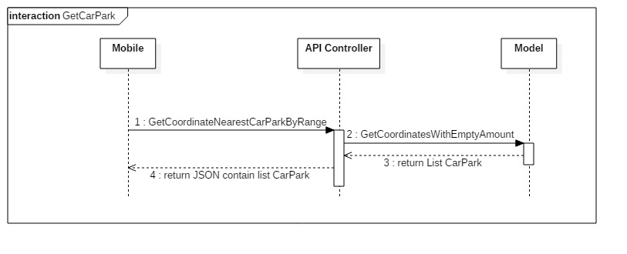

Figure : GetCarPark Diagram

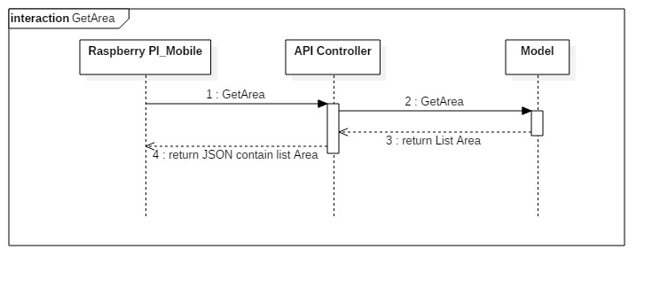

Figure : GetArea Diagram

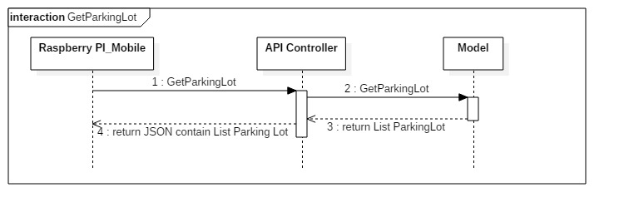

Figure : GetParkingLot Diagram

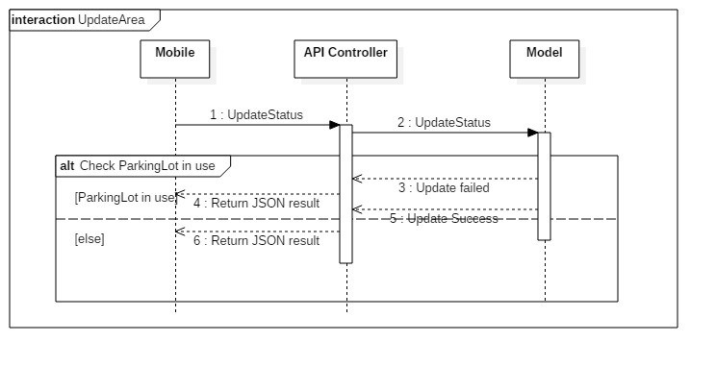

Figure : UpdateArea Diagram

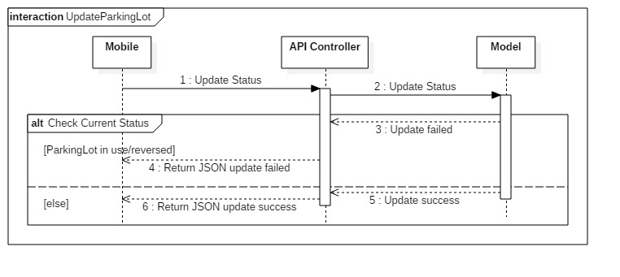

Figure : UpdateParkingLot Diagram

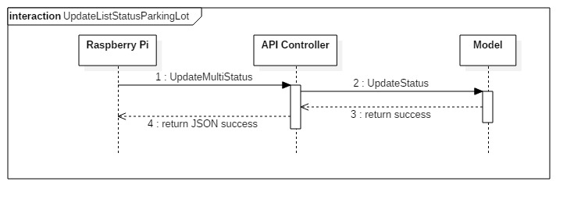

Figure : UpdateListStatusParkingLot Diagram

### Mobile Detailed Description

#### Class Diagram

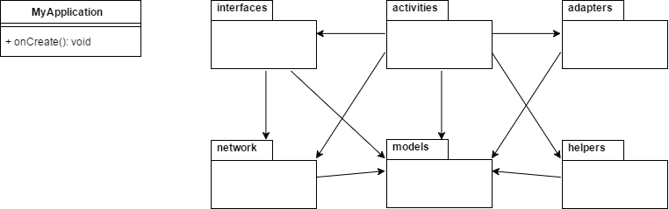

Figure : Main class diagram and package view

| **Packages Dictionary: describe packages** | |
| --- | --- |
| **Package Name** | **Description** |
| Interfaces | Package that provides interfaces for API communication |
| Activities | Package that provides all activities for Mobile Application |
| Adapters | Package that provides adapters for Recycler View / List View / Info Window |
| Network | Package that provides network models and network classes |
| Models | Package that provides all models |
| Helpers | Package that provides all helper class for database, network, pubnub… |

Table : Packages dictionary

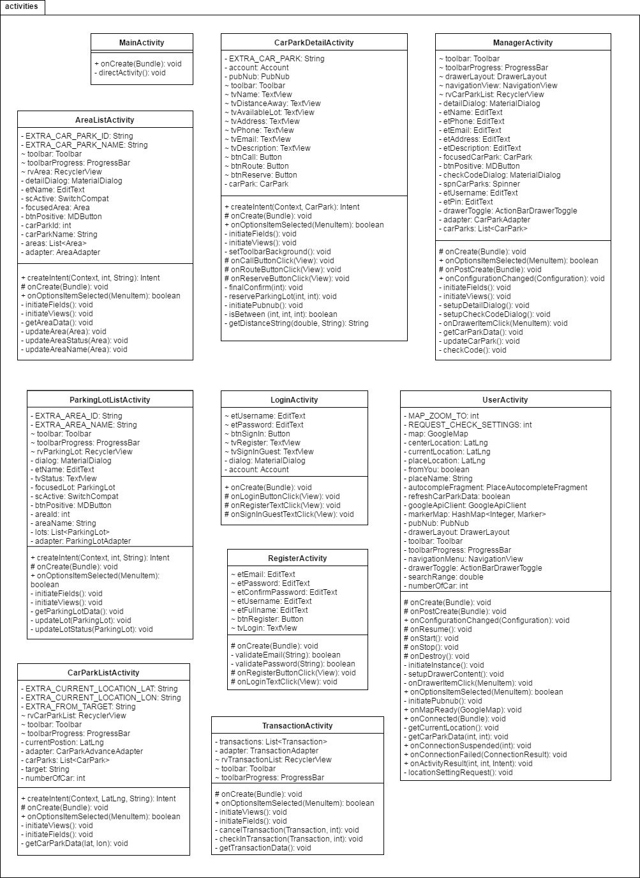

Figure : Activities package class diagram

| **Class Dictionary: describes class** | |
| --- | --- |
| **Class Name** | **Description** |
| MainActivity | Activity to handle direction of activity flow when app start |
| CarParkDetailActivity | Activity to provide detail information of car park and to handle request from user |
| ManagerActivity | Activity to provide manager with car parks information and to handle commands |
| AreaListActivity | Activity to provide list of areas in car park and handle commands |
| ParkingLotListActivity | Activity to provide list of parking lots in area and handle commands |
| LoginActivity | Activity to handle login request of user |
| RegisterActivity | Activity to handle register request of user |
| UserActivity | Activity to provide user with car parks information in map view and handle commands and directions to other activities |
| CarParkListActivity | Activity to provide user with car parks information in list view and handle commands |
| TransactionActivity | Activity to provide user with list of history transactions and handle commands |

Table : Activities package class dictionary

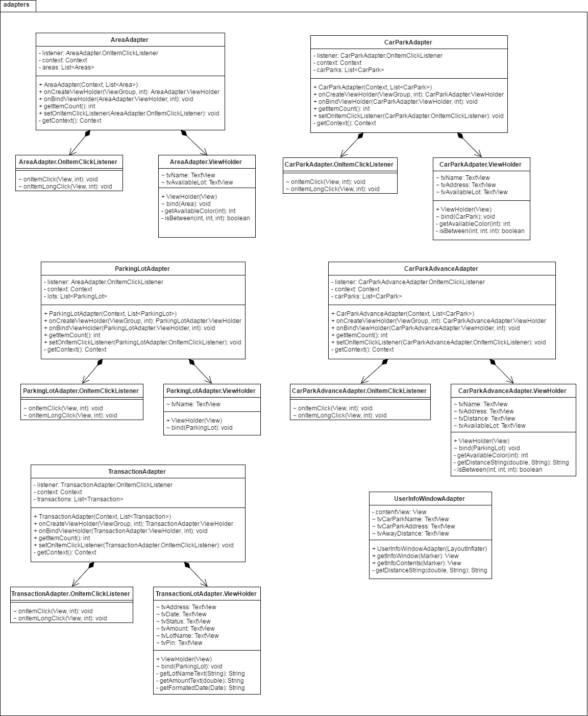

Figure : Adapters package class diagram

| **Class Dictionary: describes class** | |
| --- | --- |
| **Class Name** | **Description** |
| AreaAdapter | Provides a binding from Area data set to views that are displayed within a Recycler View |
| AreaAdapter  .OnItemClickListener | Interface definition for a callback to be invoked when an item in AreaAdapter has been click |
| AreaAdapter  .ViewHolder | Describes an item view and metadata about its place within the Recycler View |
| CarParkAdapter | Provides a binding from Car Park data set to views that are displayed within a Recycler View |
| CarParkAdapter  .OnItemClickListener | Interface definition for a callback to be invoked when an item in CarParkAdapter has been click |
| CarParkAdapter  .ViewHolder | Describes an item view and metadata about its place within the Recycler View |
| ParkingLotAdapter | Provides a binding from Parking Lot data set to views that are displayed within a Recycler View |
| ParkingLotAdapter  .OnItemClickListener | Interface definition for a callback to be invoked when an item in ParkingLotdapter has been click |
| ParkingLotAdapter  .ViewHolder | Describes an item view and metadata about its place within the Recycler View |
| CarParkAdvanceAdapter | Provides a binding from Car Park Advance data set to views that are displayed within a Recycler View |
| CarParkAdvanceAdapter  .OnItemClickListener | Interface definition for a callback to be invoked when an item in CarParkAdvanceAdapter has been click |
| CarParkAdvanceAdapter  .ViewHolder | Describes an item view and metadata about its place within the Recycler View |
| TransactionAdapter | Provides a binding from Transaction data set to views that are displayed within a Recycler View |
| TransactionAdapter  .OnItemClickListener | Interface definition for a callback to be invoked when an item in TransactionAdapter has been click |
| TransactionAdapter  .ViewHolder | Describes an item view and metadata about its place within the Recycler View |
| UserInfoWindowAdapter | Provides views for customized rendering of info windows |

Table : Adapters package class dictionary

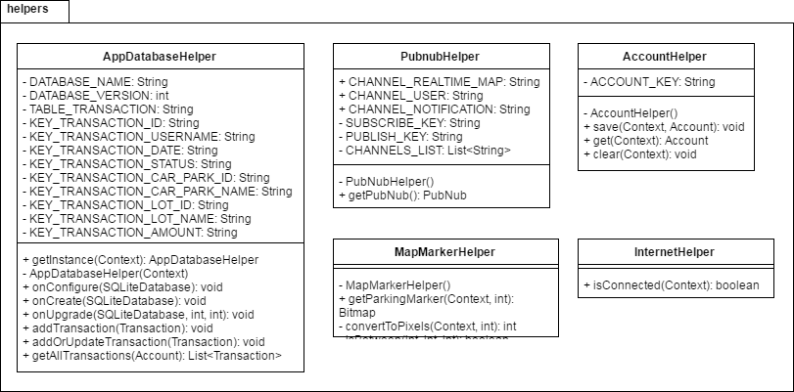

Figure : Helpers package class diagram

| **Class Dictionary: describes class** | |
| --- | --- |
| **Class Name** | **Description** |
| AppDatabaseHelper | A helper class provides API to work with SQLite |
| PubnubHelper | A helper class provides API to work with PubNub |
| AccountHelper | A helper class provides API to work with account data in shared preferences |
| MapMarkerHelper | A helper class provides utility for Google Map Marker |
| InternetHelper | A helper class provides utility for network |

Table : Helpers package class dictionary

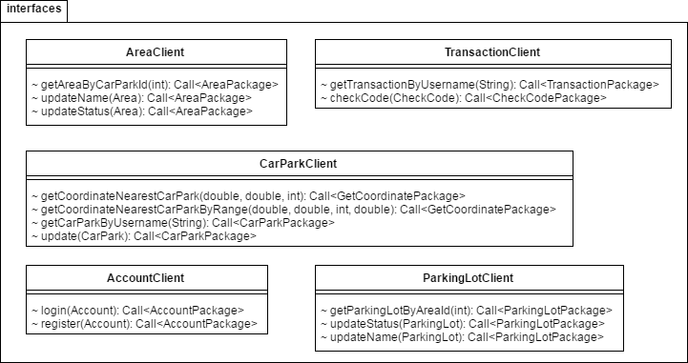

Figure : Interfaces package class diagram

| **Class Dictionary: describes class** | |
| --- | --- |
| **Class Name** | **Description** |
| AreaClient | An interface to consume API call for Area |
| TransactionClient | An interface to consume API call for Transaction |
| CarParkClient | An interface to consume API call for Car Park |
| AccountClient | An interface to consume API call for Account |
| ParkingLotClient | An interface to consume API call for Parking Lot |

Table : Interfaces package class dictionary

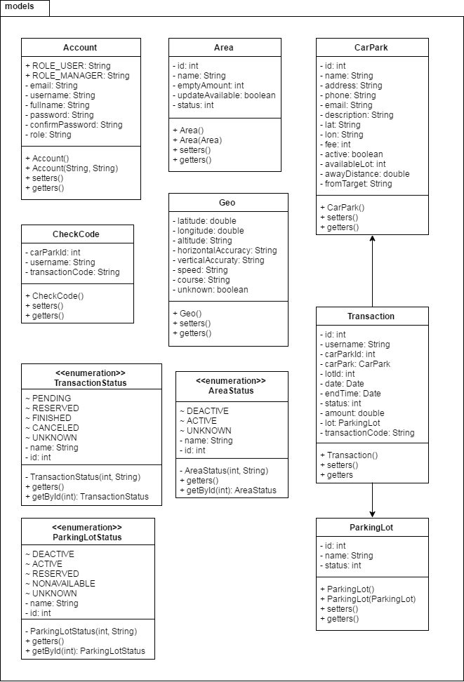

Figure : Models package class diagram

| **Class Dictionary: describes class** | |
| --- | --- |
| **Class Name** | **Description** |
| Account | Contain the account information |
| Area | Contain the area information |
| CheckCode | Contain the check code information |
| Geo | Contain the geo information |
| CarPark | Contain the car park information |
| Transaction | Contain the transaction information |
| ParkingLot | Contain the parking lot information |
| TransactionStatus | An enumeration contains the status of transaction |
| AreaStatus | An enumeration contains the status of area |
| ParkingLotStatus | An enumeration contains the status of parking lot |

Table : Models package class dictionary

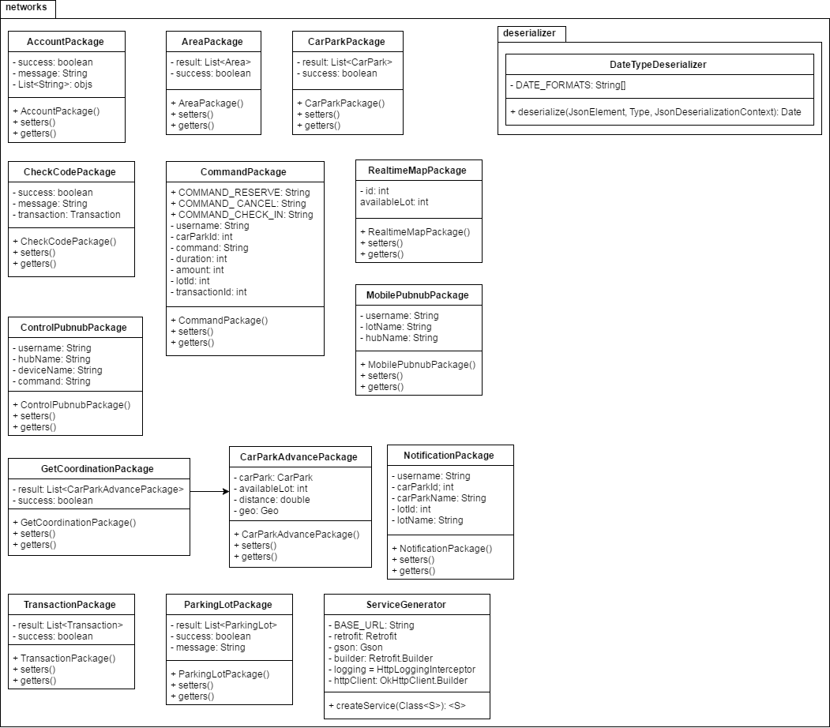

Figure : Networks package class diagram

| **Class Dictionary: describes class** | |
| --- | --- |
| **Class Name** | **Description** |
| AccountPackage | Contain the account information used in network |
| AreaPackage | Contain the area information used in network |
| CarParkPackage | Contain the car park information used in network |
| CheckCodePackage | Contain the check code information used in network |
| CommandPackage | Contain the command information used in network |
| RealtimeMapPackage | Contain the realtime map information used in network |
| ControlPubnubPackage | Contain the control pubnub information used in network |
| MobilePubnubPackage | Contain the mobile pubnub information used in network |
| GetCoordinationPackage | Contain the get coordination information used in network |
| CarParkAdvancePackage | Contain the car park advance information used in network |
| NotificationPackage | Contain the notification information used in network |
| TransactionPackage | Contain the transaction information used in network |
| ParkingLotPackage | Contain the parking lot information used in network |
| ServiceGenerator | A generator to generate retrofit service with interfaces |
| DateTypeDeserializer | A deserializer that can deserialize multiple type of Date format in json |

Table : Networks package class dictionary

#### Class Diagram Explanation

##### [Activities] MainActivity

**Attributes**

N/A

**Methods**

|  |  |  |  |
| --- | --- | --- | --- |
| **Method** | **Return type** | **Visibility** | **Description** |
| onCreate | Void | Protected | Initialize activity |
| directActivity | Void | Private | Direct flow of activity depend on shared preferences status |

Table : [Activities] MainActivity methods

##### [Activities] CarParkDetailActivity

**Attributes**

|  |  |  |  |
| --- | --- | --- | --- |
| **Attribute** | **Type** | **Visibility** | **Description** |
| EXTRA_CAR_PARK | String | private | Extra name used in Intent |
| account | Account | private | Login user account |
| pubNub | PubNub | private | Instance of PubNub |
| toolbar | Toolbar | package | Instance of Toolbar |
| tvName | TextView | package | View of car park name |
| tvDistanceAway | TextView | package | View of distance between car park and target |
| tvAvailableLot | TextView | package | View of car park available lot |
| tvAddress | TextView | package | View of car park address |
| tvPhone | TextView | package | View of car park phone |
| tvEmail | TextView | package | View of car park email |
| tvDescription | TextView | package | View of car park description |
| btnCall | Button | package | View of call button |
| btnRoute | Button | package | View of request routing button |
| btnReserve | Button | package | View of request reservation button |
| carpark | CarPark | package | Object of CarPark |

Table : [Activities] CarParkDetailActivity attributes

**Methods**

|  |  |  |  |
| --- | --- | --- | --- |
| **Method** | **Return type** | **Visibility** | **Description** |
| createIntent | Intent | public | Return Intent of activity |
| onCreate | void | protected | Initialize activity |
| onOptionsItemSelected | boolean | public | Callback when options item is selected |
| initiateFields | void | private | Initialize all member variables |
| initiateViews | void | private | Initialize all views |
| setToolbarBackground | void | private | Set background for toolbar |
| onCallButtonClick | void | protected | Callback when call button is clicked |
| onRouteButtonClick | void | protected | Callback when route button is clicked |
| onReserveButtonClick | void | protected | Callback when reserve butotn is clicked |
| finalConfirm | void | private | Show final confirmation of request |
| reserveParkingLot | void | private | Process to reserve a parking lot |
| initatePubnub | void | private | Initalize PubNub instance |
| isBetween | boolean | private | Check if the number is between 2 other numbers |
| getDistanceString | String | private | Return distance in string format |

Table : [Activities] CarParkDetailActivity methods

##### [Activities] ManagerActivity

**Attributes**

|  |  |  |  |
| --- | --- | --- | --- |
| **Attribute** | **Type** | **Visibility** | **Description** |
| toolbar | Toolbar | protected | Instance of Toolbar |
| toolbarProgress | ProgressBar | protected | Instance of ProgressBar |
| drawerLayout | DrawerLayout | protected | Instance of DrawerLayout |
| navigationView | NavigationView | protected | Instance of NavigationView |
| rvCarParkList | RecyclerView | protected | Recycler View of car park list |
| detailDialog | MaterialDialog | private | Detail dialog of car park |
| etName | EditText | private | View of car park name in detail dialog |
| etPhone | EditText | private | View of car park phone in detail dialog |
| etEmail | EditText | private | View of car park email in detail dialog |
| etAddress | EditText | private | View of car park address in detail dialog |
| etDescription | EditText | private | View of car park description in detail dialog |
| focusedCarPark | CarPark | private | Instance of focused car park |
| btnPositive | MDButton | private | View of positive button of detail dialog |
| checkCodeDialog | MaterialDialog | private | Check code dialog |
| spnCarParks | Spinner | private | Drop down list of car parks in check code dialog |
| etUsername | EditText | private | View of username in check code dialog |
| etPin | EditText | private | View of pin code in check code dialog |
| drawerToggle | ActionBarDrawerToggle | private | Instance of ActionBarDrawerToggle |
| carParks | List<CarPark> | private | List of CarPark |
| adapter | CarParkAdapter | private | Adapter of CarPark |

Table : [Activities] ManagerActivity attributes

**Methods**

|  |  |  |  |
| --- | --- | --- | --- |
| **Method** | **Return type** | **Visibility** | **Description** |
| onCreate | void | protected | Initialize activity |
| onOptionsItemSelected | boolean | public | Callback when options item is selected |
| onPostCreate | void | protected | Callback after activity is created |
| onConfigurationChanged | void | public | Callback when activity change configuration |
| initiateFields | void | private | Initialize member variables |
| initiateViews | void | private | Initialize views |
| setupDetailDialog | void | private | Initialize detail dialog |
| setupCheckCodeDialog | void | private | Initialize check code dialog |
| onDrawerItemClick | void | private | Callback when drawer item is clicked |
| getCarParkData | void | private | Get car park data using API |
| updateCarPark | void | private | Update car park data using API |
| checkCode | void | private | Check username and pin code using API |

Table : [Activities] ManagerActivity methods

##### [Activities] AreaListActivity

**Attributes**

|  |  |  |  |
| --- | --- | --- | --- |
| **Attribute** | **Type** | **Visibility** | **Description** |
| EXTRA_CAR_PARK_ID | String | private | Extra name of intent |
| EXTRA_CAR_PARK_NAME | String | private | Extra name of intent |
| toolbar | Toolbar | protected | Instance of Toolbar |
| toolbarProgress | ProgressBar | protected | Instance of ProgressBar |
| rvArea | RecyclerView | protected | Recycler View of area list |
| detailDialog | MaterialDialog | private | Detail dialog of area |
| etName | EditText | private | View of area name in detail dialog |
| scActive | SwitchCompat | private | View of area active switch in detail dialog |
| focusedArea | Area | private | Instance of focused Area |
| btnPositive | MDButton | private | View of positive button in detail dialog |
| carParkId | int | private | Value of car park id |
| carParkName | String | private | Value of car park name |
| areas | List<Area> | private | List of Area |
| adapter | AreaAdapter | private | Adapter of Area |

Table : [Activities] AreaListActivity attributes

**Methods**

|  |  |  |  |
| --- | --- | --- | --- |
| **Method** | **Return type** | **Visibility** | **Description** |
| createIntent | Intent | public | Return intent of activity |
| onCreate | void | protected | Initialize activity |
| onOptionsItemSelected | boolean | public | Callback when options item is selected |
| initiateFields | void | private | Initialize member variables |
| initiateViews | void | private | Initialize views |
| getAreaData | void | private | Get area data using API |
| updateArea | void | private | Check change of area and call correct update method |
| updateAreaStatus | void | private | Update area status using API |
| updateAreaName | void | private | Update area name using API |

Table : [Activities] AreaListActivity methods

##### [Activities] ParkingLotListActivity

**Attributes**

|  |  |  |  |
| --- | --- | --- | --- |
| **Attribute** | **Type** | **Visibility** | **Description** |
| EXTRA_AREA_ID | String | private | Extra of intent |
| EXTRA_AREA_NAME | String | private | Extra of intent |
| toolbar | Toolbar | protected | Instance of Toolbar |
| toolbarProgress | ProgressBar | protected | Instance of ProgressBar |
| rvParkingLot | RecyclerView | protected | Recycler View of parking lot list |
| dialog | MaterialDialog | private | Detail dialog of parking lot |
| etName | EditText | private | View of parking lot name in detail dialog |
| tvStatus | TextView | private | View of lot status in detail dialog |
| focusedLot | ParkingLot | private | Instance of focused Parking Lot |
| btnPositive | MDButton | private | View of positive button in detail dialog |
| areaId | int | private | Value of area id |
| areaName | String | private | Value of area name |
| lots | List<ParkingLot> | private | List of Parking Lot |
| adapter | ParkingLotAdapter | private | Adapter of Parking Lot |

Table : [Activities] ParkingLotListActivity attributes

**Methods**

|  |  |  |  |
| --- | --- | --- | --- |
| **Method** | **Return type** | **Visibility** | **Description** |
| createIntent | Intent | public | Return intent of activity |
| onCreate | void | protected | Initialize activity |
| onOptionsItemSelected | boolean | public | Callback when options item is selected |
| initiateFields | void | private | Initialize member variables |
| initiateViews | void | private | Initialize views |
| getParkingLotData | void | private | Get parking lot data using API |
| updateLot | void | private | Update lot information using API |
| updateLotStatus | void | private | Update lot status using API |

Table : [Activities] ParkingLotListActivity methods

##### [Activities] LoginActivity

**Attributes**

|  |  |  |  |
| --- | --- | --- | --- |
| **Attribute** | **Type** | **Visibility** | **Description** |
| etUsername | EditText | package | View of username |
| etPassword | EditText | package | View of password |
| btnSignIn | EditText | package | View of sign in button |
| tvRegister | TextView | package | View of register text |
| tvSignInGuest | TextView | package | View of sign in as guest text |
| dialog | MaterialDialog | private | Progress dialog |
| account | Account | private | Instance of Account |

Table : [Activities] LoginActivity attributes

**Methods**

|  |  |  |  |
| --- | --- | --- | --- |
| **Method** | **Return type** | **Visibility** | **Description** |
| onCreate | void | public | Initialize activity |
| onLoginButtonClick | void | protected | Callback when login button is clicked |
| onRegisterTextClick | void | protected | Callback when register text is clicked |
| onSignInGuestTextClick | void | protected | Callback when sign in as guest is clicked |

Table : [Activities] LoginActivity methods

##### [Activities] RegisterActivity

**Attributes**

|  |  |  |  |
| --- | --- | --- | --- |
| **Attribute** | **Type** | **Visibility** | **Description** |
| etEmail | EditText | package | View of email |
| etPassword | EditText | package | View of password |
| etConfirmPassword | EditText | package | View of confirm password |
| etUsername | EditText | package | View of username |
| etFullname | EditText | package | View of fullname |
| btnRegister | Button | package | View of register button |
| tvLogin | TextView | package | View of login text |

Table : [Activities] RegisterActivity attributes

**Methods**

|  |  |  |  |
| --- | --- | --- | --- |
| **Method** | **Return type** | **Visibility** | **Description** |
| onCreate | void | protected | Initialize activity |
| validateEmail | boolean | private | Check email format |
| validatePassword | boolean | private | Check password format |
| onRegisterButtonClick | void | protected | Callback when register button is clicked |
| onLoginTextClick | void | protected | Callback when login text is clicked |

Table : [Activities] RegisterActivity methods

##### [Activities] UserActivity

**Attributes**

|  |  |  |  |
| --- | --- | --- | --- |
| **Attribute** | **Type** | **Visibility** | **Description** |
| MAP_ZOOM_TO | int | private | Value of map zoom |
| REQUEST_CHECK_SETTING | int | private | Value of request check setting |
| map | GoogleMap | private | Instance of GoogleMap |
| centerLocation | LatLng | private | Location of map center |
| currentLocation | LatLng | private | Location of current postion |
| placeLocation | LatLng | private | Location of searched place |
| fromYou | boolean | private | Flag to check if the distance show on marker is from current location or from place |
| placeName | String | private | Name of searched place |
| autocompleFragment | Place  Autocomplete  Fragment | private | Instance of PlaceAutocompleteFragment |
| refreshCarParkData | boolean | private | Flag to check if need to refresh car park data on map |
| googleApiClient | GoogleApi  Client | private | Instance of GoogleApiClient |
| markerMap | HashMap<  Integer, Marker> | private | Map of marker and car park id |
| pubNub | PubNub | private | Instance of PubNub |
| drawerLayout | DrawerLayout | private | Instance of DrawerLayout |
| toolbar | Toolbar | private | Instance of Toolbar |
| toobarProgress | ProgressBar | private | Instance of ProgressBar |
| navigationMenu | NavigationView | private | Instance of NavigationView |
| drawerToggle | ActionBar  DrawerToggle | private | Instance of ActionBarDrawerToggle |
| searchRange | double | private | Value of search range |
| numberOfCar | int | private | Value of number of car to request data from API |

Table : [Activities] UserActivity attributes

**Methods**

|  |  |  |  |
| --- | --- | --- | --- |
| **Method** | **Return type** | **Visibility** | **Description** |
| onCreate | void | protected | Initialize activity |
| onPostCreate | void | protected | Callback after activity is created |
| onConfigurationChanged | void | public | Callback after activity change configuration |
| onResume | void | protected | Callback when activity resume |
| onStart | void | protected | Callback when activity start |
| onStop | void | protected | Callback when activity stop |
| onDestroy | void | protected | Callback when activity destroy |
| initiateInstance | void | private | Initialize member variables and views |
| setupDrawerContent | void | private | Setup drawer |
| onDrawerItemClick | void | private | Callback when drawer item is clicked |
| onOptionsItemSelected | boolean | public | Callback when options item is selected |
| initiatePubnub | void | private | Initialize PubNub |
| onMapReady | void | public | Callback when google map is ready |
| onConnected | void | public | Callback when google client is connected |
| getCurrentLocation | void | private | Get current location |
| getCarParkData | void | private | Get car park data using API |
| onConnectionSuspended | void | public | Callback when connection is suspended |
| onConnectionFailed | void | public | Callback when connection is failed |
| onActivityResult | vodi | public | Callback when intent return result |
| locationSettingRequest | void | private | Request turn on location for app |

Table : [Activities] UserActivity methods

##### [Activities] CarParkListActivity

**Attributes**

|  |  |  |  |
| --- | --- | --- | --- |
| **Attribute** | **Type** | **Visibility** | **Description** |
| EXTRA_CURRENT  _LOCATION_LAT | String | private | Extra for intent |
| EXTRA_CURRENT  _LOCATION_LON | String | private | Extra for intent |
| EXTRA_FROM_TARGET | String | private | Extra for intent |
| rvCarParkList | RecyclerView | package | Recycler View for car park list |
| toolbar | Toolbar | package | Instance of Toolbar |
| toolbarProgress | ProgressBar | package | Instance of ProgressBar |
| currentPosition | LatLng | private | Current location |
| adapter | CarParkAdvance  Adapter | private | Advance adapter of Car Park |
| carParks | List<CarPark> | private | List of CarPark |
| target | String | private | Name of target |
| numberOfCar | int | private | Value of number of car to request search |

Table : [Activities] CarParkListActivity attributes

**Methods**

|  |  |  |  |
| --- | --- | --- | --- |
| **Method** | **Return type** | **Visibility** | **Description** |
| createIntent | Intent | public | Return intent of activity |
| onCreate | void | protected | Initialize activity |
| onOptionsItemSelected | boolean | public | Callback when options item is selected |
| initiateViews | void | private | Initialize views |
| initiateFields | void | private | Initialize member variables |
| getCarParkData | void | private | Get car park data using API |

Table : [Activities] CarParkListActivity methods

##### [Activities] TransactionActivity

**Attributes**

|  |  |  |  |
| --- | --- | --- | --- |
| **Attribute** | **Type** | **Visibility** | **Description** |
| transactions | List<Transaction> | private | List of Transaction |
| adapter | TransactionAdapter | private | Adapter of Transaction |
| rvTransactionList | RecyclerView | package | Recycler View of transaction list |
| toolbar | Toolbar | package | Instance of Toolbar |
| toolbarProgress | ProgressBar | package | Instance of ProgressBar |

Table : [Activities] TransactionActivity attributes

**Methods**

|  |  |  |  |
| --- | --- | --- | --- |
| **Method** | **Return type** | **Visibility** | **Description** |
| onCreate | void | protected | Initialize activity |
| onOptionsItemSelected | boolean | public | Callback when options item is selected |
| initiateViews | void | private | Initialize views |
| initiateFields | void | private | Initialize fields |
| cancelTransaction | void | private | Callback when cancel transaction button is clicked |
| checkInTransaction | void | private | Callback when check in transaction button is clicked |
| getTransactionData | void | private | Get transaction data using API |

Table : [Activities] TransactionActivity methods

##### [Adapters] AreaAdapter

**Attributes**

|  |  |  |  |
| --- | --- | --- | --- |
| **Attribute** | **Type** | **Visibility** | **Description** |
| listener | AreaAdapter.  OnItemClickListener | private | Interface of item click listener |
| context | Context | private | Context of adapter |
| areas | List<Area> | private | List of Area |

Table : [Adapters] AreaAdapter attributes

**Methods**

|  |  |  |  |
| --- | --- | --- | --- |
| **Method** | **Return type** | **Visibility** | **Description** |
| onCreateViewHolder | AreaAdapter.  ViewHolder | public | Callback when creating view holder |
| onBindViewHolder | AreaAdapter.  ViewHolder | public | Callback when binding data to view holder |
| getItemCount | int | public | Return number of items in list |
| setOnItemClickListener | void | public | Set listener callback for item |
| getContext | Context | private | Return adapter context |

Table : [Adapters] AreaAdapter methods

##### [Adapters] AreaAdapter.OnItemClickListener

**Attributes**

N/A

**Methods**

|  |  |  |  |
| --- | --- | --- | --- |
| **Method** | **Return type** | **Visibility** | **Description** |
| onItemClick | void | package | Callback when item in list is clicked |
| onItemLongClick | void | package | Callback when item in list is being hold |

Table : [Adapters] AreaAdapter.OnItemClickListener methods

##### [Adapters] AreaAdapter.ViewHolder

**Attributes**

|  |  |  |  |
| --- | --- | --- | --- |
| **Attribute** | **Type** | **Visibility** | **Description** |
| tvName | TextView | package | View of area name |
| tvAvailableLot | TextView | package | View of area available lot |

Table : [Adapters] AreaAdapter.ViewHolder attributes

**Methods**

|  |  |  |  |
| --- | --- | --- | --- |
| **Method** | **Return type** | **Visibility** | **Description** |
| bind | void | package | Bind data to view holder |
| getAvailableColor | int | private | Return color for available view |
| isBetween | boolean | private | Check if number is between 2 other numbers |

Table : [Adapters] AreaAdapter.ViewHolder methods

##### [Adapters] CarParkAdapter

**Attributes**

|  |  |  |  |
| --- | --- | --- | --- |
| **Attribute** | **Type** | **Visibility** | **Description** |
| listener | CarParkAdapter.  OnItemClickListener | private | Interface of item click listener |
| context | Context | private | Context of adapter |
| carParks | List<CarPark> | private | List of CarPark |

Table : [Adapters] CarParkAdapter attributes

**Methods**

|  |  |  |  |
| --- | --- | --- | --- |
| **Method** | **Return type** | **Visibility** | **Description** |
| onCreateViewHolder | CarParkAdapter.  ViewHolder | public | Callback when creating view holder |
| onBindViewHolder | CarParkAdapter.  ViewHolder | public | Callback when binding data to view holder |
| getItemCount | int | public | Return number of items in list |
| setOnItemClickListener | void | public | Set listener callback for item |
| getContext | Context | private | Return adapter context |

Table : [Adapters] CarParkAdapter methods

##### [Adapters] CarParkAdapter.OnItemClickListener

**Attributes**

N/A

**Methods**

|  |  |  |  |
| --- | --- | --- | --- |
| **Method** | **Return type** | **Visibility** | **Description** |
| onItemClick | void | package | Callback when item in list is clicked |
| onItemLongClick | void | package | Callback when item in list is being hold |

Table : [Adapter] CarParkAdapter.OnItemClickListener methods

##### [Adapters] CarParkAdapter.ViewHolder

**Attributes**

|  |  |  |  |
| --- | --- | --- | --- |
| **Attribute** | **Type** | **Visibility** | **Description** |
| tvName | TextView | package | View of car park name |
| tvAddress | TextView | package | View of car park address |
| tvAvailableLot | TextView | package | View of car park available lot |

Table : [Adapters] CarParkAdapter.ViewHolder attributes

**Methods**

|  |  |  |  |
| --- | --- | --- | --- |
| **Method** | **Return type** | **Visibility** | **Description** |
| bind | void | package | Bind data to view holder |
| getAvailableColor | int | private | Return color for available view |
| isBetween | boolean | private | Check if number is between 2 other numbers |

Table : [Adapters] CarParkAdapter.ViewHolder methods

##### [Adapters] ParkingLotAdapter

**Attributes**

|  |  |  |  |
| --- | --- | --- | --- |
| **Attribute** | **Type** | **Visibility** | **Description** |
| listener | ParkingLotAdapter.  OnItemClickListener | private | Interface of item click listener |
| context | Context | private | Context of adapter |
| lots | List<ParkingLot> | private | List of ParkingLot |

Table : [Adapters] ParkingLotAdapter attributes

**Methods**

|  |  |  |  |
| --- | --- | --- | --- |
| **Method** | **Return type** | **Visibility** | **Description** |
| onCreateViewHolder | ParkingLotAdapter.  ViewHolder | public | Callback when creating view holder |
| onBindViewHolder | ParkingLotAdapter.  ViewHolder | public | Callback when binding data to view holder |
| getItemCount | int | public | Return number of items in list |
| setOnItemClickListener | void | public | Set listener callback for item |
| getContext | Context | private | Return adapter context |

Table : [Adapters] ParkingLotAdapter methods

##### [Adapters] ParkingLotAdapter.OnItemClickListener

**Attributes**

N/A

**Methods**

|  |  |  |  |
| --- | --- | --- | --- |
| **Method** | **Return type** | **Visibility** | **Description** |
| onItemClick | void | package | Callback when item in list is clicked |
| onItemLongClick | void | package | Callback when item in list is being hold |

Table : [Adapters] ParkingLotAdapter.OnItemClickListener methods

##### [Adapters] ParkingLotAdapter.ViewHolder

**Attributes**

|  |  |  |  |
| --- | --- | --- | --- |
| **Attribute** | **Type** | **Visibility** | **Description** |
| tvName | TextView | package | View of parking lot name |

Table : [Adapters] ParkingLotAdapter.ViewHolder attributes

**Methods**

|  |  |  |  |
| --- | --- | --- | --- |
| **Method** | **Return type** | **Visibility** | **Description** |
| bind | void | package | Bind data to view holder |

Table : [Adapters] ParkingLotAdapter.ViewHolder methods

##### [Adapters] CarParkAdvanceAdapter

**Attributes**

|  |  |  |  |
| --- | --- | --- | --- |
| **Attribute** | **Type** | **Visibility** | **Description** |
| listener | CarParkAdvanceAdapter.  OnItemClickListener | private | Interface of item click listener |
| context | Context | private | Context of adapter |
| carParks | List<CarPark> | private | List of CarPark |

Table : [Adapters] CarParkAdvanceAdapter attributes

**Methods**

|  |  |  |  |
| --- | --- | --- | --- |
| **Method** | **Return type** | **Visibility** | **Description** |
| onCreateViewHolder | CarParkAdvanceAdapter.  ViewHolder | public | Callback when creating view holder |
| onBindViewHolder | CarParkAdvanceAdapter.  ViewHolder | public | Callback when binding data to view holder |
| getItemCount | int | public | Return number of items in list |
| setOnItemClickListener | void | public | Set listener callback for item |
| getContext | Context | private | Return adapter context |

Table : [Adapters] CarParkAdvanceAdapter methods

##### [Adapters] CarParkAdvanceAdapter.OnItemClickListener

**Attributes**

N/A

**Methods**

|  |  |  |  |
| --- | --- | --- | --- |
| **Method** | **Return type** | **Visibility** | **Description** |
| onItemClick | void | package | Callback when item in list is clicked |
| onItemLongClick | void | package | Callback when item in list is being hold |

Table : [Adapters] CarParkAdvanceAdapter.OnItemClickListener methods

##### [Adapters] CarParkAdvanceAdapter.ViewHolder

**Attributes**

|  |  |  |  |
| --- | --- | --- | --- |
| **Attribute** | **Type** | **Visibility** | **Description** |
| tvName | TextView | package | View of car park name |
| tvAvailableLot | TextView | package | View of car park available lot |
| tvDistance | TextView | package | View of car park distance |
| tvAddress | TextView | package | View of car park address |

Table : [Adapters] CarParkAdvanceAdapter.ViewHolder attributes

**Methods**

|  |  |  |  |
| --- | --- | --- | --- |
| **Method** | **Return type** | **Visibility** | **Description** |
| bind | void | package | Bind data to view holder |
| getAvailableColor | int | private | Return color for available view |
| isBetween | boolean | private | Check if number is between 2 other numbers |
| getDistanceString | String | private | Get distance in string format |

Table : [Adapters] CarParkAdvanceAdapter.ViewHolder methods

##### [Adapters] TransactionAdapter

**Attributes**

|  |  |  |  |
| --- | --- | --- | --- |
| **Attribute** | **Type** | **Visibility** | **Description** |
| listener | TransactionAdapter.  OnItemClickListener | private | Interface of item click listener |
| context | Context | private | Context of adapter |
| transactions | List<Transaction> | private | List of Transaction |

Table : [Adapters] TransactionAdapter attributes

**Methods**

|  |  |  |  |
| --- | --- | --- | --- |
| **Method** | **Return type** | **Visibility** | **Description** |
| onCreateViewHolder | TransactionAdapter.  ViewHolder | public | Callback when creating view holder |
| onBindViewHolder | TransactionAdapter.  ViewHolder | public | Callback when binding data to view holder |
| getItemCount | int | public | Return number of items in list |
| setOnItemClickListener | void | public | Set listener callback for item |
| getContext | Context | private | Return adapter context |

Table : [Adapters] TransactionAdapter methods

##### [Adapters] TransactionAdapter.OnItemClickListener

**Attributes**

N/A

**Methods**

|  |  |  |  |
| --- | --- | --- | --- |
| **Method** | **Return type** | **Visibility** | **Description** |
| onItemClick | void | package | Callback when item in list is clicked |
| onItemLongClick | void | package | Callback when item in list is being hold |

Table : [Adapters] TransactionAdapter.OnItemClickListener methods

##### [Adapters] TransactionAdapter.ViewHolder

**Attributes**

|  |  |  |  |
| --- | --- | --- | --- |
| **Attribute** | **Type** | **Visibility** | **Description** |
| tvAddress | TextView | package | View of transaction address |
| tvDate | TextView | package | View of transaction date |
| tvStatus | TextView | package | View of transaction status |
| tvAmount | TextView | package | View of transaction amount |
| tvLotName | TextView | package | View of transaction lot name |
| tvPin | TextView | package | View of transaction pin code |

Table : [Adapters] TransactionAdapter.ViewHolder attributes

**Methods**

|  |  |  |  |
| --- | --- | --- | --- |
| **Method** | **Return type** | **Visibility** | **Description** |
| bind | void | package | Bind data to view holder |
| getLotNameText | String | private | Get lot name in string format |
| getAmountText | String | private | Get amount in string format |
| getFormatedDate | String | private | Get date in string format |

Table : [Adapters] TransactionAdapter.ViewHolder methods

##### [Adapters] UserInfoWindowAdapter

**Attributes**

|  |  |  |  |
| --- | --- | --- | --- |
| **Attribute** | **Type** | **Visibility** | **Description** |
| contentView | View | private | Content view |
| tvCarParkName | TextView | package | View of car park name |
| tvCarParkAddress | TextView | package | View of car park address |
| tvAwayDistance | TextView | package | View of car park away distance |

Table : [Adapters] UserInfoWindowAdapter attributes

**Methods**

|  |  |  |  |
| --- | --- | --- | --- |
| **Method** | **Return type** | **Visibility** | **Description** |
| getInfoWindow | View | public | Return Info Window view |
| getInfoContents | View | public | Return Info Contents view |
| getDistanceString | String | private | Get distance in string format |

Table : [Adapters] UserInfoWindowAdapter methods

##### [Helpers] AppDatabaseHelper

**Attributes**

|  |  |  |  |
| --- | --- | --- | --- |
| **Attribute** | **Type** | **Visibility** | **Description** |
| DATABASE_NAME | String | private | Name of database |
| DATABASE_VERSION | int | private | Version number of database |
| TABLE_TRANSACTION | String | private | Name of transaction table |
| KEY_TRANSACTION_ID | String | private | Key of transaction id |
| KEY_TRANSACTION  _USERNAME | String | private | Key of transaction username |
| KEY_TRANSACTION  _DATE | String | private | Key of transaction date |
| KEY_TRANSACTION  _STATUS | String | private | Key of transaction status |
| KEY_TRANSACTION  _CAR_PARK_ID | String | private | Key of transaction car park id |
| KEY_TRANSACTION  _CAR_PARK_NAME | String | private | Key of transaction car park name |
| KEY_TRANSACTION  _LOT_ID | String | private | Key of transaction lot id |
| KEY_TRANSACTION  _LOT_NAME | String | private | Key of transaction lot name |
| KEY_TRANSACTION  _AMOUNT | String | private | Key of transaction amount |

Table : [Helpers] AppDatabaseHelper attributes

**Methods**

|  |  |  |  |
| --- | --- | --- | --- |
| **Method** | **Return type** | **Visibility** | **Description** |
| getInstance | AppDatabaseHelper | public | Return singleton instance of helper |
| onConfigure | void | public | Callback when database is configured |
| onCreate | void | public | Callback when database is created |
| onUpgrade | void | public | Callback when database is upgraded |
| addTransaction | void | public | Add transaction to database |
| addOrUpdateTransaction | void | public | Add or Update transaction to database |
| getAllTransactions | List<Transaction> | public | Return all transactions of user in database |

Table : [Helpers] AppDatabaseHelper methods

##### [Helpers] PubnubHelper

**Attributes**

|  |  |  |  |
| --- | --- | --- | --- |
| **Attribute** | **Type** | **Visibility** | **Description** |
| CHANNEL_REALTIME_MAP | String | public | Name of realtime map channel |
| CHANNEL_USER | String | public | Name of user channel |
| CHANNEL_NOTIFICATION | String | public | Name of notification channel |
| SUBSCRIBE_KEY | String | private | Pubnub subscribe key |
| PUBLISH_KEY | String | private | Pubnub publish key |
| CHANNELS_LIST | List<String> | private | List of pubnub channels |

Table : [Helpers] PubnubHelper attributes

**Methods**

|  |  |  |  |
| --- | --- | --- | --- |
| **Method** | **Return type** | **Visibility** | **Description** |
| getPubNub | PubNub | public | Return a singleton instance of PubNub |

Table : [Helpers] PubnubHelper methods

##### [Helpers] AccountHelper

**Attributes**

|  |  |  |  |
| --- | --- | --- | --- |
| **Attribute** | **Type** | **Visibility** | **Description** |
| ACCOUNT_KEY | String | private | Key name of account in shared preferences |

Table : [Helpers] AccountHelper attributes

**Methods**

|  |  |  |  |
| --- | --- | --- | --- |
| **Method** | **Return type** | **Visibility** | **Description** |
| save | void | public | Save account information in shared preferences |
| get | Account | public | Get account information from shared preferences |
| clear | void | public | Delete all account informations in shared preferences |

Table : [Helpers] AccountHelper methods

##### [Helpers] MapMarkerHelper

**Attributes**

N/A

**Methods**

|  |  |  |  |
| --- | --- | --- | --- |
| **Method** | **Return type** | **Visibility** | **Description** |
| getParkingMarker | Bitmap | public | Return a custom bitmap marker |
| convertToPixels | int | private | Convert dp to pixels |
| isBetween | boolean | private | Check if the number is between 2 other numbers |

Table : [Helpers] MapMarkerHelper methods

##### [Helpers] InternetHelper

**Attributes**

N/A

**Methods**

|  |  |  |  |
| --- | --- | --- | --- |
| **Method** | **Return type** | **Visibility** | **Description** |
| isConnected | boolean | public | Check if internet is available |

Table : [Helpers] InternetHelper methods

##### [Interfaces] AreaClient

**Attributes**

N/A

**Methods**

|  |  |  |  |
| --- | --- | --- | --- |
| **Method** | **Return type** | **Visibility** | **Description** |
| getAreaByCarParkId | Call<AreaPackage> | package | Interface for get area by car park id API |
| updateName | Call<AreaPackage> | package | Interface for update area name API |
| updateStatus | Call<AreaPackage> | package | Interface for update area status API |

Table : [Interfaces] AreaClient methods

##### [Interfaces] TransactionClient

**Attributes**

N/A

**Methods**

|  |  |  |  |
| --- | --- | --- | --- |
| **Method** | **Return type** | **Visibility** | **Description** |
| getTransactionByUsername | Call<Transaction  Package> | package | Interface for get transactions by username API |
| checkCode | Call<Transaction  Package> | package | Interface for check code API |

Table : [Interfaces] TransactionClient methods

##### [Interfaces] CarParkClient

**Attributes**

N/A

**Methods**

|  |  |  |  |
| --- | --- | --- | --- |
| **Method** | **Return type** | **Visibility** | **Description** |
| getCoordinate  NearesCarPark | Call<Get  CoordinatePackage> | package | Interface for get nearest car park API |
| getCoordinate  NearestCarPark  ByRange | Call<Get  CoordinatePackage> | package | Interface for get nearest car park in range API |
| getCarPark  ByUsername | Call<CarPark  Package> | package | Interface for get car park by username API |
| update | Call<CarPark  Package> | package | Interface for update car park API |

Table : [Interfaces] CarParkClient methods

##### [Interfaces] AccountClient

**Attributes**

N/A

**Methods**

|  |  |  |  |
| --- | --- | --- | --- |
| **Method** | **Return type** | **Visibility** | **Description** |
| login | Call<Account  Package> | package | Interface for login API |
| register | Call<Account  Package> | package | Interface for register API |

Table : [Interfaces] AccountClient methods

##### [Interfaces] ParkingLotClient

**Attributes**

N/A

**Methods**

|  |  |  |  |
| --- | --- | --- | --- |
| **Method** | **Return type** | **Visibility** | **Description** |
| getParkingLot  ByAreaId | Call<Parking  LotPackage> | package | Interface for get parking lot by area id API |
| updateStatus | Call<Parking  LotPackage> | package | Interface for update parking lot status API |
| updateName | Call<Parking  LotPackage> | package | Interface for update parking lot name API |

Table : [Interfaces] ParkingLotClient methods

##### [Models] Account

**Attributes**

|  |  |  |  |
| --- | --- | --- | --- |
| **Attribute** | **Type** | **Visibility** | **Description** |
| ROLE_USER | String | public | Value of role user |
| ROLE_MANAGER | String | public | Value of role manager |
| email | String | private | Email of account |
| username | String | private | Username of account |
| fullname | String | private | Fullname of account |
| password | String | private | Password of account |
| confirmPassword | String | private | Confirm password |
| role | String | private | Role of account |

Table : [Models] Account attributes

**Methods**

|  |  |  |  |
| --- | --- | --- | --- |
| **Method** | **Return type** | **Visibility** | **Description** |
| Getter | Attribute type | public | Get attribute value |
| Setter | Void | public | Set value of attribute |

Table : [Models] Account methods

##### [Models] Area

**Attributes**

|  |  |  |  |
| --- | --- | --- | --- |
| **Attribute** | **Type** | **Visibility** | **Description** |
| id | int | private | Unique id of area |
| name | String | private | Name of area |
| emptyAmount | int | private | Current available lot of area |
| updateAvailable | boolean | private | Flag to check if area is updatable |
| status | int | private | Current status of area |

Table : [Models] Area attributes

**Methods**

|  |  |  |  |
| --- | --- | --- | --- |
| **Method** | **Return type** | **Visibility** | **Description** |
| Getter | Attribute type | public | Get attribute value |
| Setter | Void | public | Set value of attribute |

Table : [Models] Area methods

##### [Models] CheckCode

**Attributes**

|  |  |  |  |
| --- | --- | --- | --- |
| **Attribute** | **Type** | **Visibility** | **Description** |
| carParkId | int | private | Unique id of car park |
| username | String | private | Username of user want to check in with code |
| transactionCode | String | private | Pin code come with transaction |

Table : [Models] CheckCode attributes

**Methods**

|  |  |  |  |
| --- | --- | --- | --- |
| **Method** | **Return type** | **Visibility** | **Description** |
| Getter | Attribute type | public | Get attribute value |
| Setter | Void | public | Set value of attribute |

Table : [Models] CheckCode methods

##### [Models] Geo

**Attributes**

|  |  |  |  |
| --- | --- | --- | --- |
| **Attribute** | **Type** | **Visibility** | **Description** |
| latitude | double | private | Geo location latitude |
| longitude | double | private | Geo location longitude |
| altitude | String | private | Geo location altitude |
| horizontalAccuracy | String | private | Geo location horizontal accuracy |
| verticalAccuracy | String | private | Geo location vertical accuracy |
| speed | String | private | Geo location speed |
| course | String | private | Geo location course |
| unknown | boolean | private | Flag to check Geo location |

Table : [Models] Geo attributes

**Methods**

|  |  |  |  |
| --- | --- | --- | --- |
| **Method** | **Return type** | **Visibility** | **Description** |
| Getter | Attribute type | public | Get attribute value |
| Setter | Void | public | Set value of attribute |

Table : [Models] Geo methods

##### [Models] CarPark

**Attributes**

|  |  |  |  |
| --- | --- | --- | --- |
| **Attribute** | **Type** | **Visibility** | **Description** |
| id | int | private | Unique id of car park |
| name | String | private | Name of car park |
| address | String | private | Address of car park |
| phone | String | private | Phone of car park |
| email | String | private | Email of car park |
| description | String | private | Description of car park |
| lat | String | private | Latitude of car park |
| lon | String | private | Longitude of car park |
| fee | int | private | Fee per hour of car park |
| active | boolean | private | Flag to check if car park is active |
| availableLot | int | private | Current available parking lot in car park |
| awayDistance | double | private | Away distance of car park from target |
| fromTarget | String | private | Target to check away distance |

Table : [Models] CarPark attributes

**Methods**

|  |  |  |  |
| --- | --- | --- | --- |
| **Method** | **Return type** | **Visibility** | **Description** |
| Getter | Attribute type | public | Get attribute value |
| Setter | Void | public | Set value of attribute |

Table : [Models] CarPark methods

##### [Models] Transaction

**Attributes**

|  |  |  |  |
| --- | --- | --- | --- |
| **Attribute** | **Type** | **Visibility** | **Description** |
| id | int | private | Unique id of transaction |
| username | String | private | Username of transaction |
| carParkId | int | private | Car park id of transaction |
| carpark | CarPark | private | Instance of CarPark object in transaction |
| lotId | int | private | Parking Lot id of transaction |
| lot | ParkingLot | private | Instance of ParkingLot object in transaction |
| date | Date | private | The moment user request reservation |
| endTime | Date | private | The end of reservation |
| status | int | private | Status of reservation |
| amount | double | private | Cost of the reservation |
| transactionCode | String | private | Pin code of transaction |

Table : [Models] Transaction attributes

**Methods**

|  |  |  |  |
| --- | --- | --- | --- |
| **Method** | **Return type** | **Visibility** | **Description** |
| Getter | Attribute type | public | Get attribute value |
| Setter | Void | public | Set value of attribute |

Table : [Models] Transaction methods

##### [Models] ParkingLot

**Attributes**

|  |  |  |  |
| --- | --- | --- | --- |
| **Attribute** | **Type** | **Visibility** | **Description** |
| id | int | private | Unique if of parking lot |
| name | String | private | Name of parking lot |
| status | int | private | Status of parking lot |

Table : [Models] ParkingLot attributes

**Methods**

|  |  |  |  |
| --- | --- | --- | --- |
| **Method** | **Return type** | **Visibility** | **Description** |
| Getter | Attribute type | public | Get attribute value |
| Setter | Void | public | Set value of attribute |

Table : [Models] ParkingLot methods

##### [Models] TransactionStatus

**Attributes**

|  |  |  |  |
| --- | --- | --- | --- |
| **Attribute** | **Type** | **Visibility** | **Description** |
| PENDING | enum | package | Enumeration of transaction pending status |
| RESERVED | enum | package | Enumeration of transaction reserved status |
| FINISHED | enum | package | Enumeration of transaction finished status |
| CANCELED | enum | package | Enumeration of transaction canceled status |
| UNKNOWN | enum | package | Enumeration of transaction unknown status |
| name | String | private | Name of enum |
| id | int | private | Id of enum |

Table : [Models] TransactionStatus attributes

**Methods**

|  |  |  |  |
| --- | --- | --- | --- |
| **Method** | **Return type** | **Visibility** | **Description** |
| Getter | Attribute type | public | Get attribute value |
| getById | TransactionStatus | public | Get enum by id |

Table : [Models] TransactionStatus methods

##### [Models] AreaStatus

**Attributes**

|  |  |  |  |
| --- | --- | --- | --- |
| **Attribute** | **Type** | **Visibility** | **Description** |
| DEACTIVE | enum | package | Enumeration of area deactive status |
| ACTIVE | enum | package | Enumeration of area active status |
| UNKNOWN | enum | package | Enumeration of area unknown status |
| name | String | private | Name of enum |
| id | int | private | Id of enum |

Table : [Models] AreaStatus attributes

**Methods**

|  |  |  |  |
| --- | --- | --- | --- |
| **Method** | **Return type** | **Visibility** | **Description** |
| Getter | Attribute type | public | Get attribute value |
| getById | AreaStatus | public | Get enum by id |

Table : [Models] AreaStatus methods

##### [Models] ParkingLotStatus

**Attributes**

|  |  |  |  |
| --- | --- | --- | --- |
| **Attribute** | **Type** | **Visibility** | **Description** |
| DEACTIVE | enum | package | Enumeration of parking lot deactive status |
| ACTIVE | enum | package | Enumeration of parking lot active status |
| RESERVED | enum | package | Enumeration of parking lot reserved status |
| NONAVAILABLE | enum | package | Enumeration of parking lot non-available status |
| name | String | package | Name of enum |
| id | int | package | Id of enum |

Table : [Models] ParkingLotStatus attributes

**Methods**

|  |  |  |  |
| --- | --- | --- | --- |
| **Method** | **Return type** | **Visibility** | **Description** |
| Getter | Attribute type | public | Get attribute value |
| getById | ParkingLotStatus | public | Get enum by id |

Table : [Models] ParkingLotStatus methods

##### [Network] AccountPackage

**Attributes**

|  |  |  |  |
| --- | --- | --- | --- |
| **Attribute** | **Type** | **Visibility** | **Description** |
| success | boolean | private | Flag to check status of package |
| message | String | private | Message from server |
| objs | List<String> | private | List of account role |

Table : [Network] AccountPackage attributes

**Methods**

|  |  |  |  |
| --- | --- | --- | --- |
| **Method** | **Return type** | **Visibility** | **Description** |
| Getter | Attribute type | public | Get attribute value |
| Setter | Void | public | Set value of attribute |

Table : [Network] AccountPackage methods

##### [Network] AreaPackage

**Attributes**

|  |  |  |  |
| --- | --- | --- | --- |
| **Attribute** | **Type** | **Visibility** | **Description** |
| result | List<Area> | private | List of area returned from server |
| success | boolean | private | Flag to check status of package |

Table : [Network] AreaPackage attributes

**Methods**

|  |  |  |  |
| --- | --- | --- | --- |
| **Method** | **Return type** | **Visibility** | **Description** |
| Getter | Attribute type | public | Get attribute value |
| Setter | Void | public | Set value of attribute |

Table : [Network] AreaPackage methods

##### [Network] CarParkPackage

**Attributes**

|  |  |  |  |
| --- | --- | --- | --- |
| **Attribute** | **Type** | **Visibility** | **Description** |
| result | List<CarPark> | private | List of car park returned from server |
| success | boolean | private | Flag to check the success of package |

Table : [Network] CarParkPackage attributes

**Methods**

|  |  |  |  |
| --- | --- | --- | --- |
| **Method** | **Return type** | **Visibility** | **Description** |
| Getter | Attribute type | public | Get attribute value |
| Setter | Void | public | Set value of attribute |

Table : [Network] CarParkPackage methods

##### [Network] CheckCodePackage

**Attributes**

|  |  |  |  |
| --- | --- | --- | --- |
| **Attribute** | **Type** | **Visibility** | **Description** |
| success | boolean | private | Flag to check the success of package |
| message | String | private | Message of package |
| transaction | Transaction | private | Transaction object returned from server |

Table : [Network] CheckCodePackage attributes

**Methods**

|  |  |  |  |
| --- | --- | --- | --- |
| **Method** | **Return type** | **Visibility** | **Description** |
| Getter | Attribute type | public | Get attribute value |
| Setter | Void | public | Set value of attribute |

Table : [Network] CheckCodePackage methods

##### [Network] CommandPackage

**Attributes**

|  |  |  |  |
| --- | --- | --- | --- |
| **Attribute** | **Type** | **Visibility** | **Description** |
| COMMAND_RESERVE | String | public | Value of reserve command |
| COMMAND_CANCEL | String | public | Value of cancel command |
| COMAND_CHECK_IN | String | public | Value of check in command |
| username | String | private | Username request command |
| carParkId | int | private | Id of target car park |
| command | String | private | Command of package |
| duration | int | private | Duration of reservation if command is reserve |
| amount | int | private | Total cost of reservation if command is reserve |
| lotId | int | private | Id of parking lot if command is cancel or check in |
| transactionId | int | private | Id of transaction if command is cancel or check in |

Table : [Network] CommandPackage attributes

**Methods**

|  |  |  |  |
| --- | --- | --- | --- |
| **Method** | **Return type** | **Visibility** | **Description** |
| Getter | Attribute type | public | Get attribute value |
| Setter | Void | public | Set value of attribute |

Table : [Network] CommandPackage methods

##### [Network] RealtimeMapPackage

**Attributes**

|  |  |  |  |
| --- | --- | --- | --- |
| **Attribute** | **Type** | **Visibility** | **Description** |
| id | int | private | Id of car park |
| availableLot | int | private | Current available lot of car park |

Table : [Network] RealtimeMapPackage attributes

**Methods**

|  |  |  |  |
| --- | --- | --- | --- |
| **Method** | **Return type** | **Visibility** | **Description** |
| Getter | Attribute type | public | Get attribute value |
| Setter | Void | public | Set value of attribute |

Table : [Network] RealtimeMapPackage methods

##### [Network] ControlPubnubPackage

**Attributes**

|  |  |  |  |
| --- | --- | --- | --- |
| **Attribute** | **Type** | **Visibility** | **Description** |
| username | String | private | Username request command |
| hubName | String | private | Name of target hub |
| deviceName | String | private | Name of target device |
| command | String | private | Command of package |

Table : [Network] ControlPubnubPackage attributes

**Methods**

|  |  |  |  |
| --- | --- | --- | --- |
| **Method** | **Return type** | **Visibility** | **Description** |
| Getter | Attribute type | public | Get attribute value |
| Setter | Void | public | Set value of attribute |

Table : [Network] ControlPubnubPackage methods

##### [Network] MobilePubnubPackage

**Attributes**

|  |  |  |  |
| --- | --- | --- | --- |
| **Attribute** | **Type** | **Visibility** | **Description** |
| username | String | private | Username of package |
| lotName | String | private | Lot name of package |
| hubName | String | private | Hub name of package |

Table : [Network] MobilePubnubPackage attributes

**Methods**

|  |  |  |  |
| --- | --- | --- | --- |
| **Method** | **Return type** | **Visibility** | **Description** |
| Getter | Attribute type | public | Get attribute value |
| Setter | Void | public | Set value of attribute |

Table : [Network] MobilePubnubPackage methods

##### [Network] GetCoordinationPackage

**Attributes**

|  |  |  |  |
| --- | --- | --- | --- |
| **Attribute** | **Type** | **Visibility** | **Description** |
| result | List<CarPark  AdvancePackage> | private | List of car park advance package |
| success | boolean | private | Flag to check status of package |

Table : [Network] GetCoordinationPackage attributes

**Methods**

|  |  |  |  |
| --- | --- | --- | --- |
| **Method** | **Return type** | **Visibility** | **Description** |
| Getter | Attribute type | public | Get attribute value |
| Setter | Void | public | Set value of attribute |

Table : [Network] GetCoordinationPackage methods

##### [Network] CarParkAdvancePackage

**Attributes**

|  |  |  |  |
| --- | --- | --- | --- |
| **Attribute** | **Type** | **Visibility** | **Description** |
| carpark | CarPark | private | Instance of car park object |
| availableLot | int | private | Current available lot in car park |
| distance | double | private | Calculated distance away from car park |
| geo | Geo | private | Instanc of geo object |

Table : [Network] CarParkAdvancePackage attributes

**Methods**

|  |  |  |  |
| --- | --- | --- | --- |
| **Method** | **Return type** | **Visibility** | **Description** |
| Getter | Attribute type | public | Get attribute value |
| Setter | Void | public | Set value of attribute |

Table : [Network] CarParkAdvancePackage methods

##### [Network] NotificationPackage

**Attributes**

|  |  |  |  |
| --- | --- | --- | --- |
| **Attribute** | **Type** | **Visibility** | **Description** |
| username | String | private | Username of notification |
| carParkId | int | private | Id of car park in notification |
| carParkName | String | private | Name of car park |
| lotId | int | private | Id of reserved lot in notification |
| lotName | String | private | Name of reserved lot |

Table : [Network] NotificationPackage attributes

**Methods**

|  |  |  |  |
| --- | --- | --- | --- |
| **Method** | **Return type** | **Visibility** | **Description** |
| Getter | Attribute type | public | Get attribute value |
| Setter | Void | public | Set value of attribute |

Table : [Network] NotificationPackage methods

##### [Network] TransactionPackage

**Attributes**

|  |  |  |  |
| --- | --- | --- | --- |
| **Attribute** | **Type** | **Visibility** | **Description** |
| result | List<Transaction> | private | List of transaction returned from server |
| success | boolean | private | Flag to check status of package |

Table : [Network] TransactionPackage attributes

**Methods**

|  |  |  |  |
| --- | --- | --- | --- |
| **Method** | **Return type** | **Visibility** | **Description** |
| Getter | Attribute type | public | Get attribute value |
| Setter | Void | public | Set value of attribute |

Table : [Network] TransactionPackage methods

##### [Network] ParkingLotPackage

**Attributes**

|  |  |  |  |
| --- | --- | --- | --- |
| **Attribute** | **Type** | **Visibility** | **Description** |
| result | List<ParkingLot> | private | List of parking lot returned from server |
| success | boolean | private | Flag to check status of package |
| message | String | private | Message of package |

Table : [Network] ParkingLotPackage attributes

**Methods**

|  |  |  |  |
| --- | --- | --- | --- |
| **Method** | **Return type** | **Visibility** | **Description** |
| Getter | Attribute type | public | Get attribute value |
| Setter | Void | public | Set value of attribute |

Table : [Network] ParkingLotPackage methods

##### [Network] ServiceGenerator

**Attributes**

|  |  |  |  |
| --- | --- | --- | --- |
| **Attribute** | **Type** | **Visibility** | **Description** |
| BASE_URL | String | private | Base url of API server |
| retrofit | Retrofit | private | Instance of Retrofit 2 |
| gson | Gson | private | Instance of Gson |
| builder | Retrofi.Builder | private | Builder to create retrofit instance |
| logging | HttpLoggin  Interceptor | private | Logging object |
| httpClient | OkHttpClient.  Builder | private | Builder to create http client instance |

Table : [Network] ServiceGenerator attributes

**Methods**

|  |  |  |  |
| --- | --- | --- | --- |
| **Method** | **Return type** | **Visibility** | **Description** |
| createService | Service type | public | Generate new instance of service interface |

Table : [Network] ServiceGenerator methods

##### [Network] DateTypeDeserializer

**Attributes**

|  |  |  |  |
| --- | --- | --- | --- |
| **Attribute** | **Type** | **Visibility** | **Description** |
| DATE_FORMAT | String[] | private | List of common date time format |

Table : [Network] DateTypeDeserializer attributes

**Methods**

|  |  |  |  |
| --- | --- | --- | --- |
| **Method** | **Return type** | **Visibility** | **Description** |
| deserialize | Date | public | Return date object from json |

Table : [Network] DateTypeDeserializer methods

#### Interaction Diagram

##### Load car parks on map

**Summary:** This diagram shows the process of app loads car parks data from API server and display them on map as marker, and update their available lots in real time.

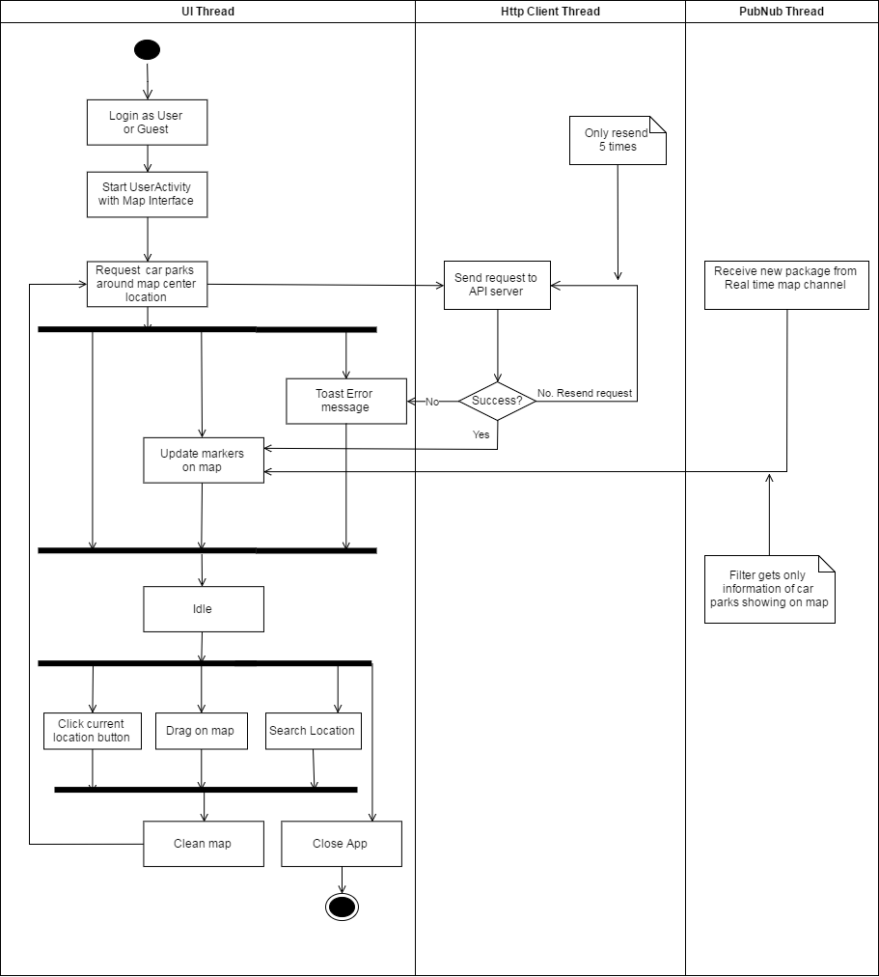

Figure : Interaction diagram - Load car parks on map

##### Load car parks in list

**Summary:** This diagram shows the process of app loads car parks data from API server and display them in list format, and update their available lots in real time.

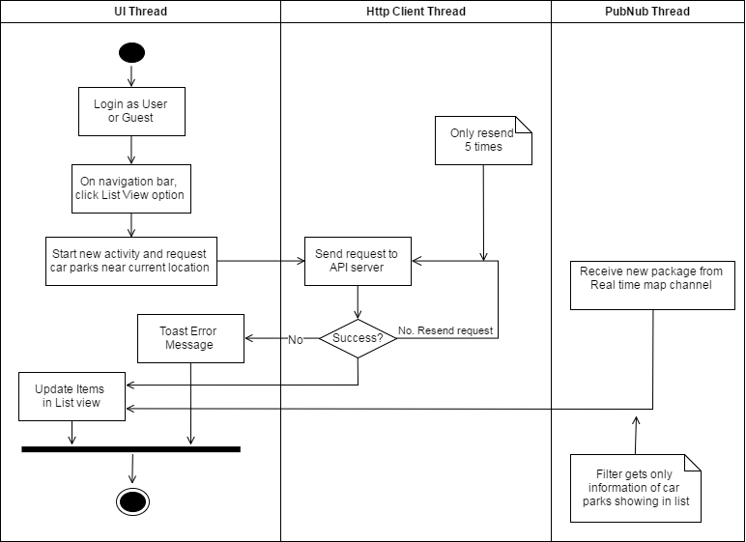

Figure : Interaction diagram - Load car parks in list

##### Car park detail information

**Summary:** This diagram shows the process of app loads car park detail information from API server and display it, update its available lots in real time and other action user can perform on the detail page.

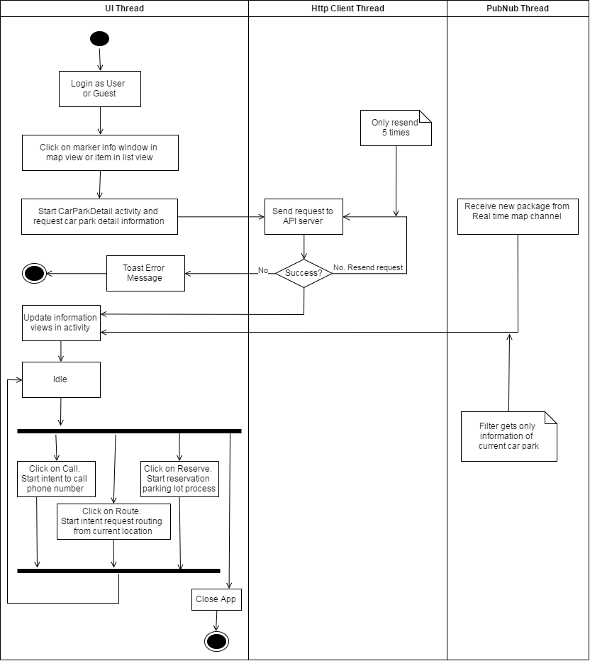

Figure : Interaction diagram - Car park detail information

##### Reserve parking lot process

**Summary:** This diagram shows the process of reserving parking lot, and receive notification about the reservation.

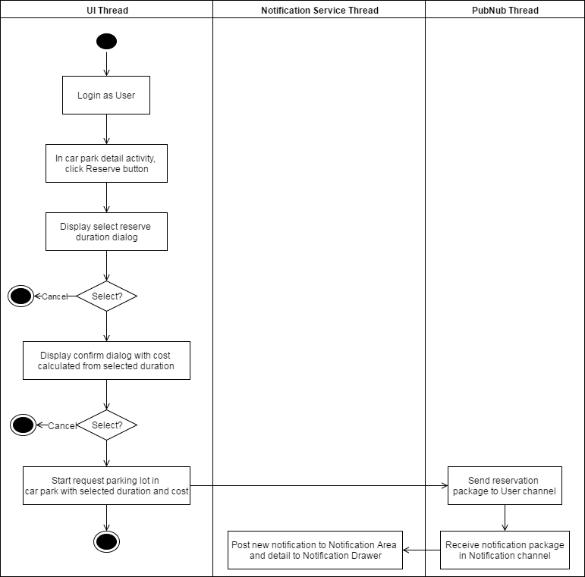

Figure : Interaction diagram - Reserve parking lot process

##### Transaction controller

**Summary:** This diagram shows the process of getting all transactions of user from API server and perform check-in, cancel process.

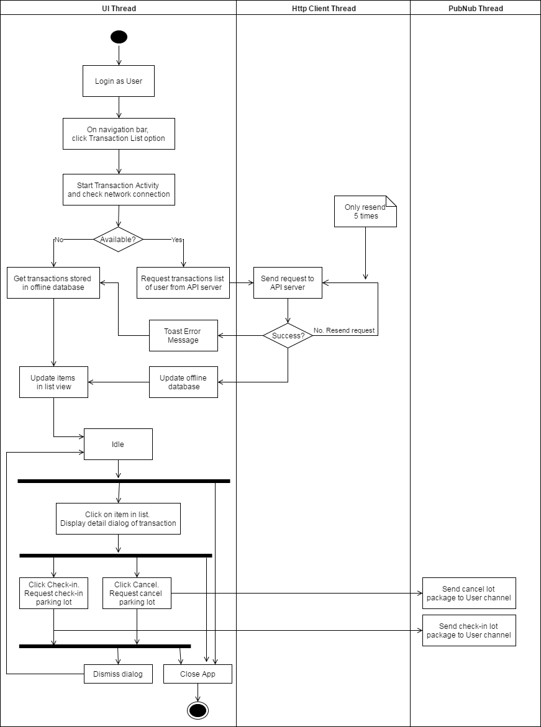

Figure : Interaction diagram - Transaction controller

##### Manage car parks

**Summary:** This diagram shows the process of app loads car parks from API server and display them in list from, update their available lots in real time, manage information and update to server and hub.

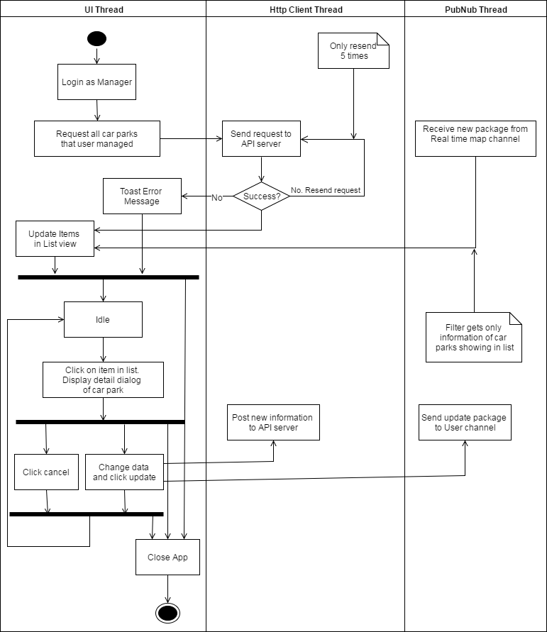

Figure : Interaction diagram - Manage car parks

##### Manage areas

**Summary:** This diagram shows the process of app loads areas from API server and display them in list from, manage information and update to server and hub.

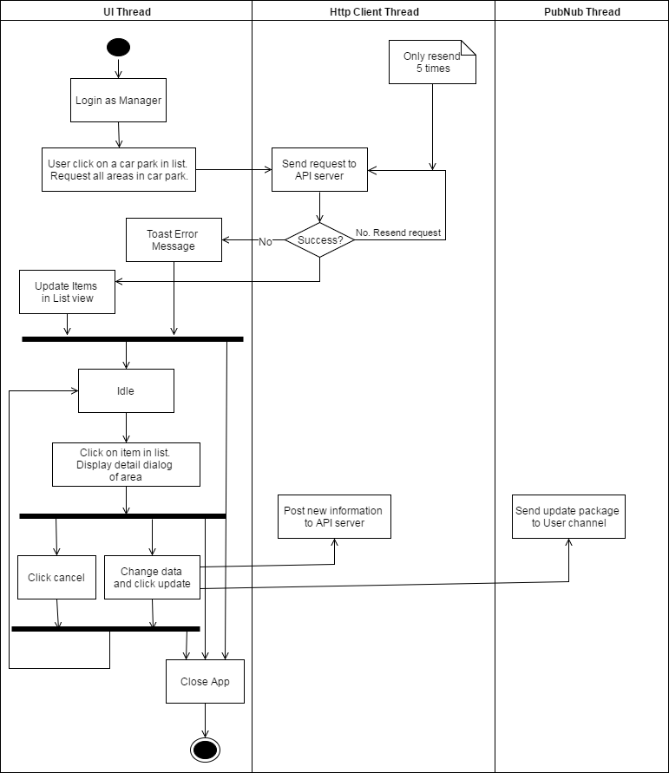

Figure : Interaction diagram - Manage areas

##### Manage parking lots

**Summary:** This diagram shows the process of app loads parking lot from API server and display them in list from, manage information and update to server and hub.

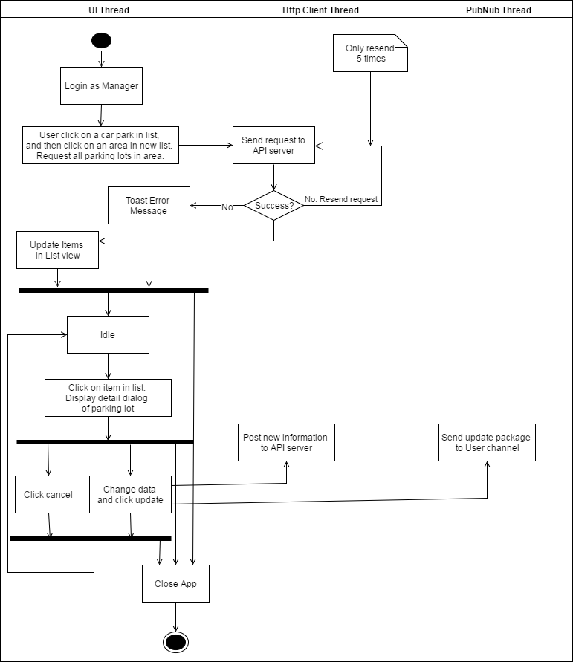

Figure : Interaction diagram - Manage parking lots

##### Check reservation PIN code

**Summary:** This diagram shows the process of how manager of car park can help user check-in their reservation.

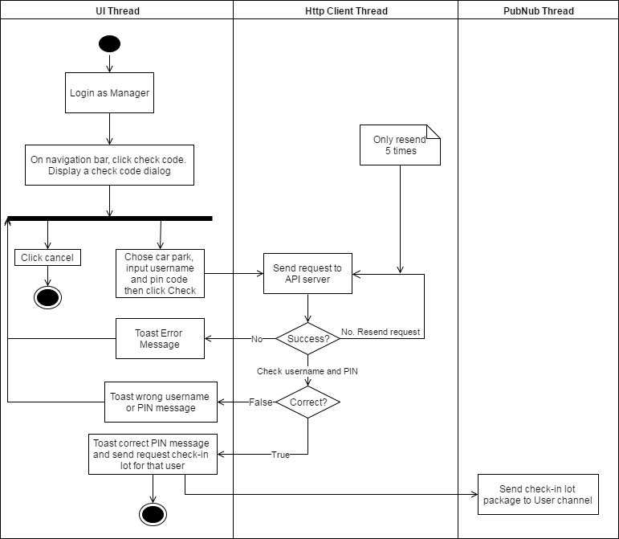

Figure : Interaction diagram - Check reservation PIN code

### Embedded Program Detailed Description

#### Class Diagram

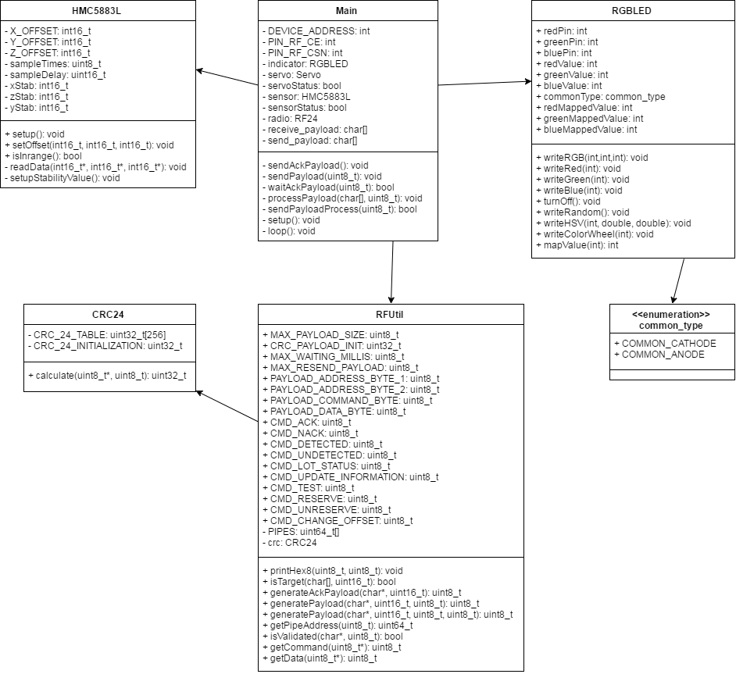

Figure : Lot node class diagram

| **Class Dictionary: describes class** | |
| --- | --- |
| **Class Name** | **Description** |
| Main | Core program of node |
| RFUtil | Contain necessary information and methods support RF module |
| CRC24 | Contain the checksum method for RFUtil |
| HMC5883L | Provides methods to use the magnetometer |
| RGBLED | Provides methods to control LED RGB |
| common_type | Enumeration contains type of LED RGB |

Table : Lot node class dictionary

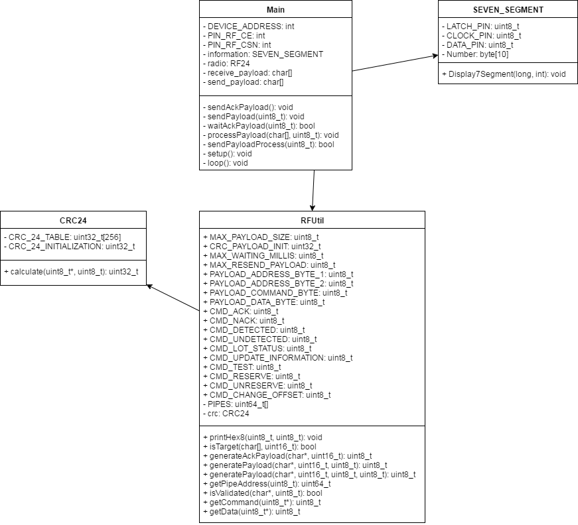

Figure : Sign node class diagram

| **Class Dictionary: describes class** | |
| --- | --- |
| **Class Name** | **Description** |
| Main | Core program of node |
| RFUtil | Contain necessary information and methods support RF module |
| CRC24 | Contain the checksum method for RFUtil |
| SEVEN_SEGMENT | Provide methods to use 7-segments sign |

Table : Sign node class dictionary

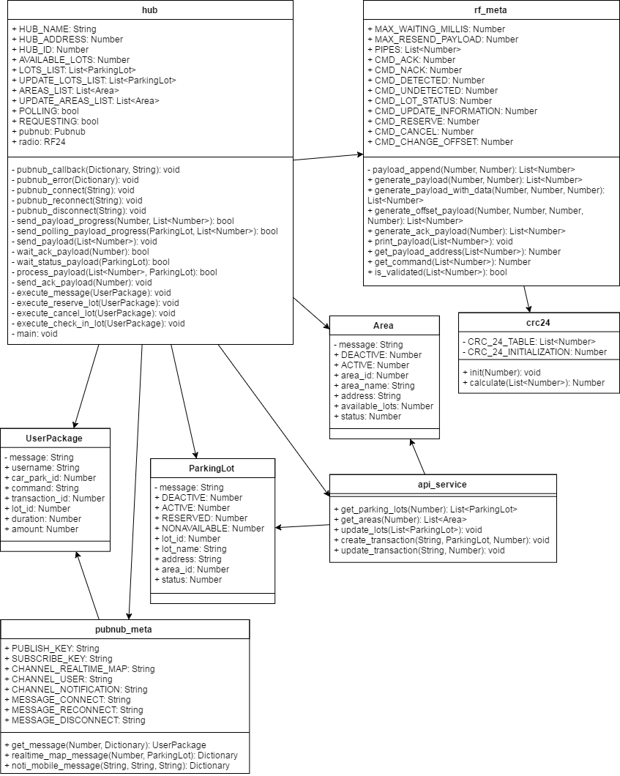

Figure : Hub class diagram

| **Class Dictionary: describes class** | |
| --- | --- |
| **Class Name** | **Description** |
| hub | Main program of Hub |
| rf_meta | Contain information and necessary methods for RF |
| crc24 | Contain the checksum method for rf_meta |
| ParkingLot | Information of parking lot |
| Area | Information of area |
| UserPackage | Information of user message in PubNub |
| api_service | Contain methods for API service |
| pubnub_meta | Contain methods for PubNub service |

Table : Hub class dictionary

#### Class Diagram Explanation

##### [Lot] Main

**Attributes**

|  |  |  |  |
| --- | --- | --- | --- |
| **Attribute** | **Type** | **Visibility** | **Description** |
| DEVICE_ADDRESS | int | private | Address of node |
| PIN_RF_CE | int | private | Pin used for CE pin of RF |
| PIN_RF_CSN | int | private | Pin used for CSN of RF |
| indicator | RGBLED | private | Instance of RGBLED |
| servo | Servo | private | Instance of Servo |
| servoStatus | bool | private | Flag to check if servo is running |
| sensor | HMC5883L | private | Instance of HMC5883L |
| sensorStatus | bool | private | Flag to check if the sensor detect car nearby |
| receive_payload | char[] | private | Received payload from RF |
| send_payload | char[] | private | Payload that will be send using RF |

Table : [Lot] Main attributes

**Methods**

|  |  |  |  |
| --- | --- | --- | --- |
| **Method** | **Return type** | **Visibility** | **Description** |
| sendAckPayload | void | private | Send ACK payload to Hub |
| sendPayload | void | private | Send payload to Hub |
| waiAckPayload | void | private | Wait for ACK payload from Hub |
| processPayload | void | private | Check received payload and perform work depend on the command |
| sendPayloadProcess | bool | private | Perform the process to send payload |
| setup | void | private | Run the setup whenever device start or reset |
| loop | void | private | Repeat until device stop |

Table : [Lot] Main methods

##### [Lot] HMC5883L

**Attributes**

|  |  |  |  |
| --- | --- | --- | --- |
| **Attribute** | **Type** | **Visibility** | **Description** |
| X_OFFSET | int16_t | private | Offset of X axis |
| Y_OFFSET | int16_t | private | Offset of Y axis |
| Z_OFFSET | int16_t | private | Offset of Z axis |
| sampleTimes | uint8_t | private | The number of times to sample to get stabilized axis |
| sampleDelay | uint16_t | private | The delay between sample |
| xStab | int16_t | private | Stabilized value of X axis |
| yStab | int16_t | private | Stabilized value of Y axis |
| zStab | int16_t | private | Stabilized value of Z axis |

Table : [Lot] HMC5883L attributes

**Methods**

|  |  |  |  |
| --- | --- | --- | --- |
| **Method** | **Return type** | **Visibility** | **Description** |
| setup | void | public | Run necessary methods to make the module work |
| setOffset | void | public | Set offset for the module to check if car is in range |
| isInRange | bool | public | Check if car is in range |
| readData | void | private | Get x,y,z axis from the module |
| setupStabilityValue | void | private | Perform sample multiple times to calculate stabilized axis |

Table : [Lot] HMC5883L methods

##### [Lot] RGBLED

**Attributes**

|  |  |  |  |
| --- | --- | --- | --- |
| **Attribute** | **Type** | **Visibility** | **Description** |
| redPin | int | public | LED pin |
| greenPin | int | public | LED pin |
| bluePin | int | public | LED pin |
| redValue | int | public | RGB value |
| greenValue | int | public | RGB value |
| blueValue | int | public | RGB value |
| commonType | common_type | public | LED type |
| redMappedValue | int | public | RGB value mapped based on commonType |
| greenMappedValue | int | public | RGB value mapped based on commonType |
| blueMappedValue | int | public | RGB value mapped based on commonType |

Table : [Lot] RGBLED attributes

**Methods**

|  |  |  |  |
| --- | --- | --- | --- |
| **Method** | **Return type** | **Visibility** | **Description** |
| writeRGB | void | public | Set all pins values |
| writeRed | void | public | Set just the red pin |
| writeGreen | void | public | Set just the green pin |
| writeBlue | void | public | Set just the blue pin |
| turnOff | void | public | Turn all pins off |
| writeRandom | void | public | Show a random color |
| writeHSV | void | public | Writes the LED based on HSV values |
| writeColorWheel | void | public | Show the HSV Color Wheel |
| mapValue | void | public | Map a value based on the common_type |

Table : [Lot] RGBLED methods

##### [Lot] common_type

**Attributes**

|  |  |  |  |
| --- | --- | --- | --- |
| **Attribute** | **Type** | **Visibility** | **Description** |
| COMMON_CATHODE | enum | public | Value of common cathode LED type |
| COMMON_ANODE | enum | public | Value of common anode LED type |

Table : [Lot] common_type attributes

**Methods**

N/A

##### [Sign] Main

**Attributes**

|  |  |  |  |
| --- | --- | --- | --- |
| **Attribute** | **Type** | **Visibility** | **Description** |
| DEVICE_ADDRESS | int | private | Address of node |
| PIN_RF_CE | int | private | Pin used for CE pin of RF |
| PIN_RF_CSN | int | private | Pin used for CSN of RF |
| information | SERVEN_SEGMENT | private | Instance of SEVEN_SEGMENT |
| receive_payload | char[] | private | Received payload from RF |
| send_payload | char[] | private | Payload that will be send using RF |

Table : [Sign] Main attributes

**Methods**

|  |  |  |  |
| --- | --- | --- | --- |
| **Method** | **Return type** | **Visibility** | **Description** |
| sendAckPayload | void | private | Send ACK payload to Hub |
| sendPayload | void | private | Send payload to Hub |
| waiAckPayload | void | private | Wait for ACK payload from Hub |
| processPayload | void | private | Check received payload and perform work depend on the command |
| sendPayloadProcess | bool | private | Perform the process to send payload |
| setup | void | private | Run the setup whenever device start or reset |
| loop | void | private | Repeat until device stop |

Table : [Sign] Main methods

##### [Sign] SEVEN_SEGMENT

**Attributes**

|  |  |  |  |
| --- | --- | --- | --- |
| **Attribute** | **Type** | **Visibility** | **Description** |
| LATCH_PIN | uint8_t | private | Latch pin of 595 |
| CLOCK_PIN | uint8_t | private | Clock pin of 595 |
| DATA_PIN | uint8_t | private | Data pin of 595 |
| Number | byte[10] | private | Binary array for display 7-segments led using 595 |

Table : [Sign] SEVEN_SEGMENT attributes

**Methods**

|  |  |  |  |
| --- | --- | --- | --- |
| **Method** | **Return type** | **Visibility** | **Description** |
| Display7Segment | void | public | Display available lot number to 7-segmens sign |

Table : [Sign] SEVEN_SEGMENT methods

##### [Lot/Sign] RFUtil

**Attributes**

|  |  |  |  |
| --- | --- | --- | --- |
| **Attribute** | **Type** | **Visibility** | **Description** |
| MAX_PAYLOAD_SIZE | uint8_t | public | Max size of payload |
| CRC_PAYLOAD_INIT | uint32_t | public | Initialize value to use with CRC24 |
| MAX_WAITING_MILLIS | uint8_t | public | Max waiting ACK time in millis |
| MAX_RESEND_PAYLOAD | uint8_t | public | Max resend times |
| PAYLOAD_ADDRESS_  BYTE_1 | uint8_t | public | Position of 1st address byte |
| PAYLOAD_ADDRESS_  BYTE_2 | uint8_t | public | Position of 2nd address byte |
| PAYLOAD_COMMAND_  BYTE | uint8_t | public | Position of command byte |
| PAYLOAD_DATA_BYTE | uint8_t | public | Position of data byte |
| CMD_ACK | uint8_t | public | ACK command byte |
| CMD_NACK | uint8_t | public | NACK command byte |
| CMD_DETECTED | uint8_t | public | Detected command byte |
| CMD_UNDETECTED | uint8_t | public | Undetected command byte |
| CMD_LOT_STATUS | uint8_t | public | Lot status command byte |
| CMD_UPDATE  _INFORMATION | uint8_t | public | Update information command byte |
| CMD_TEST | uint8_t | public | Test command byte |
| CMD_RESERVE | uint8_t | public | Reserve command byte |
| CMD_UNRESERVE | uint8_t | public | Unreserve command byte |
| CMD_CHANGE_OFFSET | uint8_t | public | Change offset command byte |
| PIPES | uint64_t[] | private | List of pipes address |
| crc | CRC24 | private | Instance of CRC24 |

Table : [Lot/Sign] RFUtil attributes

**Methods**

|  |  |  |  |
| --- | --- | --- | --- |
| **Method** | **Return type** | **Visibility** | **Description** |
| printHex8 | void | public | Print payload as hex format |
| isTarget | bool | public | Check if the target of payload is current device |
| generateAckPayload | uint8_t | public | Create ACK payload. Return payload size |
| generatePayload | uint8_t | public | Create payload. Return payload size |
| getPipeAddress | uint64_t | public | Return pipe address from position |
| isValidated | bool | public | Check if payload satisfy CRC |
| getCommand | uint8_t | public | Return command byte from payload |
| getData | uint8_t | public | Return data byte from payload |

Table : [Lot/Sign] RFUtil methods

##### [Lot/Sign] CRC24

**Attributes**

|  |  |  |  |
| --- | --- | --- | --- |
| **Attribute** | **Type** | **Visibility** | **Description** |
| CRC_24_TABLE | uint32_t[256] | private | Table of CRC24 defined value |
| CRC_24  _INITIALIZATION | uint32_t | private | Initialization value for crc calculate |

Table :: [Lot/Sign] CRC24 attributes

**Methods**

|  |  |  |  |
| --- | --- | --- | --- |
| **Method** | **Return type** | **Visibility** | **Description** |
| calculate | uint32_t | public | Return the calculated checksum |

Table : [Lot/Sign] CRC24 methods

##### [Hub] hub

**Attributes**

|  |  |  |  |
| --- | --- | --- | --- |
| **Attribute** | **Type** | **Visibility** | **Description** |
| HUB_NAME | String | public | Name of car park |
| HUB_ADDRESS | Number | public | 2 bytes address of hub |
| HUB_ID | Number | public | Id of car park |
| AVAILABLE_LOTS | Number | public | Current available lots in car park |
| LOTS_LIST | List<ParkingLot> | public | List of parking lots |
| UPDATE_  LOTS_LIST | List<ParkingLot> | public | List of lots need to update |
| AREAS_LIST | List<Area> | public | List of areas |
| UPDATE_  AREAS_LISST | List<Area> | public | List of areas need to update |
| POLLING | bool | public | Flag to check if the main progress is polling |
| REQUESTING | bool | public | Flag to check if there is a need to change main progress to execute message |
| pubnub | Pubnub | public | Instance of Pubnub |
| radio | RF24 | public | Insantce of RF24 |

Table : [Hub] hub attributes

**Methods**

|  |  |  |  |
| --- | --- | --- | --- |
| **Method** | **Return type** | **Visibility** | **Description** |
| pubnub_callback | void | private | Callback when a pubnub message is received |
| pubnub_error | void | private | Callback when there is a error in sending pubnub message |
| pubnub_connect | void | private | Callback when successfully connect to pubnub channel |
| pubnub_reconnect | void | private | Callback when need to reconnect channel |
| pubnub_disconnect | void | private | Callback when the connection with pubnub channel is cut |
| send_payload_progress | bool | private | Progress to send payload |
| send_polling_  payload_progress | bool | private | Progress to send polling payload |
| send_payload | void | private | Send payload using RF module |
| wait_ack_payload | bool | private | Wait for ack payload from target |
| wait_status_payload | bool | private | Wait for update status from lot |
| process_payload | bool | private | Check and process received payload |
| send_ack_payload | void | private | Send ACK payload to target |
| execute_message | void | private | Check and execute received pubnub message |
| execute_reserve_lot | void | private | Process to perform reserve lot action |
| execute_cancel_lot | void | private | Process to perform cancel lot action |
| execute_check_in_lot | void | private | Process to perform check in lot action |
| main | void | private | Perform program of main thread |

Table : [Hub] hub methods

##### [Hub] rf_meta

**Attributes**

|  |  |  |  |
| --- | --- | --- | --- |
| **Attribute** | **Type** | **Visibility** | **Description** |
| MAX_WAITING  _MILLIS | Number | public | Max wait times for ACK |
| MAX_RESEND_  PAYLOAD | Number | public | Max times to resend payload |
| PIPES | List<Number> | public | List of pipes address for RF |
| CMD_ACK | Number | public | Byte of ACK command |
| CMD_NACK | Number | public | Byte of NACK command |
| CMD_DETECTED | Number | public | Byte of detected command |
| CMD_UNDETECTED | Number | public | Byte of undetected command |
| CMD_LOT_STATUS | Number | public | Byte of lot status command |
| CMD_UPDATE_  INFORMATION | Number | public | Byte of update information command |
| CMD_RESERVE | Number | public | Byte of reserve command |
| CMD_CANCEL | Number | public | Byte of cancel command |
| CMD_CHANGE_  OFFSET | Number | public | Byte of change offset command |

Table : [Hub] rf_meta attributes

**Methods**

|  |  |  |  |
| --- | --- | --- | --- |
| **Method** | **Return type** | **Visibility** | **Description** |
| payload_append | List<Number> | private | Add byte to payload |
| generate_payload | List<Number> | public | Create payload with target address and command |
| generate_payload_  with_data | List<Number> | public | Create payload with target address, command and data byte |
| generate_offset_  payload | List<Number> | public | Create special payload to update offset |
| generate_ack_  payload | List<Number> | public | Create ACK payload |
| print_payload | void | public | Print payload in hex form |
| get_payload_address | Number | public | Get address from payload |
| get_command | Number | public | Get command from payload |
| is_validated | bool | public | Check checksum of payload |

Table : [Hub] rf_meta methods

##### [Hub] crc24

**Attributes**

|  |  |  |  |
| --- | --- | --- | --- |
| **Attribute** | **Type** | **Visibility** | **Description** |
| CRC_24_TABLE | List<Number> | private | Table of CRC24 defined value |
| CRC_24  _INITIALIZATION | Number | private | Initialization value for crc calculate |

Table : [Hub] crc24 attributes

**Methods**

|  |  |  |  |
| --- | --- | --- | --- |
| **Method** | **Return type** | **Visibility** | **Description** |
| init | void | public | Set crc24 initialization to another value |
| calculate | Number | public | Return the calculated checksum |

Table : [Hub] crc24 methods

##### [Hub] api_service

**Attributes**

N/A

**Methods**

|  |  |  |  |
| --- | --- | --- | --- |
| **Method** | **Return type** | **Visibility** | **Description** |
| get_parking_lots | List<ParkingLot> | public | Get all active lots of car park from API server |
| get_areas | List<Area> | public | Get all active areas of car park from API server |
| update_lots | void | public | Update lot information using API |
| create_transaction | void | public | Create new transaction using API |
| update_transaction | void | public | Update transaction status using API |

Table : [Hub] api_service methods

##### [Hub] pubnub_meta

**Attributes**

|  |  |  |  |
| --- | --- | --- | --- |
| **Attribute** | **Type** | **Visibility** | **Description** |
| PUBLISH_KEY | String | public | Publish key for pubnub |
| SUBSCRIBE_KEY | String | public | Subscribe key for pubnub |
| CHANNEL  _REALTIME_MAP | String | public | Key name of realtime map channel |
| CHANNEL_USER | String | public | Key name of user channel |
| CHANNEL  _NOTIFICATION | String | public | Key name of notification channel |
| MESSAGE _CONNECT | String | public | Value of connect message |
| MESSAGE  _RECONNECT | String | public | Value of reconnect message |
| MESSAGE  _DISCONNECT | String | public | Value of disconnect message |

Table : [Hub] pubnub_meta attributes

**Methods**

|  |  |  |  |
| --- | --- | --- | --- |
| **Method** | **Return type** | **Visibility** | **Description** |
| get_message | UserPackage | public | Return user package from json |
| realtime_map  _message | Dictionary | public | Create a json for realtime map channel |
| noti_mobile  _message | Dictionary | public | Create a json for notification channel |

Table : [Hub] pubnub_meta methods

##### [Hub] Area

**Attributes**

|  |  |  |  |
| --- | --- | --- | --- |
| **Attribute** | **Type** | **Visibility** | **Description** |
| message | String | private | Format to string of object |
| DEACTIVE | Number | public | Value of deactive status |
| ACTIVE | Number | public | Value of active status |
| area_id | Number | public | Unique Id of area |
| area_name | String | public | Name of area |
| address | Number | public | Byte address of sign node |
| availables_lots | Number | public | Current available lots in area |
| status | Number | public | Status of area |

Table : [Hub] Area attributes

**Methods**

N/A

##### [Hub] ParkingLot

**Attributes**

|  |  |  |  |
| --- | --- | --- | --- |
| **Attribute** | **Type** | **Visibility** | **Description** |
| message | String | private | Format to string of object |
| DEACTIVE | Number | public | Value of deactive status |
| ACTIVE | Number | public | Value of active status |
| RESERVED | Number | public | Value of reserved status |
| NONAVAILABLE | Number | public | Value of non-available status |
| lot_id | Number | public | Unique id of parking lot |
| lot_name | String | public | Name of parking lot |
| address | Number | public | Byte address of lot node |
| area_id | Number | public | Unique Id of area contains lot |
| status | Number | public | Status of lot |

Table : [Hub] ParkingLot attributes

**Methods**

N/A

##### [Hub] UserPackage

**Attributes**

|  |  |  |  |
| --- | --- | --- | --- |
| **Attribute** | **Type** | **Visibility** | **Description** |
| message | String | private | Format to string of object |
| username | String | public | Username send the request |
| car_park_id | Number | public | Id of car park |
| command | String | public | Command of package |
| transaction_id | Number | public | Transaction Id if command is cancel or check in transaction |
| lot_id | Number | public | Lot node id if command is cancel or check in |
| duration | Number | public | Duration of the reservation if command is reserve |
| amount | Number | public | Cost of the reservation if command is reserve |

Table : [Hub] UserPackage attributes

**Methods**

N/A

#### Interaction Diagram

##### Lot node process

**Summary:** This diagram shows the process of the MCU in lot node detects car, transmits and receives data from RF network and controls other actuator.

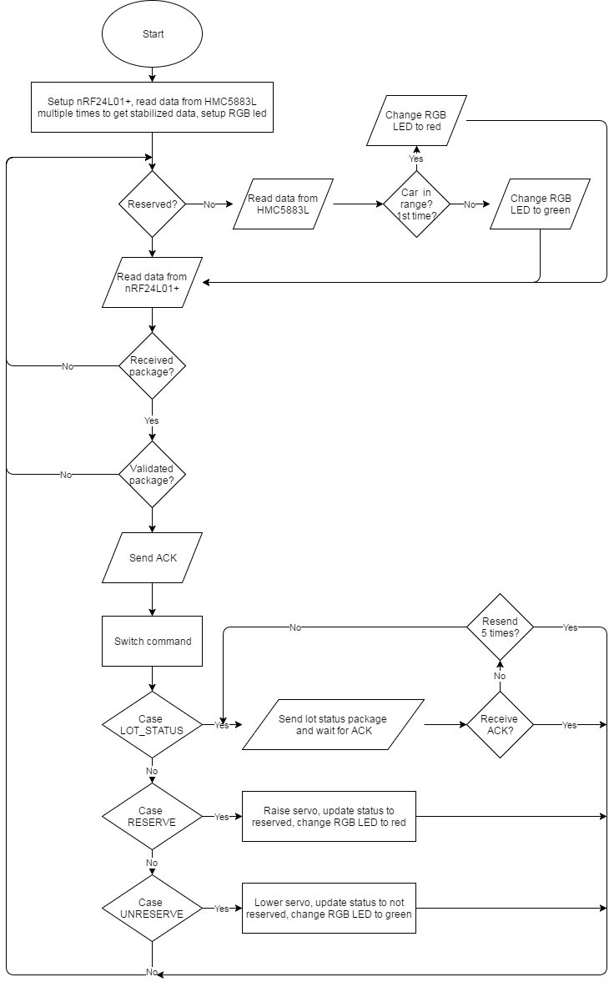

Figure : Interaction diagram - Lot node process

##### Sign node process

**Summary:** This diagram shows the process of the MCU in sign node transmits and receives data from RF network and controls led board.

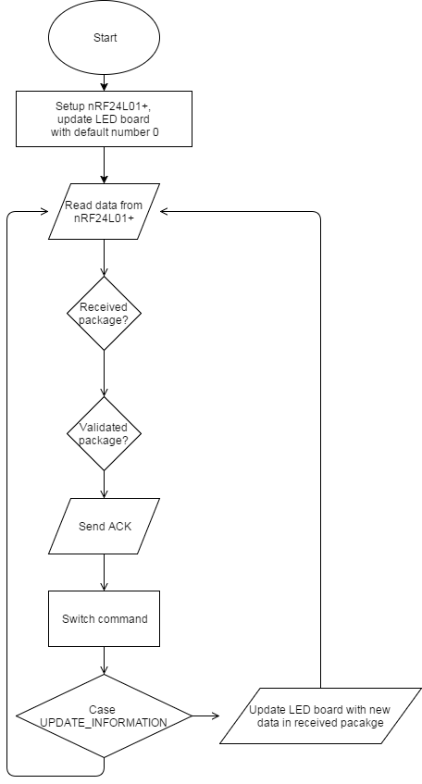

Figure : Interaction diagram - Sign node

##### Hub polling process

**Summary:** This diagram shows the process of the hub performs polling to get new data from lot nodes, update sign nodes if necessary, send updated information to API server and PubNub server

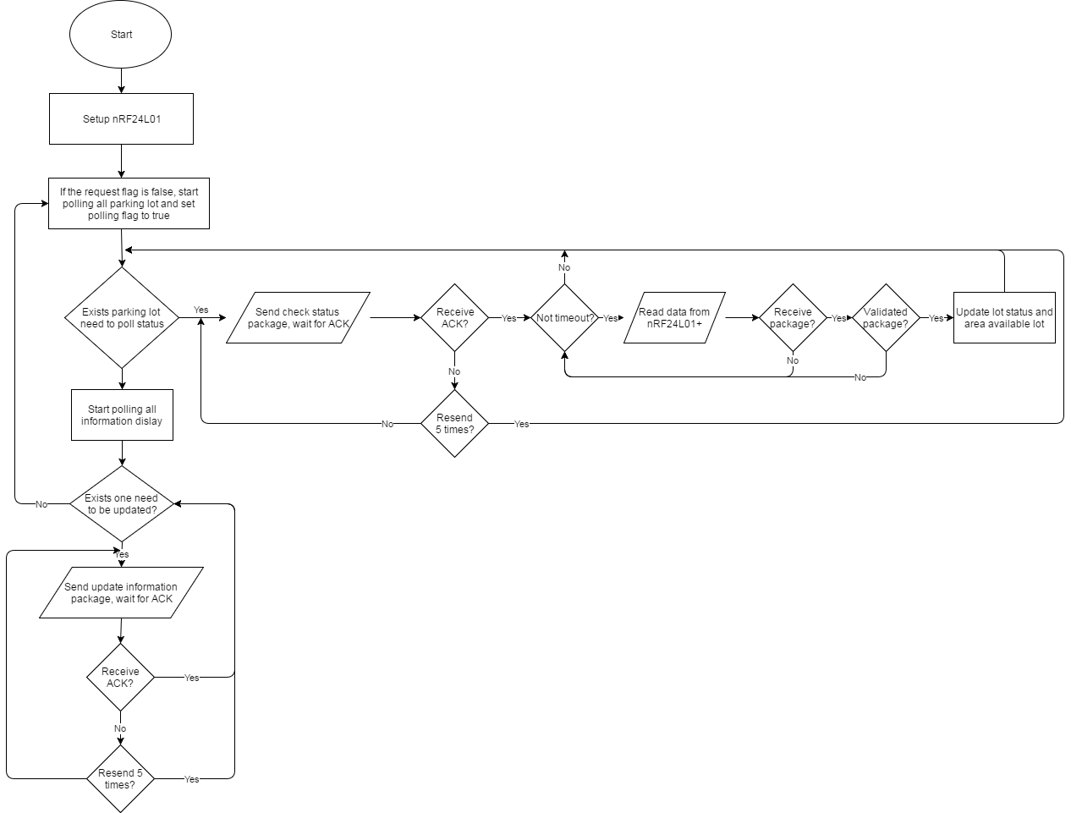

Figure : Interaction diagram - Hub polling process

##### Hub execute request process

**Summary:** This diagram shows the process of the hub receives requests from PubNub server and execute them.

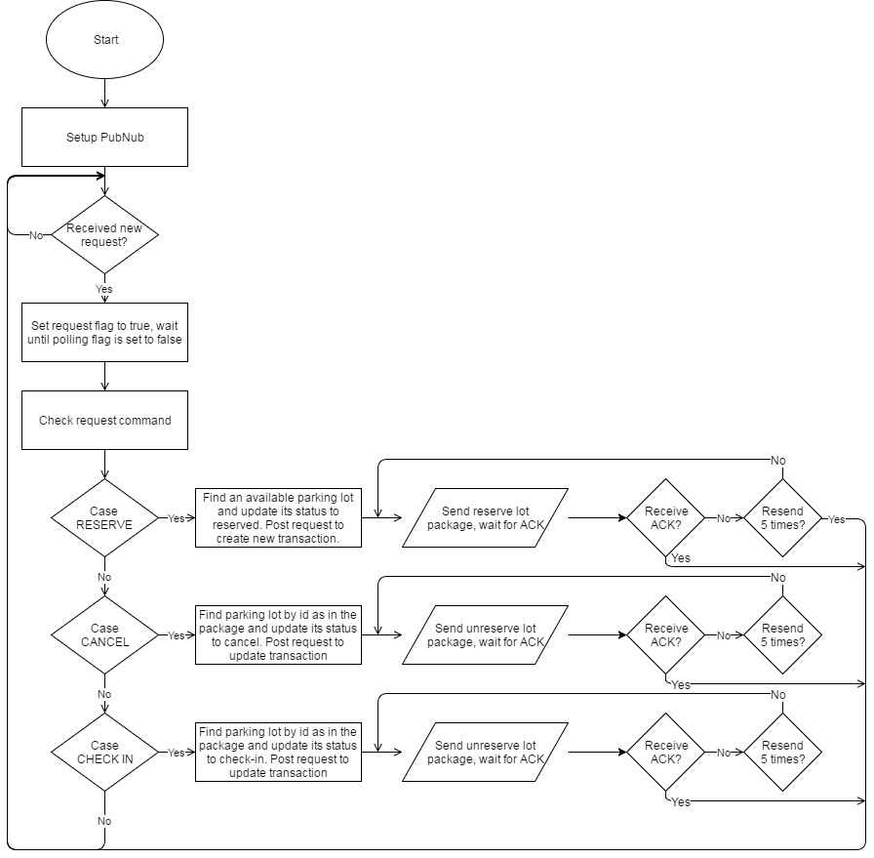

Figure : Interaction diagram - Hub request process

### Hardware Detailed Description

#### Raspberry Pi 3 model B

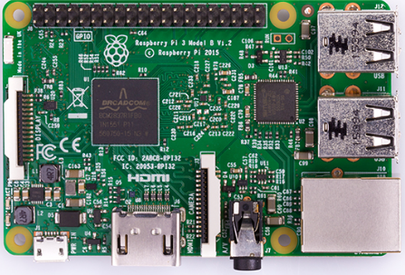

Figure : Raspberry Pi 3 model B

The Raspberry Pi 3 is the third generation Raspberry Pi. It replaced the Raspberry Pi 2 Model B in February 2016.

The Raspberry Pi 3 is a low cost, credit-card size computer that includes 802.11n Wi-Fi and Bluetooth 4.1. Even though it requires lots of additional hardware to function as a full PC with limited operating system selection, with the introduction of wireless connectivity and a boost in performance over its previous iteration, make the Raspberry Pi 3 Model B appropriate for a wider variety of projects – and it still costs just $35.

**PROS:**

* Great value
* Significant performance increase
* Great free online learning resources
* Built-in wireless connections

**CONS:**

* No Android support yet

**SPECS:**

* Quad-core 1.2GHz Broadcom BCM2837RIFBG SoC
* 400MHz VideoCore IV graphics
* 1GB RAM
* Single-band 802.11n Wi-Fi
* Bluetooth 4.1
* 4 x USB 2
* 40 x GPIO pins
* 10/100 Ethernet
* MicroSD slot
* 86 x 56 x 21mm (WDH)
* 45g

**PINOUT:**

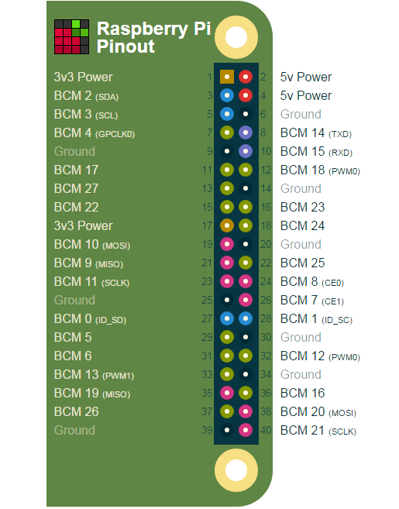

Figure : Raspberry Pi 3 Model B pinount

#### Arduino Nano

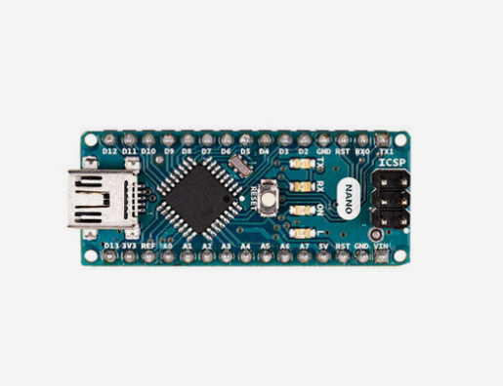

Figure : Arduino Nano

Arduino Nano is a surface mount breadboard embedded version with integrated USB. It is a small, complete, and breadboard-friendly board based on ATmega328 (Arduino Nano 3.x).

**SPECS:**

|  |  |
| --- | --- |
| Microcontroller | Atmel ATmega328 |
| Operating Voltage (logic level) | 5V |
| Input Voltage (recommended) | 7-12V |
| Input Voltage (limits) | 6-20V |
| Digital I/O Pins | 14 (of which 6 provide PWM output) |
| Analog Input Pins | 8 |
| DC Current per I/O Pin | 40mA |
| Flash Memory | 32KB (of which 2 KB used by bootloader) |
| SRAM | 2KB |
| EEPROM | 1KB |
| Clock Speed | 16MHz |
| Dimensions | 0.70” x 1.70” |

Figure : Arduino Nano specifications

**FEATURES:**

* Automatic reset during program download
* Power OK blue LED
* Green (TX), red (RX) and orange (L) LED
* Auto sensing/switching power input
* Small mini-B USB for programming and serial monitor
* ICSP header for direct programming and serial monitor
* Standard 0.1” spacing DIP (breadboard friendly)
* Manual reset switch

**POWER**:

The Arduino Nano can be powered via the mini-B USB connection, 6-20V unregulated external power supply (pin 30), or 5V regulated external power supply (pin 27). The power source is automatically selected to the highest voltage source.

**PINOUT:**

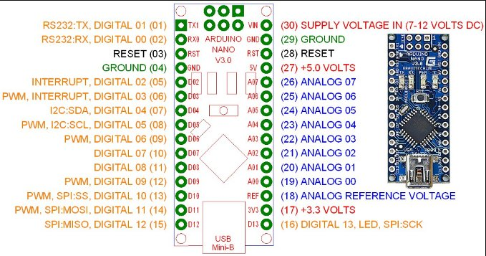

Figure : Arduino Nano pinout

#### Compass module 3-Axis HMC5883L

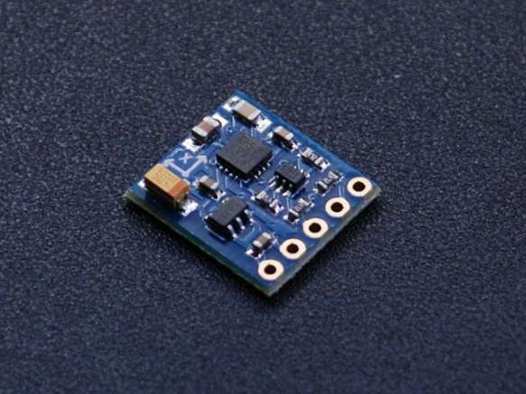

Figure : 3-Axis HMC5883L

The Honeywell HMC5883L is a surface-mount, multi-chip module designed for low-field magnetic sensing with a digital interface for applications such as low cost compassing and magnetometry.

**FEATURES:**

* 3-Axis magnetoresistive sensors and ASIC in a 3.0 x 3.0 x 0.9mm LCC surface mount package.
* 12-Bit ADC coupled with low noise AMR sensors achieves 2 milli-gauss field resolution in ±8 Gauss Fields.
* Built-in self-test.
* Low voltage operations (2.16 to 3.6V) and low power consumption (100μA).
* Built-in strap drive circuits.
* I2C digital interface.
* Lead free package construction.
* Fast 160Hz maximum output rate.

**PINOUT:**

* **VIN:** this is the power in pin, give it 3-5VDC. It is reverse-polarity protected. Use the same voltage as you do for the controlling microcontroller's logic.
* **GND:** this is the common power and data ground pin.
* **SDA** and **SCL:** these are the I2C data and clock pins used to send and receive data from the module to your microcontroller. There are 10K pull-ups on these pins to the VIN pin. You can connect these pins to 5V I2C lines, there are level shifters on board to safely bring the pins down to 3V.
* **RDY:** this is the 'data ready' pin output. If you want to stream data at high speed (higher than 100 times a second) you may want to listen to this pin for when data is ready to be read.

**ANISOTROPIC MAGNETO-RESISTIVE SENSORS**

The Honeywell HMC5883L magneto-resistive sensor circuit is a trio of sensors and application specific support circuits to measure magnetic fields. With power supply applied, the sensor converts any incident magnetic field in the sensitive axis directions to a differential voltage output. The magneto-resistive sensors are made of a nickel-iron (permalloy) thin-film and patterned as a resistive strip element. In the presence of a magnetic field, a change in the bridge resistive elements causes a corresponding change in voltage across the bridge outputs.

These resistive elements are aligned together to have a common sensitive axis (indicated by arrows in the pinout diagram) that will provide positive voltage change with magnetic fields increasing in the sensitive direction. Because the output is only proportional to the magnetic field component along its axis, additional sensor bridges are placed at orthogonal directions to permit accurate measurement of magnetic field in any orientation.

**MODES OF OPERATION**

* **Continuous-Measurement Mode:** the device continuously makes measurements, at user selectable rate, and places measured data in data output registers.
* **Single-Measurement Mode:** this is the default power-up mode. During single-measurement mode, the device makes a single measurement and places the measured data in data output registers. After the measurement is complete and output data registers are updated, the device is placed in idle mode.
* **Idle Mode:** during this mode the device is accessible through the I2C bus, but major sources of power consumption are disabled, such as, but not limited to, the ADC, the amplifier, and the sensor bias current. All registers maintain values while in idle mode. The I2C bus is enabled for use by other devices on the network while in idle mode.

**REGISTER LIST**

|  |  |  |
| --- | --- | --- |
| **Address Location** | **Name** | **Access** |
| 00 | Configuration Register A | Read/Write |
| 01 | Configuration Register B | Read/Write |
| 02 | Mode Register | Read/Write |
| 03 | Data Output X MSB Register | Read |
| 04 | Data Output X LSB Register | Read |
| 05 | Data Output Z MSB Register | Read |
| 06 | Data Output Z LSB Register | Read |
| 07 | Data Output Y MSB Register | Read |
| 08 | Data Output Y LSB Register | Read |
| 09 | Status Register | Read |
| 10 | Identification Register A | Read |
| 11 | Identification Register B | Read |
| 12 | Identification Register C | Read |

Table : HMC55883L Register list

#### RF module nRF24L01+

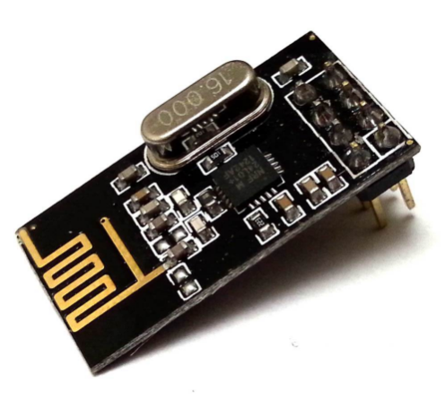

Figure : RF module nRF24L01+

The nRF24L01+ is a single chip 2.4GHz transceiver with an embedded baseband protocol engine (Enhanced ShockBurst™), suitable for ultra-low power wireless applications. The nRF24L01+ is designed for operation in the world wide ISM frequency band at 2.400 - 2.4835GHz.

**FEATURES:**

* Worldwide 2.4GHz ISM band operation
* 250kbps, 1Mbps and 2Mbps on air data rates
* Ultra low power operation
* 11.3mA TX at 0dBm output power
* 13.5mA RX at 2Mbps air data rate
* 900nA in power down
* 26µA in standby-I
* On chip voltage regulator
* 1.9 to 3.6V supply range
* Enhanced ShockBurst™
* Automatic packet handling
* Auto packet transaction handling
* 6 data pipe MultiCeiver™
* Drop-in compatibility with nRF24L01
* On-air compatible in 250kbps and 1Mbps with nRF2401A, nRF2402, nRF24E1 and nRF24E2
* Low cost BOM
* ±60ppm 16MHz crystal
* 5V tolerant inputs
* Compact 20-pin 4x4mm QFN package

**PINOUT:**

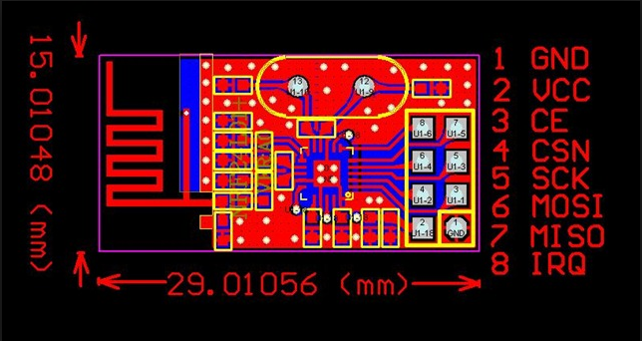

Figure : nRF24L01+ pinout

|  |  |  |  |
| --- | --- | --- | --- |
| **Pin** | **Name** | **Pin function** | **Description** |
| 1 | GND | Power | Ground (0V) |
| 2 | VCC | Power | Power Supply (+1.9V - +3.6V DC) |
| 3 | CE | Digital Input | Chip Enable Actives RX or TX mode |
| 4 | CSN | Digital Input | SPI Chip Select |
| 5 | SCK | Digital Input | SPI Clock |
| 6 | MOSI | Digital Input | SPI Slave Data Input |
| 7 | MISO | Digital Output | SPI Slave Data Output, with tri-state option |
| 8 | IRQ | Digital Output | Maskable interrupt pin. Active low. |

Table : nRF24L01+ pinout

**MODES OF OPERATION**

* **Power down mode:** In power down mode nRF24L01+ is disabled using minimal current consumption. All register values available are maintained and the SPI is kept active, enabling change of configuration and the uploading/downloading of data registers.
* **Standby-I mode:** By setting the PWR_UP bit in the CONFIG register to 1, the device enters standby-I mode. Standby-I mode is used to minimize average current consumption while maintaining short start up times. In this mode only part of the crystal oscillator is active. Change to active modes only happens if CE is set high and when CE is set low, the nRF24L01 returns to standby-I mode from both the TX and RX modes.
* **Standby-II mode:** In standby-II mode extra clock buffers are active and more current is used compared to standby-I mode. nRF24L01+ enters standby-II mode if CE is held high on a PTX device with an empty TX FIFO. If a new packet is uploaded to the TX FIFO, the PLL immediately starts and the packet is transmitted after the normal PLL settling delay (130µs).
* **RX mode:** The RX mode is an active mode where the nRF24L01+ radio is used as a receiver. To enter this mode, the nRF24L01+ must have the PWR_UP bit, PRIM_RX bit and the CE pin set high. In RX mode the receiver demodulates the signals from the RF channel, constantly presenting the demodulated data to the baseband protocol engine. The baseband protocol engine constantly searches for a valid packet. If a valid packet is found (by a matching address and a valid CRC) the payload of the packet is presented in a vacant slot in the RX FIFOs. If the RX FIFOs are full, the received packet is discarded.
* **TX mode:** The TX mode is an active mode for transmitting packets. To enter this mode, the nRF24L01+ must have the PWR_UP bit set high, PRIM_RX bit set low, a payload in the TX FIFO and a high pulse on the CE for more than 10µs. The nRF24L01+ stays in TX mode until it finishes transmitting a packet.

**PACKET FORMAT:**



Figure : nRF24L01+ packet format

* **Preamble:** The preamble is a bit sequence used to synchronize the receiver’s demodulator to the incoming bit stream. The preamble is one byte long and is either 01010101 or 10101010. If the first bit in the address is 1 the preamble is automatically set to 10101010 and if the first bit is 0 the preamble is automatically set to 01010101. This is done to ensure there are enough transitions in the preamble to stabilize the receiver.
* **Address:** This is the address for the receiver. An address ensures that the packet is detected and received by the correct receiver, preventing accidental cross talk between multiple nRF24L01+ systems.
* **Packet Control Field:** The packet control field contains a 6 bit **payload length** field, a 2 bit **PID** (Packet Identity) field and a 1 bit **NO_ACK flag**. **Payload length** specifies the length of the payload in bytes. **PID** is used to detect if the received packet is new or retransmitted. **NO_ACK flag** is only used when the auto acknowledgement feature is used.
* **Payload:** The payload is the user defined content of the packet. It can be 0 to 32 bytes wide and is transmitted on-air when it is uploaded to nRF24L01+.
* **CRC:** The CRC is the mandatory error detection mechanism in the packet. It is either 1 or 2 bytes and is calculated over the address, Packet Control Field and Payload.

**SPI COMMANDS**

|  |  |  |  |
| --- | --- | --- | --- |
| **Command name** | **Command** | **# Data bytes** | **Operation** |
| R_REGISTER | 000A AAAA | 1 to 5 LSByte first | Read command and status registers. AAAAA = 5 bit Register Map Address |
| W_REGISTER | 001A AAAA | 1 to 5 LSByte first | Write command and status registers. AAAAA = 5 bit Register Map Address Executable in power down or standby modes only. |
| R_RX_PAYLOAD | 0110 0001 | 1 to 32 LSByte first | Read RX-payload: 1 – 32 bytes. A read operation always starts at byte 0. Payload is deleted from FIFO after it is read. Used in RX mode. |
| W_TX_PAYLOAD | 1010 0000 | 1 to 32 LSByte first | Write TX-payload: 1 – 32 bytes. A write operation always starts at byte 0 used in TX payload. |
| FLUSH_TX | 1110 0001 | 0 | Flush TX FIFO, used in TX mode |
| FLUSH_RX | 1110 0010 | 0 | Flush RX FIFO, used in RX mode Should not be executed during transmission of acknowledge, that is, acknowledge package will not be completed. |
| REUSE_TX_PL | 1110 0011 | 0 | Used for a PTX device  Reuse last transmitted payload. TX payload reuse is active until W_TX_PAYLOAD or FLUSH TX is executed. TX payload reuse must not be activated or deactivated during package transmission. |
| R_RX_PL_WIDa | 0110 0000 | 1 | Read RX payload width for the top R_RX_PAYLOAD in the RX FIFO. |
| W_ACK_PAYLOADa | 1010 1PPP | 1 to 32 LSByte first | Used in RX mode. Write Payload to be transmitted together with ACK packet on PIPE PPP. (PPP valid in the range from 000 to 101). Maximum three ACK packet payloads can be pending. Payloads with same PPP are handled using first in - first out principle. Write payload: 1– 32 bytes. A write operation always starts at byte 0. |
| W_TX_PAYLOAD_NO ACKa | 1011 0000 | 1 to 32 LSByte first | Used in TX mode. Disables AUTOACK on this specific packet. |
| NOP | 1111 1111 | 0 | No Operation. Might be used to read the STATUS register |

Table : nRF24L01+ SPI commands

#### Lot node

##### RGB LED common anode



Figure : RGB LED common anode

RGB LED allows you to change the lights to any color to show state of parking slot.

**SPECS:**

* Forward Voltage (RGB): (2.0, 3.2, 3.2)V
* Max Forward Current (RGB): (20, 20, 20)mA
* Max Luminosity (RGB): (2800, 6500, 1200)mcd

**PINOUT:**



Figure : RGB LED common anode pinout

##### Transistor TIP122



Figure : Transistor TIP122

A single digital pin on Arduino Nano do not provide enough current to power RGB LED, A solution for this situation is to use an NPN Darlington Transistor designed for medium power linear switching applications, so we use TIP122 Transistor to provide RGB LED with power from an external source. It can power devices up to 100VDC at 5 Amps.

**SPECS:**

* TIP122 is power transistors
* Collector Current: 5 ampere
* Collector-Emitter Volt: 100 volts
* Power Dissipation: 65 watts

**PINOUT:**



Figure : Transistor TIP122 pinout

##### Servo motor SG90



Figure : Servo motor SG90

PGSS use Servo Motor SG90 to control barrier at each parking slot.

**SPECS:**

|  |  |
| --- | --- |
| **Torque** | 1.80 kg-cm at 4.8V |
| **Speed** | 0.1sec/60° at 4.8V |
| **Voltage** | 4.0V to 7.2V, 4.6V - 5.2V nominal |
| **Dimensions** | 23mm x 12.2mm x 29mm |
| **Rotation range** | 180o |
| **Weight** | 9g |
| **Pulse width** | 500-2400uS |
| **Operating Temperature range** | 30°C to 60°C |

Table : Servo motor SG90 specifications

**PINOUT:**

|  |  |  |
| --- | --- | --- |
| **Pin of Servo SG90** | **Name** | **Description** |
| Red | VCC | Power supply 5V |
| Black | GND | Power supply ground |
| Yellow | Signal | The servo will move based on the signal sent to signal wire. |

Table : Servo motor SG90 pinout

#### Sign node

##### 7-Segment LED display

##### Power logic 8-bit shift register TPIC6B595



Figure : Power logic 8-bit shift register TPIC6B595

To display high power 7-segment display, we choose IC TPIC6B595 instead of IC 74HC595 because TPIC6B595 is asimple shift register IC that can control high-voltage/high-current devices directly**.** Each output pin can sink 150mA and then supports the maximum of Load Voltage at 50V.

**PINOUT:**



Figure : Power logic 8-bit shift register TPIC6B595 pinout

|  |  |  |  |
| --- | --- | --- | --- |
| **Pin** | | **I/O** | **Description** |
| **Name** | **No.** | O | Open-drain output |
| DRAIN0 | 4 |
| DRAIN1 | 5 |
| DRAIN2 | 6 |
| DRAIN3 | 7 |
| DRAIN4 | 14 |
| DRAIN5 | 15 |
| DRAIN6 | 16 |
| DRAIN7 | 17 |
| G | 9 | I | Output enable, active-low |
| GND | 10,11,19 | - | Power ground |
| NC | 1, 20 | - | No internal connection |
| RCK | 12 | I | Register clock |
| SERIN | 3 | I | Serial data input |
| SEROUT | 18 | O | Serial data output |
| SRCK | 15 | I | Shift register clock |
| SRCLR | 8 | I | Shift register clear, active-low |
| VCC | 2 | I | Power supply |

Table : Power logic 8-bit shift register TPIC6B595 pinout

#### Components connection

## Interface

### Component Interface

### User Interface Design

#### Common Interface

##### Login screen

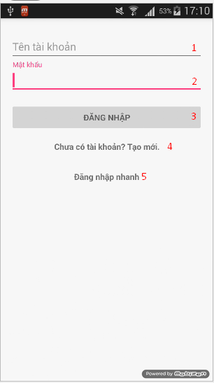

Figure : Login screen

**Fields**

|  |  |  |  |  |  |  |  |
| --- | --- | --- | --- | --- | --- | --- | --- |
| **No** | **Field**  **Name** | **Description** | **Read**  **Only** | **Mandatory** | **Control**  **Type** | **Data**  **Type** | **Length** |
| 1 | Username | Fill in username | N/A | Yes | Edittext | String | N/A |
| 2 | Password | Fill in password | N/A | Yes | Edittext | String | N/A |

Table : Login screen fields

**Button/Hyperlinks**

|  |  |  |  |  |
| --- | --- | --- | --- | --- |
| **No** | **Function** | **Description** | **Validation** | **Outcome** |
| 3 | Sign in | Log-in into the system | N/A | Transfer to User Activity |
| 4 | Register | Register new account | N/A | Transfer to Register Activity |
| 5 | Sign In as Guest | Log-in into the system as Guest | N/A | Transfer to User Activity |

Table : Login screen button/hyperlinks

##### Register screen

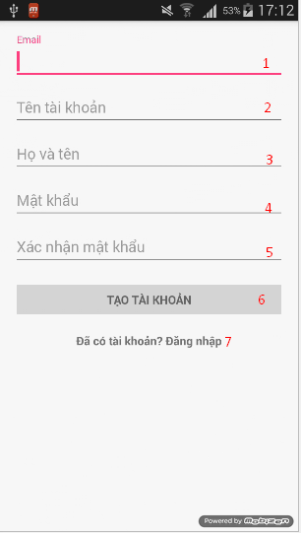

Figure : Register screen

**Fields**

|  |  |  |  |  |  |  |  |
| --- | --- | --- | --- | --- | --- | --- | --- |
| **No** | **Field**  **Name** | **Description** | **Read**  **Only** | **Mandatory** | **Control**  **Type** | **Data**  **Type** | **Length** |
| 1 | Email | Fill in email | N/A | Yes | Edittext | String | N/A |
| 2 | Username | Fill in username | N/A | Yes | Edittext | String | N/A |
| 3 | Fullname | Fill in fullname | N/A | Yes | Edittext | String | N/A |
| 4 | Password | Fill in password | N/A | Yes | Edittext | String | N/A |
| 5 | Confirm Password | Fill in confirm password | N/A | Yes | Edittext | String | N/A |

Table : Register screen fields

**Button/Hyperlinks**

|  |  |  |  |  |
| --- | --- | --- | --- | --- |
| **No** | **Function** | **Description** | **Validation** | **Outcome** |
| 6 | Register | Register new account | N/A | Transfer to Login Activity |
| 7 | Sign up | Sign up to app | N/A | Transfer to Login Activity |

Table : Register screen button/hyperlinks

#### User/Guest Interface

##### Map view screen

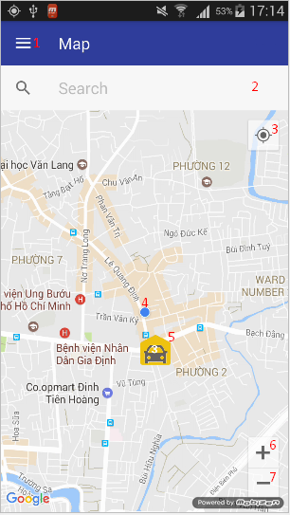

Figure : Map view screen

**Fields**

|  |  |  |  |  |  |  |  |
| --- | --- | --- | --- | --- | --- | --- | --- |
| **No** | **Field**  **Name** | **Description** | **Read**  **Only** | **Mandatory** | **Control**  **Type** | **Data**  **Type** | **Length** |
| 2 | Location Search | Fill in location name to search | N/A | No | Editttext | String | N/A |
| 4 | Current Location | The dot show current location of user | Yes | Yes | Image | Drawable | N/A |
| 5 | Car park marker | Map marker of car park | Yes | Yes | Image | Drawable | N/A |

Table : Map view screen fields

**Button/Hyperlinks**

|  |  |  |  |  |
| --- | --- | --- | --- | --- |
| **No** | **Function** | **Description** | **Validation** | **Outcome** |
| 1 | Navigation drawer | Open navigation drawer | N/A | Open navigation drawer |
| 3 | Current Location | Button to center map to current location | N/A | Center map to current location |
| 6 | Zoom in | Map zoom in button | N/A | Map zoom in |
| 7 | Zoom out | Map zoom out button | N/A | Map zoom out |

Table : Map view screen button/hyperlinks

##### Navigation view

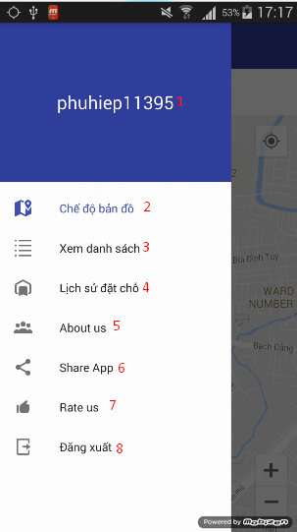

Figure : Navigation view

**Fields**

|  |  |  |  |  |  |  |  |
| --- | --- | --- | --- | --- | --- | --- | --- |
| **No** | **Field**  **Name** | **Description** | **Read**  **Only** | **Mandatory** | **Control**  **Type** | **Data**  **Type** | **Length** |
| 1 | Username | Fill in username | Yes | Yes | Textview | String | N/A |

Table : Navigation view fields

**Button/Hyperlinks**

|  |  |  |  |  |
| --- | --- | --- | --- | --- |
| **No** | **Function** | **Description** | **Validation** | **Outcome** |
| 2 | Map view | Change to map view button | N/A | Transfer to User Activity |
| 3 | List view | Change to car park list view button | N/A | Transfer to Car Park List Activity |
| 4 | Transaction view | Change to history transaction list view button | N/A | Transfer to Transaction Activity |
| 5 | About us | About us button | N/A | Show about us dialog |
| 6 | Share app | Share app button | N/A | Share app on social network |
| 7 | Rate us | Rate us button | N/A | Transfer to app download page on app store |
| 8 | Logout | Logout button | N/A | Transfer to Login Activity |

Table : Navigation view button/hyperlinks

##### Car park list view screen

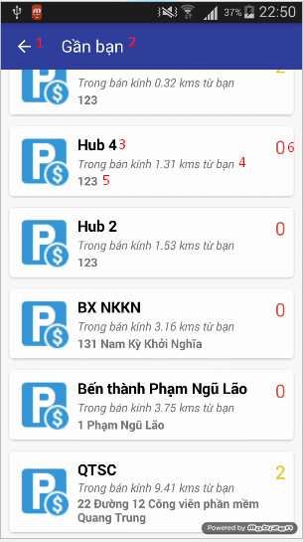

Figure : Car park list view screen

**Fields**

|  |  |  |  |  |  |  |  |
| --- | --- | --- | --- | --- | --- | --- | --- |
| **No** | **Field**  **Name** | **Description** | **Read**  **Only** | **Mandatory** | **Control**  **Type** | **Data**  **Type** | **Length** |
| 2 | Title | Display searched location or user location | Yes | Yes | Textview | String | N/A |
| 3 | Car park name | Name of car park | Yes | Yes | Textview | String | N/A |
| 4 | Distance away | Distance away from car park | Yes | Yes | Textview | String | N/A |
| 5 | Address | Address of car park | Yes | Yes | Textview | String | N/A |
| 6 | Available lot | Current available lot of car park | Yes | Yes | Textview | String | N/A |

Table : Car park list view screen fields

**Button/Hyperlinks**

|  |  |  |  |  |
| --- | --- | --- | --- | --- |
| **No** | **Function** | **Description** | **Validation** | **Outcome** |
| 1 | Back | Back to previous activity | N/A | Transfer to previous activity |

Table : Car park list view screen button/hyperlinks

##### Car park detail view screen

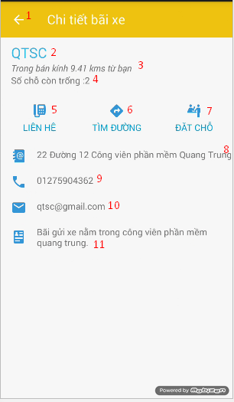

Figure : Car park detail view screen

**Fields**

|  |  |  |  |  |  |  |  |
| --- | --- | --- | --- | --- | --- | --- | --- |
| **No** | **Field**  **Name** | **Description** | **Read**  **Only** | **Mandatory** | **Control**  **Type** | **Data**  **Type** | **Length** |
| 2 | Name | Name of car park | Yes | Yes | Textview | String | N/A |
| 3 | Distance away | Distance away from car park | Yes | Yes | Textview | String | N/A |
| 4 | Available lot | Current available lot of car park | Yes | Yes | Textview | String | N/A |
| 8 | Address | Address of car park | Yes | Yes | Textview | String | N/A |
| 9 | Phone | Phone of car park | Yes | Yes | Textview | String | N/A |
| 10 | Email | Email of car park | Yes | Yes | Textview | String | N/A |
| 11 | Description | Description of car park | Yes | Yes | Textview | String | N/A |

Table : Car park detail view screen fields

**Button/Hyperlinks**

|  |  |  |  |  |
| --- | --- | --- | --- | --- |
| **No** | **Function** | **Description** | **Validation** | **Outcome** |
| 1 | Back | Back to previous activity | N/A | Transfer to previous activity |
| 5 | Call | Call button | N/A | Call action using car park phone |
| 6 | Routing | Request routing from map app | N/A | Transfer to Map App with routing request |
| 7 | Reserve | Request reserve parking lot | N/A | Show reservation dialog |

Table : Car park detail view screen button/hyperlinks

##### History transaction list view screen

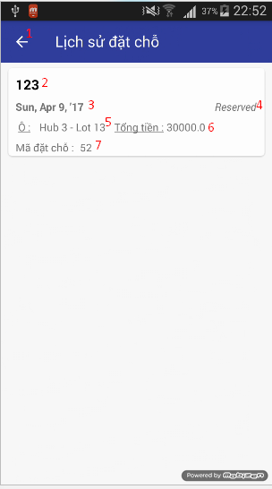

Figure : History transaction list view screen

**Fields**

|  |  |  |  |  |  |  |  |
| --- | --- | --- | --- | --- | --- | --- | --- |
| **No** | **Field**  **Name** | **Description** | **Read**  **Only** | **Mandatory** | **Control**  **Type** | **Data**  **Type** | **Length** |
| 2 | Address | Address of car park | Yes | Yes | Textview | String | N/A |
| 3 | Date | Date of reservation | Yes | Yes | Textview | String | N/A |
| 4 | Status | Status of transaction | Yes | Yes | Textview | String | N/A |
| 5 | Lot name | Name of reserved parking lot | Yes | Yes | Textview | String | N/A |
| 6 | Cost | Total cost of reservation | Yes | Yes | Textview | String | N/A |
| 7 | PIN | PIN code of reservation | Yes | Yes | Textview | String | N/A |

Table : History transaction list view screen fields

**Button/Hyperlinks**

|  |  |  |  |  |
| --- | --- | --- | --- | --- |
| **No** | **Function** | **Description** | **Validation** | **Outcome** |
| 1 | Back | Back to previous activity | N/A | Transfer to previous activity |

Table : History transaction list view screen button/hyperlinks

##### History transaction detail view screen

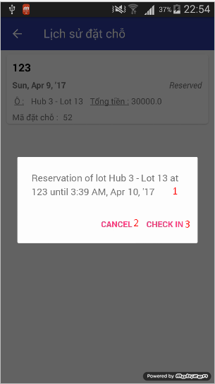

Figure : History transaction detail view screen

**Fields**

|  |  |  |  |  |  |  |  |
| --- | --- | --- | --- | --- | --- | --- | --- |
| **No** | **Field**  **Name** | **Description** | **Read**  **Only** | **Mandatory** | **Control**  **Type** | **Data**  **Type** | **Length** |
| 1 | Detail | Detail information of transaction | Yes | Yes | Textview | String | N/A |

Table : History transaction detail view screen fields

**Button/Hyperlinks**

|  |  |  |  |  |
| --- | --- | --- | --- | --- |
| **No** | **Function** | **Description** | **Validation** | **Outcome** |
| 2 | Cancel | Cancel transaction | N/A | Perform cancel transaction process |
| 3 | Check –in | Check-in car park | N/A | Perform check-in transaction process |

Table : History transaction detail view screen button/hyperlinks

##### Reservation process view screen

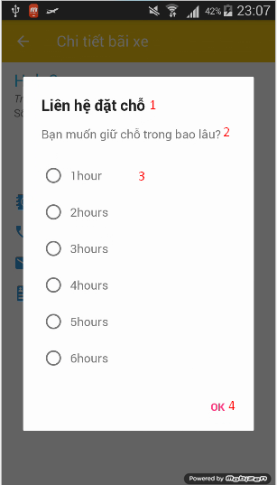

Figure : Reservation process view screen 1

**Fields**

|  |  |  |  |  |  |  |  |
| --- | --- | --- | --- | --- | --- | --- | --- |
| **No** | **Field**  **Name** | **Description** | **Read**  **Only** | **Mandatory** | **Control**  **Type** | **Data**  **Type** | **Length** |
| 1 | Title | Dialog title | Yes | Yes | Textview | String | N/A |
| 2 | Content | Content message of dialog | Yes | Yes | Textview | String | N/A |
| 3 | Choice list | Choice list of dialog | N/A | Yes | List | String | N/A |

Table : Reservation process view screen 1 fields

**Button/Hyperlinks**

|  |  |  |  |  |
| --- | --- | --- | --- | --- |
| **No** | **Function** | **Description** | **Validation** | **Outcome** |
| 4 | OK | Finish step 1 of reservation | N/A | Show reservation process dialog 2 |

Table : Reservation process view screen 1 button/hyperlinks

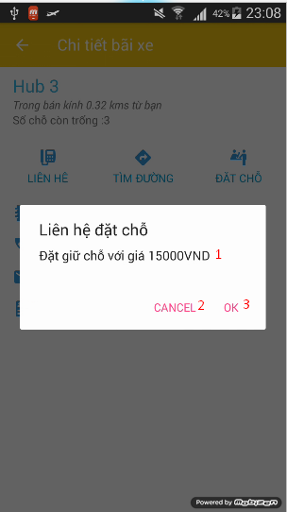

Figure : Reservation process view screen 2

**Fields**

|  |  |  |  |  |  |  |  |
| --- | --- | --- | --- | --- | --- | --- | --- |
| **No** | **Field**  **Name** | **Description** | **Read**  **Only** | **Mandatory** | **Control**  **Type** | **Data**  **Type** | **Length** |
| 1 | Cost | Message of the total cost of reservation | Yes | Yes | Textview | String | N/A |

Table : Reservation process view screen 2 fields

**Button/Hyperlinks**

|  |  |  |  |  |
| --- | --- | --- | --- | --- |
| **No** | **Function** | **Description** | **Validation** | **Outcome** |
| 2 | Cancel | Cancel the reservation | N/A | Close the dialog |
| 3 | OK | Confirm the reservation | N/A | Send the request to servers. |

Table : Reservation process view screen 2 button/hyperlinks

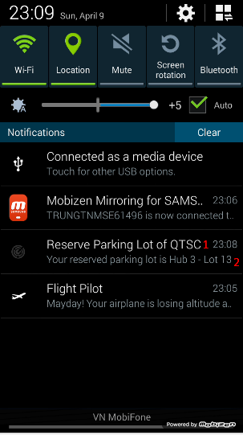

Figure : Reservation process notification

**Fields**

|  |  |  |  |  |  |  |  |
| --- | --- | --- | --- | --- | --- | --- | --- |
| **No** | **Field**  **Name** | **Description** | **Read**  **Only** | **Mandatory** | **Control**  **Type** | **Data**  **Type** | **Length** |
| 1 | Title | Title of notification | Yes | Yes | Texview | String | N/A |
| 2 | Content | Content of notification | Yes | Yes | Textview | String | N/A |

Table : Reservation process notification fields

**Button/Hyperlinks**

N/A

#### Manager Interface

##### Car park list view screen

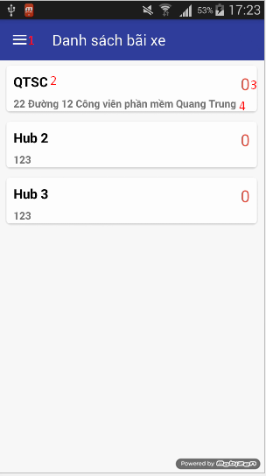

Figure : Car park list view screen

**Fields**

|  |  |  |  |  |  |  |  |
| --- | --- | --- | --- | --- | --- | --- | --- |
| **No** | **Field**  **Name** | **Description** | **Read**  **Only** | **Mandatory** | **Control**  **Type** | **Data**  **Type** | **Length** |
| 2 | Name | Name of car park | Yes | Yes | Textview | String | N/A |
| 3 | Available lot | Current available lot of car park | Yes | Yes | Textview | String | N/A |
| 4 | Address | Address of car park | Yes | Yes | Textview | String | N/A |

Table : Car park list view screen fields

**Button/Hyperlinks**

|  |  |  |  |  |
| --- | --- | --- | --- | --- |
| **No** | **Function** | **Description** | **Validation** | **Outcome** |
| 1 | Drawer | Show navigation view | N/A | Show navigation |

Table : Login screen button/hyperlinks

##### Car park detail view screen

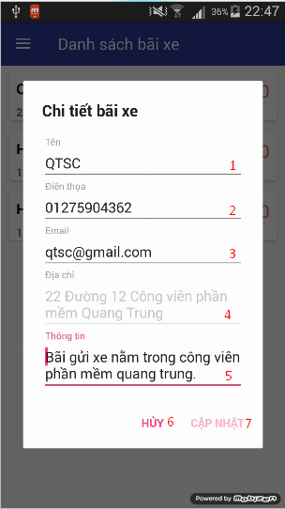

Figure : Car park detail view screen

**Fields**

|  |  |  |  |  |  |  |  |
| --- | --- | --- | --- | --- | --- | --- | --- |
| **No** | **Field**  **Name** | **Description** | **Read**  **Only** | **Mandatory** | **Control**  **Type** | **Data**  **Type** | **Length** |
| 1 | Name | Name of car park | N/A | Yes | Edittext | String | N/A |
| 2 | Phone | Phone of car park | N/A | Yes | Edittext | String | N/A |
| 3 | Email | Email of car park | N/A | Yes | Edittext | String | N/A |
| 4 | Address | Address of car park | Yes | Yes | Edittext | String | N/A |
| 5 | Description | Description of car park | N/A | Yes | Edittext | String | N/A |

Table : Car park detail view screen fields

**Button/Hyperlinks**

|  |  |  |  |  |
| --- | --- | --- | --- | --- |
| **No** | **Function** | **Description** | **Validation** | **Outcome** |
| 6 | Cancel | Cancel edit car park | N/A | Close dialog |
| 7 | Update | Update car park | N/A | Send request update car park information |

Table : Car park detail view screen button/hyperlinks

##### Area list view screen

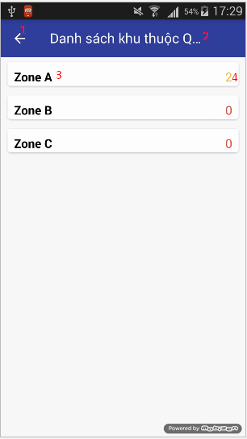

Figure : Area list view screen

**Fields**

|  |  |  |  |  |  |  |  |
| --- | --- | --- | --- | --- | --- | --- | --- |
| **No** | **Field**  **Name** | **Description** | **Read**  **Only** | **Mandatory** | **Control**  **Type** | **Data**  **Type** | **Length** |
| 2 | Title | Car park name | Yes | Yes | Textview | String | N/A |
| 3 | Name | Name of area | Yes | Yes | Textview | String | N/A |
| 4 | Available lot | Current available lot of area | Yes | Yes | Textview | String | N/A |

Table : Area list view screen fields

**Button/Hyperlinks**

|  |  |  |  |  |
| --- | --- | --- | --- | --- |
| **No** | **Function** | **Description** | **Validation** | **Outcome** |
| 1 | Back | Back to previous activity | N/A | Transfer back to previous activity |

Table : Area list view screen button/hyperlinks

##### Area detail view screen

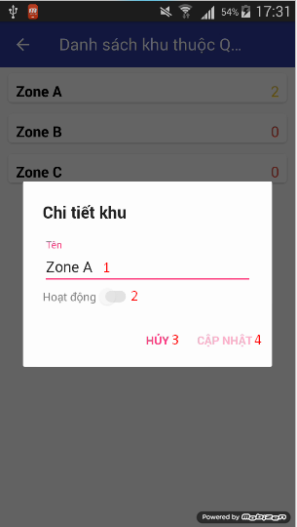

Figure : Area detail view screen

**Fields**

|  |  |  |  |  |  |  |  |
| --- | --- | --- | --- | --- | --- | --- | --- |
| **No** | **Field**  **Name** | **Description** | **Read**  **Only** | **Mandatory** | **Control**  **Type** | **Data**  **Type** | **Length** |
| 1 | Name | Name of area | N/A | Yes | Edittext | String | N/A |
| 2 | Active | Active switch of area | N/A | Yes | Switch | Bool | N/A |

Table : Area detail view screen fields

**Button/Hyperlinks**

|  |  |  |  |  |
| --- | --- | --- | --- | --- |
| **No** | **Function** | **Description** | **Validation** | **Outcome** |
| 3 | Cancel | Cancel of edit area | N/A | Close dialog |
| 4 | Update | Update area information | N/A | Send request to update area |

Table : Area detail view screen button/hyperlinks

##### Parking lot list view screen

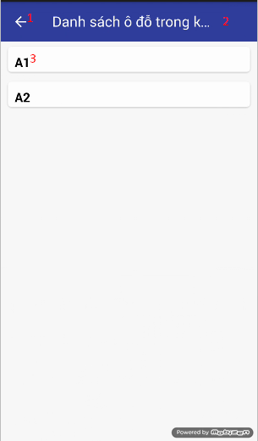

Figure : Parking lot list view screen

**Fields**

|  |  |  |  |  |  |  |  |
| --- | --- | --- | --- | --- | --- | --- | --- |
| **No** | **Field**  **Name** | **Description** | **Read**  **Only** | **Mandatory** | **Control**  **Type** | **Data**  **Type** | **Length** |
| 2 | Title | Area name | Yes | Yes | Textview | String | N/A |
| 3 | Name | Name of parking lot | Yes | Yes | Textview | String | N/A |

Table : Parking lot list view screen fields

**Button/Hyperlinks**

|  |  |  |  |  |
| --- | --- | --- | --- | --- |
| **No** | **Function** | **Description** | **Validation** | **Outcome** |
| 1 | Back | Back to previous activity | N/A | Transfer back to previous activity |

Table : Parking lot list view screen button/hyperlinks

##### Parking lot detail view screen

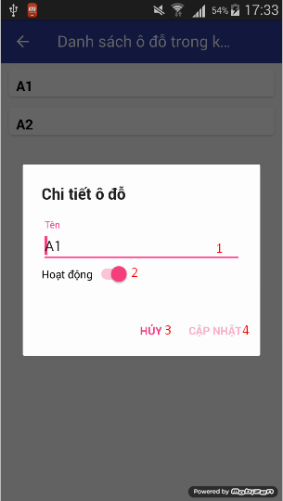

Figure : Parking lot detail view screen

**Fields**

|  |  |  |  |  |  |  |  |
| --- | --- | --- | --- | --- | --- | --- | --- |
| **No** | **Field**  **Name** | **Description** | **Read**  **Only** | **Mandatory** | **Control**  **Type** | **Data**  **Type** | **Length** |
| 1 | Name | Name of parking lot | N/A | Yes | Edittext | String | N/A |
| 2 | Active | Active switch of parking lot | N/A | Yes | Switch | Bool | N/A |

Table : Parking lot detail view screen fields

**Button/Hyperlinks**

|  |  |  |  |  |
| --- | --- | --- | --- | --- |
| **No** | **Function** | **Description** | **Validation** | **Outcome** |
| 3 | Cancel | Cancel of edit parking lot | N/A | Close dialog |
| 4 | Update | Update parking lot information | N/A | Send request to update parking lot |

Table : Parking lot detail view screen button/hyperlinks

##### Check code view screen

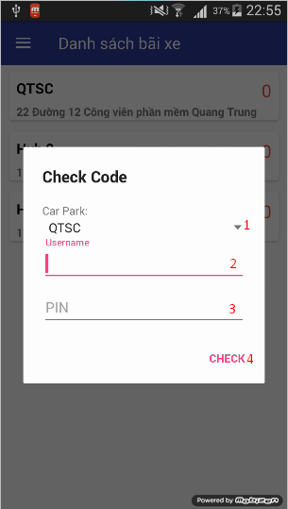

Figure : Check code view screen

**Fields**

|  |  |  |  |  |  |  |  |
| --- | --- | --- | --- | --- | --- | --- | --- |
| **No** | **Field**  **Name** | **Description** | **Read**  **Only** | **Mandatory** | **Control**  **Type** | **Data**  **Type** | **Length** |
| 1 | Car park list | List of car park | N/A | Yes | Spinner | String | N/A |
| 2 | Username | Fill in username | N/A | Yes | Edittext | String | N/A |
| 3 | PIN | Fill in PIN code | N/A | Yes | Edittext | String | N/A |

Table : Check code screen fields

**Button/Hyperlinks**

|  |  |  |  |  |
| --- | --- | --- | --- | --- |
| **No** | **Function** | **Description** | **Validation** | **Outcome** |
| 4 | Check | Check PIN code with user name and car park | N/A | Send request to check and perform check-in if correct username and pin code for car park |

Table : Check code screen button/hyperlinks

## Database Design

### Logical Diagram

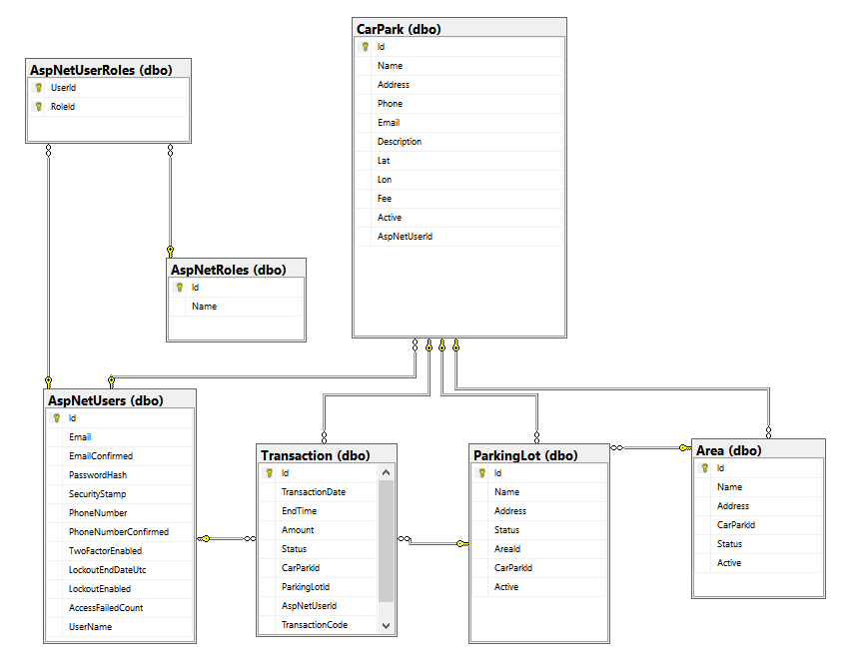

Figure : Database logical diagram

### Data Dictionary

|  |  |  |  |
| --- | --- | --- | --- |
| **Table Name** | **Column Name** | **Is Nullable** | **Data Type** |
| **Area** | Id | NO | int |
| Name | NO | nvarchar |
| Address | YES | int |
| CarParkId | NO | int |
| Status | NO | int |
| Active | NO | bit |
| **ParkingLot** | Id | NO | int |
| Name | NO | nvarchar |
| Address | NO | int |
| Status | NO | int |
| AreaId | YES | int |
| CarParkId | NO | int |
| Active | NO | bit |
| **Transaction** | Id | NO | int |
| TransactionDate | NO | datetime |
| EndTime | YES | datetime |
| Amount | NO | money |
| Status | NO | int |
| CarParkId | NO | int |
| ParkingLotId | NO | int |
| AspNetUserId | NO | nvarchar |
| TransactionCode | YES | nvarchar |
| **CarPark** | Id | NO | int |
| Name | NO | nvarchar |
| Address | NO | nvarchar |
| Phone | YES | nvarchar |
| Email | YES | nvarchar |
| Description | YES | nvarchar |
| Lat | NO | nvarchar |
| Lon | NO | nvarchar |
| Fee | YES | money |
| Active | NO | bit |
| AspNetUserId | YES | nvarchar |
| **AspNetRoles** | Id | NO | nvarchar |
| Name | NO | nvarchar |
| **AspNetUserRoles** | UserId | NO | nvarchar |
| RoleId | NO | nvarchar |
| **AspNetUsers** | Id | NO | nvarchar |
| Email | YES | nvarchar |
| EmailConfirmed | NO | bit |
| PasswordHash | YES | nvarchar |
| SecurityStamp | YES | nvarchar |
| PhoneNumber | YES | nvarchar |
| PhoneNumberConfirmed | NO | bit |
| TwoFactorEnabled | NO | bit |
| LockoutEndDateUtc | YES | datetime |
| LockoutEnabled | NO | bit |
| AccessFailedCount | NO | int |
| UserName | NO | nvarchar |

Table : Database data dictionary

## Algorithms

### GetDistance formula

To calculate the long distance with more accuracy, we must calculate the distance in the circle by using Haversine formula

$$hav\left(\frac{d}{r}\right)=hav\left(φ_{2}-φ_{1}\right)+\cos\left(φ_{1}\right)\cos\left(φ_{2}\right)hav(λ_{2}-λ_{1})$$

$hav$ is the haversine function

$$hav\left(θ\right)=\sin^{2}\left(\frac{θ}{2}\right)=\frac{1-\cos{(θ)}}{2}$$

*d* is the distance between the two points

*r* is the radius of the sphere,

*φ*1, *φ*2: latitude of point 1 and latitude of point 2, in radians

*λ*1, *λ*2: longitude of point 1 and longitude of point 2, in radians

By apply the inverse haversine or by using the arcsine, we can calculate d:

$$d=r.{hav}^{-1}\left(h\right)=2r.\arcsin\left(\sqrt{h}\right)$$

$$d=2r.arcsin⁡(\sqrt{hav\left(φ_{2}-φ_{1}\right)+\cos\left(φ_{1}\right)\cos\left(φ_{2}\right)hav\left(λ_{2}-λ_{1}\right)}$$

$$d=2r.arcsin⁡(\sqrt{\sin^{2}\left(\frac{φ_{2}-φ_{1}}{2}\right)+\cos\left(φ_{1}\right)\cos\left(φ_{2}\right)\sin^{2}(λ_{2}-λ_{1})}$$

### CRC Error Detection

#### Definition

The aim of an error detection technique is to enable the receiver of a message transmitted through a noisy (error-introducing) channel to determine whether the message has been corrupted. To do this, the transmitter constructs a value (called a checksum) that is a function of the message, and appends it to the message. The receiver can then use the same function to calculate the checksum of the received message and compare it with the appended checksum to see if the message was correctly received.

#### Define Problem

Because we do not require a license to operate radio equipment in the 2.4GHz band, as a result, other transmitter can broadcast on the same frequency that our devices use.

#### Solution theory

Two important aspects required to form a strong checksum function:

* **WIDTH:** a register width wide enough to provide a low a-priori probability of failure (e.g. 32-bits gives a 1/2^32 chance of failure).
* **CHAOS:** a formula that gives each input byte the potential to change any number of bits in the register.

For that reason, the CRC schemes use division with some changes so that if more bytes were added to the message, the checksum value could change radically again very quickly. All the arithmetic performed during CRC calculation is performed in binary with no carries, we will call it CRC arithmetic.

Adding two numbers in CRC arithmetic is the same as adding numbers in ordinary binary arithmetic except there is no carry. This means that each pair of corresponding bits determine the corresponding output bit without reference to any other bit positions. For example:

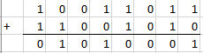

Figure : CRC arithmetic addition

Subtraction is identical:

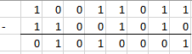

Figure : CRC arithmetic subtraction

In fact, both addition and subtraction in CRC arithmetic is equivalent to the XOR operation, and the XOR operation is its own inverse. This effectively reduces the operations of the first level of power (addition, subtraction) to a single operation that is its own inverse. This is a very convenient property of the arithmetic.

Having defined addition, we can move to multiplication and division. Multiplication is absolutely straightforward, being the sum of the first number, shifted in accordance with the second number. (note: the sum uses CRC addition)

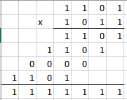

Figure : CRC arithmetic multiplication

Division is a little messier as we need to know when "a number goes into another number". To do this, we invoke the weak definition of magnitude defined earlier: that X is greater than or equal to Y if the position of the highest 1 bit of X is the same or greater than the position of the highest 1 bit of Y.

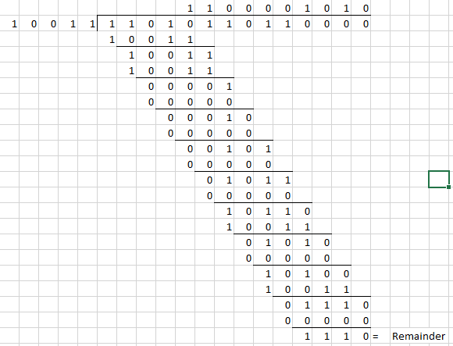

Figure : CRC arithmetic division

Having defined CRC arithmetic, we can now frame a CRC calculation as simply a division, because that's all it is. To perform a CRC calculation, we need to choose a divisor. In math marketing speak the divisor is called the "generator polynomial" or simply the "polynomial", and is a key parameter of any CRC algorithm. As a compromise, we will refer to the CRC polynomial as the "poly".

The width (position of the highest 1 bit) of the poly is very important as it dominates the whole calculation. Typically, widths of 16 or 32 are chosen so as to simplify implementation on modern computers. The width of a poly is the actual bit position of the highest bit. For example, the width of 10011 is 4, not 5. For the purposes of example, we will choose a poly of 10011 (of width W of 4).

Having chosen a poly, we can proceed with the calculation. This is simply a division (in CRC arithmetic) of the message by the poly. The only trick is that W zero bits are appended to the message before the CRC is calculated. Thus we have:

* Original message: 1101011011
* Poly: 10011
* Message after appending W zeros: 11010110110000

This is the same division as above figure, so we got the remainder, which is the calculated checksum is 1110. Usually, the checksum is then appended to the message and the result transmitted. In this case the transmission would be: 11010110111110. This ends the calculation.

A summary of the operation of the class of CRC algorithms:

* Choose a width W, and a poly G (of width W).
* Append W zero bits to the message. Call this M'.
* Divide M' by G using CRC arithmetic. The remainder is the checksum.

#### Implementation

To implement a CRC algorithm all we have to do is implement CRC division. There are two reasons why we cannot simply use the divide instruction of whatever machine we are on. The first is that we have to do the divide in CRC arithmetic. The second is that the dividend might be ten megabytes long, and todays processors do not have registers that big.

So to implement CRC division, we have to feed the message through a division register. At this point, we have to be absolutely precise about the message data. In all the following examples the message will be considered to be a stream of bytes (each of 8 bits) with bit 7 of each byte being considered to be the most significant bit (MSB). The bit stream formed from these bytes will be the bit stream with the MSB (bit 7) of the first byte first, going down to bit 0 of the first byte, and then the MSB of the second byte and so on.

For the purposes of example, consider a poly with W=4 and the poly=10111. Then, the perform the division, we need to use a 4-bit register:

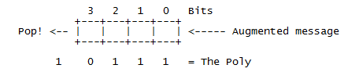

Figure : CRC implementation register

(Augmented message is the message followed by W zero bits)

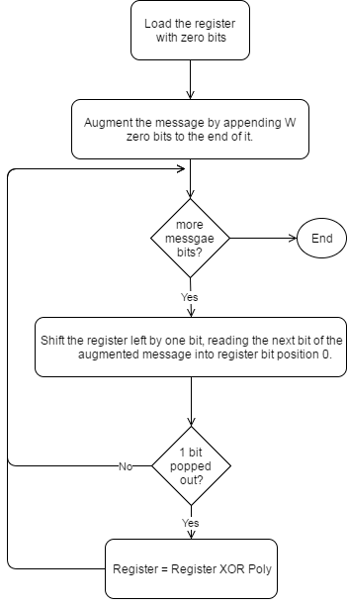

Figure : CRC implementation simple flow

#### Table-driven implementation

The implementation above is a good starting point because it corresponds directly to the theory presented so far, and because it is so simple. However, because it operates at the bit level, it is rather awkward to code (even in C), and inefficient to execute (it has to loop once for each bit). To speed it up, we need to find a way to enable the algorithm to process the message in units larger than one bit.

For the purposes of discussion, let us switch from a 4-bit poly to a 32-bit one. Our register looks much the same, except the boxes represent bytes instead of bits, and the Poly is 33 bits (one implicit 1 bit at the top and 32 "active" bits) (W=32).

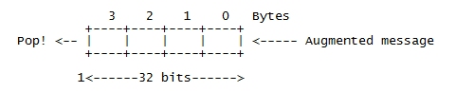

Figure : CRC 32-bits register

Consider for a moment that we use the top 8 bits of the register to calculate the value of the top bit of the register during the next 8 iterations. Suppose that we drive the next 8 iterations using the calculated values (which we could perhaps store in a single byte register and shift out to pick off each bit). Then we note three things:

* The top byte of the register now doesn't matter. No matter how many times and at what offset the poly is XORed to the top 8 bits, they will all be shifted out the right hand side during the next 8 iterations anyway.
* The remaining bits will be shifted left one position and the rightmost byte of the register will be shifted in the next byte.
* While all this is going on, the register will be subjected to a series of XOR's in accordance with the bits of the pre-calculated control byte.

Now consider the effect of XORing in a constant value at various offsets to a register. For example:

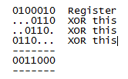

The point of this is that you can XOR constant values into a register to your heart's delight, and in the end, there will exist a value which when XORed in with the original register will have the same effect as all the other XORs.

Putting all the pieces together we have an algorithm that goes like this:

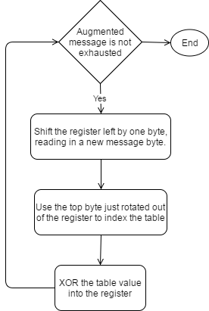

Figure : CRC implementation table-driven flow

For the actual implementation in project, we use 3 bytes in payload package as checksum, so we need to implement CRC24. Here is the table we use for CRC24 table-driven implementation:



Figure : CRC24 precomputed table

# F. User’s Manual

## Installation Guide

### Hardware installation

The installation of lot nodes and sign nodes is complicated and depends on the car park. So we decide that if car park owner need to setup the PGSS for his car park, he need to contact our team and we will setup.

### Hub installation

After install the hardware for the car park, it will have a unique Id. The hub run on Raspbian so our team or car park owner need to go to raspberry pi site and download the newest version of Raspbian for their raspberry, follow this link:

<https://www.raspberrypi.org/downloads/raspbian/>

Run the raspberry the 1st time, need to update it with the following command:

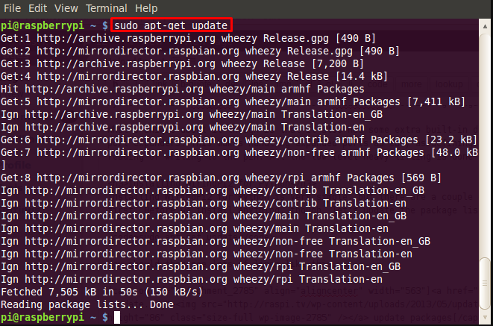

Figure : Update Raspbian

Install python-dev and enable GPIO, I2C:

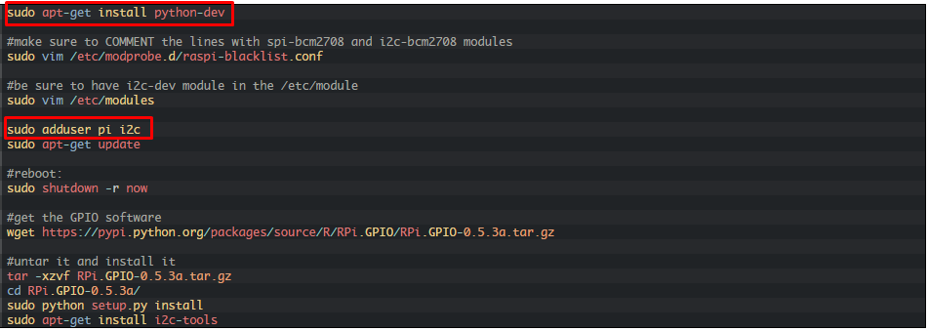

Figure : Install and enable GPIO on Raspbian

Finally, clone the code from the following git server and run Hub.py with python 3

<https://github.com/Hinaka/-FPT-CAPSTONE-PGSS/tree/master/Raspberry%20Pi>

### Mobile Application

In a real product environment, user can go to play store / app store on their respective phone and search for our app to install. But for demo sake, in our current environment, user can get the apk file from the following git server:

<https://github.com/Hinaka/-FPT-CAPSTONE-PGSS/tree/master/Android>

## User Guide

### Manager

#### Edit car park information

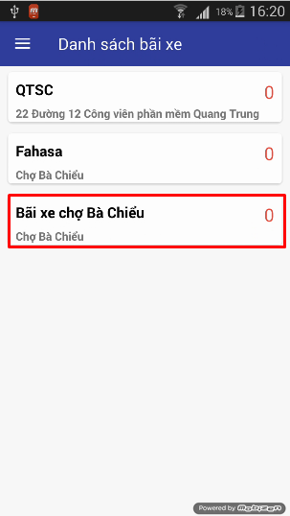

Figure : Edit car park information step 1

|  |  |
| --- | --- |
| **Step** | **Description** |
| 1 | Hold/Long click the item on the list you want to edit |

Table : Edit car park information step 1

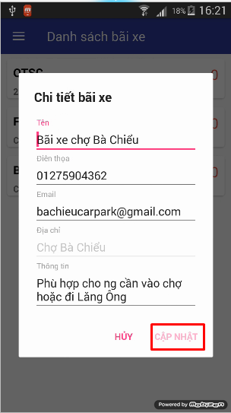

Figure : Edit car park information step 2

|  |  |
| --- | --- |
| **Step** | **Description** |
| 2 | Change car park information and click “CẬP NHẬT” to finish the edit action. |

Table : Edit car park information step 2

#### Edit area information

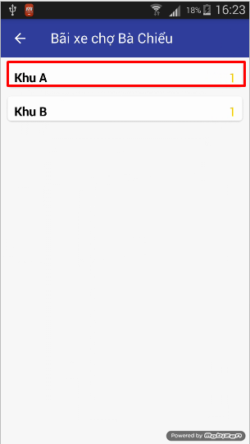

Figure : Edit area information step 1

|  |  |
| --- | --- |
| **Step** | **Description** |
| 1 | Hold/Long click the item on the list you want to edit |

Table : Edit area information step 1

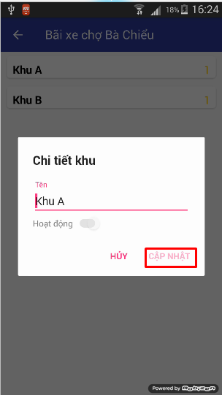

Figure : Edit area information step 2

|  |  |
| --- | --- |
| **Step** | **Description** |
| 2 | Change area information and click “CẬP NHẬT” to finish the edit action. |

Table : Edit area information step 2

#### Edit parking lot information

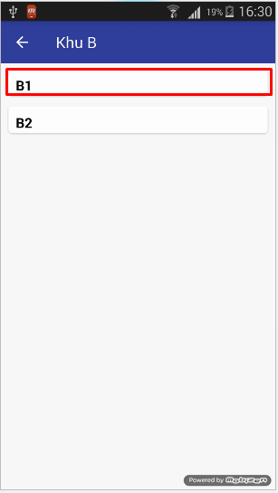

Figure : Edit parking lot information step 1

|  |  |
| --- | --- |
| **Step** | **Description** |
| 1 | Hold/Long click the item on the list you want to edit |

Table : Edit parking lot information step 1

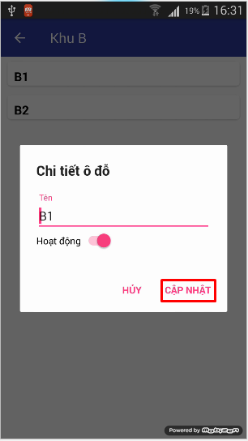

Figure : Edit parking lot information step 2

|  |  |
| --- | --- |
| **Step** | **Description** |
| 2 | Change parking lot information and click “CẬP NHẬT” to finish the edit action. |

Table : Edit parking lot information step 2

#### Check PIN code for user

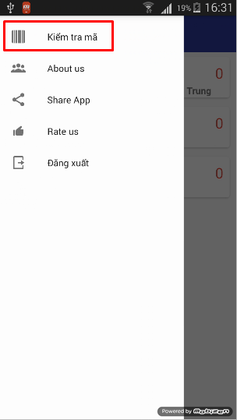

Figure : Check PIN code for user step 2

|  |  |
| --- | --- |
| **Step** | **Description** |
| 1 | On main manager screen, click on the notification button |
| 2 | On notification drawer, click “Kiểm tra mã” |

Table : Check PIN code for user step 1, 2

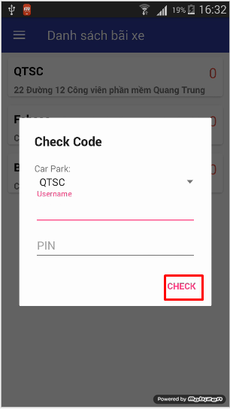

Figure : Check PIN code for user step 3

|  |  |
| --- | --- |
| **Step** | **Description** |
| 3 | Manager select car park and input username, PIN code and click CHECK to finish the action. A message will show if the code is correct. |

Table : Check PIN code for user step 3

### User

#### Search for car park near user in map

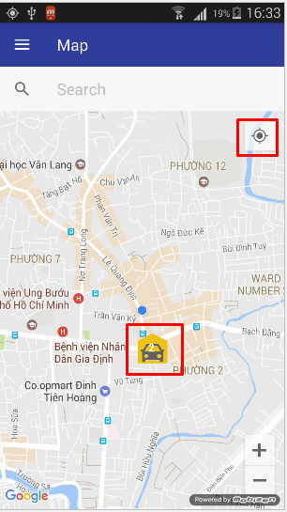

Figure : Search for car park near user in map step 1, 2

|  |  |
| --- | --- |
| **Step** | **Description** |
| 1 | Turn on the app and login as User or Guest |
| 2 | When the app first open or when the user clicks the Current Location button on the top right of the screen, the app will center to the current location of user. The nearest car park will be display on the map in a custom map marker like the screen above. |

Table : Search for car park near user in map step 1, 2

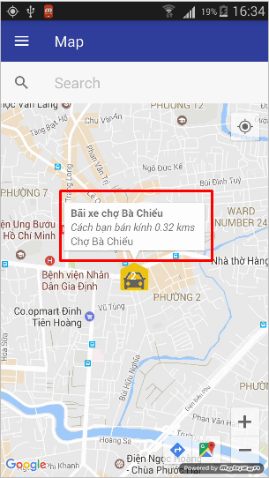

Figure : Search for car park near user in map step 3, 4

|  |  |
| --- | --- |
| **Step** | **Description** |
| 3 | User can drag on the map to look for other car park near current location, zoom-in, zoom-out… |
| 4 | User click on the marker, an info window will display basic information about car park for user. The basic information include: name, distance away from current location user and address. |

Table : Search for car park near user in map step 3, 4

#### Search for car park near location in map

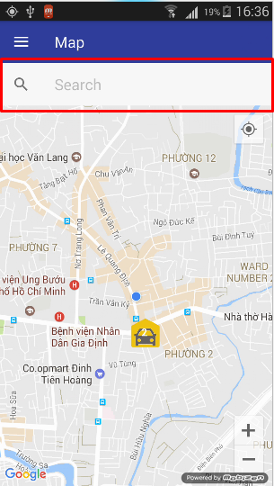

Figure : Search for car park near location in map step 1

|  |  |
| --- | --- |
| **Step** | **Description** |
| 1 | User click on the search text box in map view |
| 2 | User input the name for the search location, a place drop down list will display to help user complete the input quicker. |
| 3 | User can click on the item of drop down list or click ok on keyboard. |

Table : Search for car park near location in map step 1, 2, 3

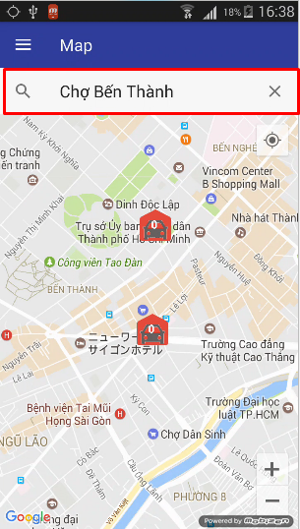

Figure : Search for car park near location in map step 4

|  |  |
| --- | --- |
| **Step** | **Description** |
| 4 | The app will center the map to searched location and display car parks near it. The value inside the search text box is the name of searched location |
| 5 | User can drag on the map to look for other car park near searched location, zoom-in, zoom-out… |
| 6 | User click on the marker, an info window will display basic information about car park for user. The basic information include: name, distance away from searched location and address. |

Table : Search for car park near location in map step 4, 5, 6

#### Search for car park near user/location in list view

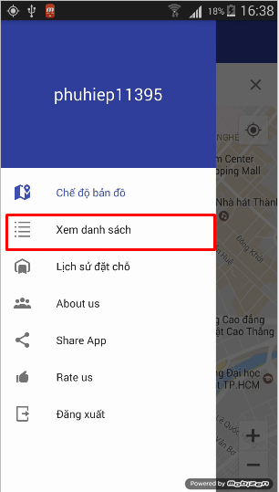

Figure : Search for car park near user/location in list view step 2

|  |  |
| --- | --- |
| **Step** | **Description** |
| 1 | On map view, click on the navigation button |
| 2 | On navigation drawer, click on “Xem danh sách” |

Table : Search for car park near user/location in list view step 1, 2

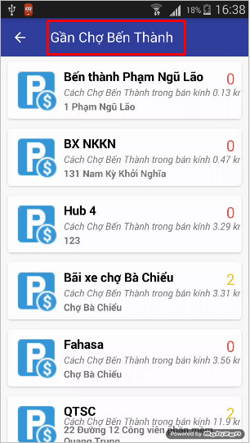

Figure : Search for car park near user/location in list view step 3

|  |  |
| --- | --- |
| **Step** | **Description** |
| 3 | The app will display nearest car parks around current user location / searched location. The item in list will display basic details, include: name, distance away from user location / searched location, address. |

Table : Search for car park near user/location in list view step 3

#### Call the car park

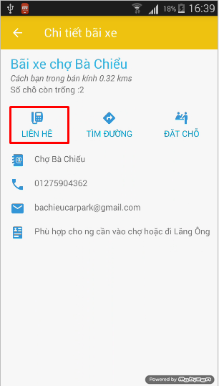

Figure : Call the car park step 1

|  |  |
| --- | --- |
| **Step** | **Description** |
| 1 | On the car park detail screen, click “LIÊN HỆ” |

Table : Call the car park step 1

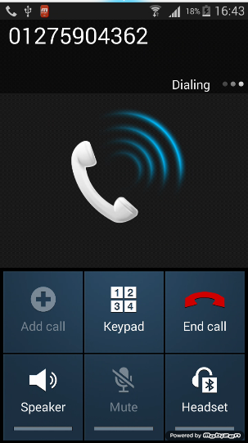

Figure : Call the car park step 2

|  |  |
| --- | --- |
| **Step** | **Description** |
| 2 | The app will perform the call action to car park phone number shown on the previous screen. |

Table : Call the car park step 2

#### Find best route from current location to car park

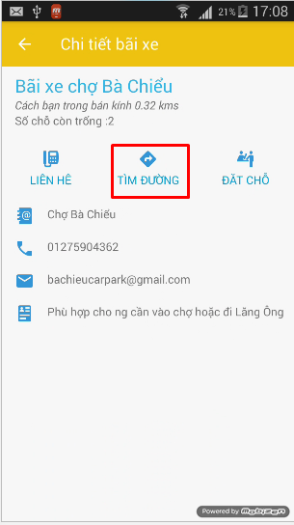

Figure : Find best route from current location to car park step 1

|  |  |
| --- | --- |
| **Step** | **Description** |
| 1 | On the car park detail screen, click “TÌM ĐƯỜNG” |

Table : Find best route from current location to car park step 1

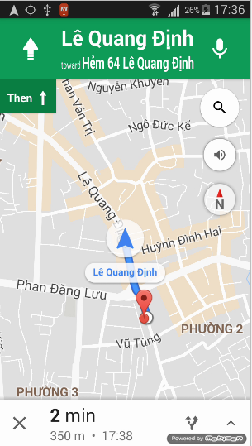

Figure : Find best route from current location to car park step 2

|  |  |
| --- | --- |
| **Step** | **Description** |
| 2 | The app will send an intent to request Google Map app to find the best route from current location to car park location |

Table : Find best route from current location to car park step 2

#### Reserve a parking lot in car park

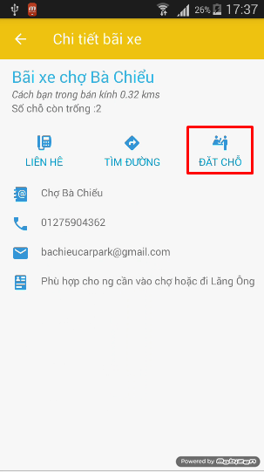

Figure : Reserve a parking lot in car park step 1

|  |  |
| --- | --- |
| **Step** | **Description** |
| 1 | On car park detail screen, click “ĐẶT CHỖ” |

Table : Reserve a parking lot in car park step 1

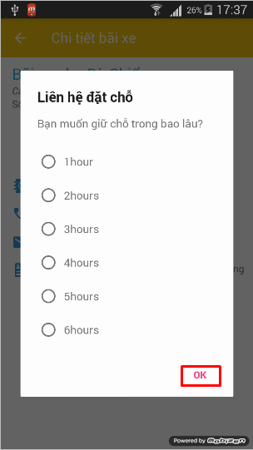

Figure : Reserve a car park in parking lot step 2

|  |  |
| --- | --- |
| **Step** | **Description** |
| 2 | User will choose the duration for the reservation, and then click OK |

Table : Reserve a car park in parking lot step 2

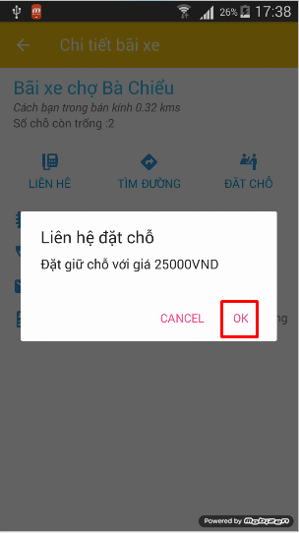

Figure : Reserve a parking lot in car park step 3

|  |  |
| --- | --- |
| **Step** | **Description** |
| 3 | A dialog contains the total cost of the reservation will be display, user click OK to finish the reserve process. |

Table : Reserve a parking lot in car park step 3

#### Cancel/Check-in reservation

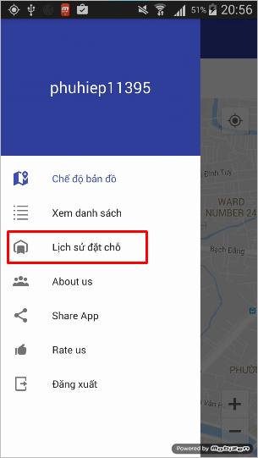

Figure : Cancel/Check-in reservation step 2

|  |  |
| --- | --- |
| **Step** | **Description** |
| 1 | On map view, click on navigation button |
| 2 | On navigation drawer, click “Lịch sử đặt chỗ” |

Table : Cancel/Check-in reservation step 1, 2

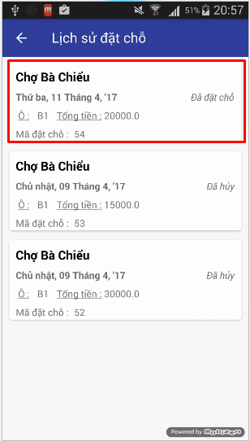

Figure : Cancel/Check-in reservation step 3

|  |  |
| --- | --- |
| **Step** | **Description** |
| 3 | Select the reservation you want to cancel/check-in. Only reservation with status “Đã đặt chỗ” can be select |

Table : Cancel/Check-in reservation step 3

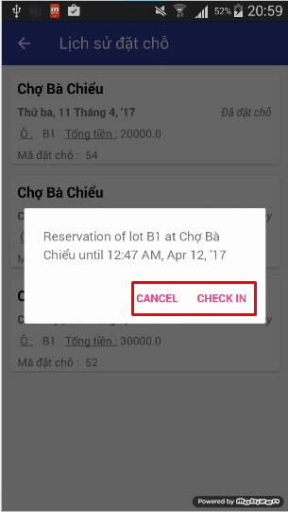

Figure : Cancel/Check-in reservation step 4

|  |  |
| --- | --- |
| **Step** | **Description** |
| 4 | A dialog contains detail information of the reservation will be shown. Choose CANCEL, CHECK IN to finish the action |

Table : Cancel/Check-in reservation step 4